Summary so far… the relationship between National Religiosities and National Attitudes to Climate Change
October 2020.
My series of 3 guest posts at professor Curry’s Climate Etc, shows that supportive attitudes to climate-change (CC) across national publics, have a dual and systemic strong relationship with religiosity. CC supportive public responses to unconstrained climate survey questions correlate with national religiosity, while oppositely, CC supportive responses to reality-constrained questions anti-correlate with national religiosity. [Reality-constrained questions force survey participants to consider and compare other reality issues in relation to climate change, typically by asking them to nominate the X ‘most important’ from a larger list of Y issues, of which one represents a climate-change issue, or literally just ‘climate-change’. Unconstrained questions don’t force such a comparative choice]. Using some of the data-series from the Climate Etc. posts, Chart 1 below summarizes this dual relationship. For many nations and plotted against national religiosity, it shows CC supportive public responses measured (and for the dashed lines, intuited) for different strengths of both unconstrained and reality-constrained survey questions.
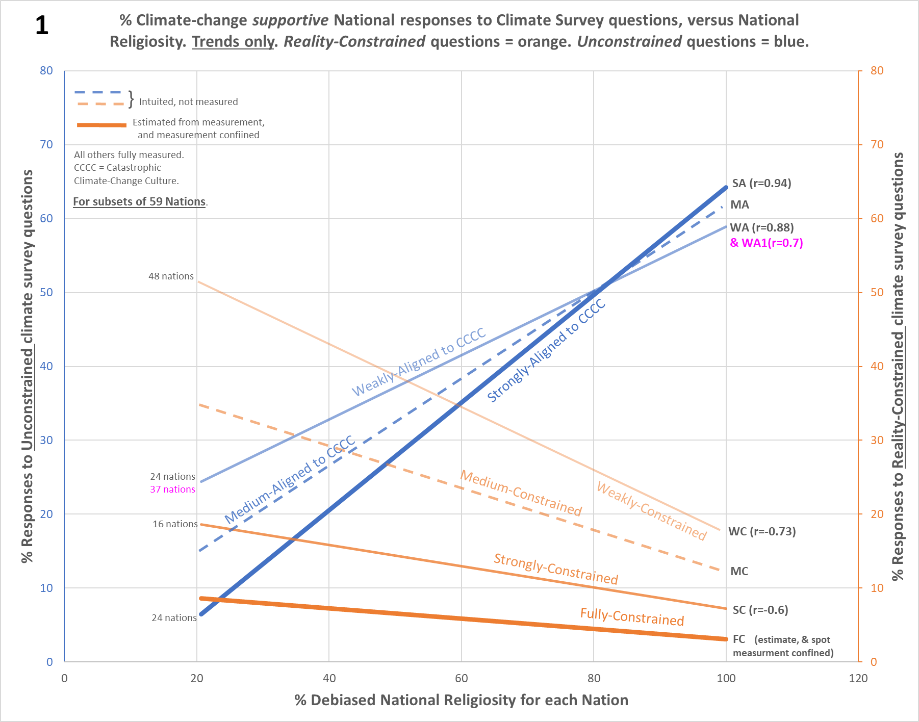
Strength for the unconstrained questions (blue lines) reflects how aligned these are to the emotive and existential values of catastrophic climate change culture (CCCC), plus how much this is targeted at the personal. Another way of thinking about this strength, is how biased the questions are towards CCCC, emotive content being a feature of bias and not of rationality. Strength for reality-constrained questions (orange lines) reflects the tightness of the constraint. Picking the ‘most important’ single issue of 9, for example, is a stronger reality-constraint, a stronger clash with the other issues, than say picking the top 3 of 12, which is stronger in turn than the top 5 of 17 ⁸. Table 1 below, shows which actual climate-change survey questions generated the data-series each line represents (each is depicted as just the stand-alone trendline), along with the related r/r²/p values.
See footnote 10 for the full-data graphic of the ‘SA’, ‘WA’, & ‘WC’ series
There are apparent paradoxes on this Chart. For instance, that within highly religious nations the most climate concerns (blue RH-ends) live simultaneously with the least priorities for action (orange RH-ends), each dependent only upon the survey question type (unconstrained, or reality-constrained). While despite overlapping values, the opposite is true at the LH side of the chart. Yet these are explainable in terms of cultural mechanics, see the second of the above posts, ‘Apparent Paradoxes in the relationship of Climate ‘Concerns, Skepticism, Activism, and Priority explained by Religiosity’, or the brief Summary of explanations below. Of course, my explanations may not be the best ones, but such strong data cries out for some explanation, which bearing in mind the nature of religious belief cannot avoid cultural factors. As Table 1 indicates, there are more series than depicted in Chart 1 above, the fuller picture being rather more complex. But before delving into that, look at the ‘r’ values for the various linear plus statistically significant series (in all the pale-purple filled cells, except where a right-red-border indicates not).
Unconstrained questions |  |  |  | Reality-constrained questions
CCCC alignment Strength | Question | Measured  (CC supportive) response | Data-points, ‘r’, ‘p’ | Constraint Strength | Those who choose… | Measured  (CC supportive)  response | Data-points,  ‘r’, ‘p’
Strong but partial scope (‘aligned to ½ CCCC’) | How likely do you think it is that climate change will cause the extinction of the human race?¹ | ‘Very likely’  Linear +  (Not shown) ª | 24, 0.61, 1.63E-3 | Full | Climate-change as important in 1 of Y (national issues) ^{2,3}  [Core-Belief Estimate] | Point samples  confine below.  (Chart 1/2 FC) ^{e} Estimate Linear - | 5, *, *
Strong | How much of an impact, if any, do you believe climate change will have on your life? ¹ | ‘A great deal’  Linear +  (Chart 1/2 SA) ^{b} | 24, 0.94, 1.24E-11 | Strong  CC sceptical in Chart F1a, ‘r’=-0.87 | Climate-change as important in 1 of 9 (global threats) ⁴ | Linear -  (Chart 1/2 SC) ^{f} | 16, -0.6, 1.41E-2
Medium | Not measured | n/a | n/a | Medium | Not measured | n/a | n/a
Weak | How much power, if any, do you think International bodies (e.g. the United Nations) have to combat climate change? ¹ | ‘A great deal’  Linear +  (Chart 1/2 WA) ^{c} | 24, 0.88, 1.64E-8 | Weak  CC sceptical in Chart F1b, ‘r’=-0.73 | ‘Action on climate-change’ as important in 6 of 17  (global issues) ⁵ | Linear -  (Chart 1/2 WC) ^{g} | 48, -0.73§, 3.68E-9  (§ is -0.8 over common 22)
Weak | How serious a problem, if at all, do you think climate change is?⁶ | ‘Extremely’. Linear +  (Chart 1/2 WA1) ^{m} | 37, 0.7, 1.46E-6
Weak with confidence offset | How serious a problem, if at all, do you think climate change is?⁶ | ‘Very or Extremely’ Linear +  (Chart 2 WA+O2) ^{d} | 37, 0.76, 3.75E-8 | Weak with confidence offset | Answer ‘China’ to blue text question below (correct) | Linear -  (Chart 2 WC+O1) ^{h} | 22, 0.84, add p
Confidence offset alone | How serious a problem, if at all, do you think climate change is?⁶ | ‘Very’. No trend, Y offset approx +30.  (Footnotes Chart F9) | 37, 0.008, 5.97E-1  Not signif
Very Weak ↓ | ↓ Linearity and response modality between Constrained / Unconstrained lost, for ‘Very Weak’ ↓
Response character | Question |  |  |  | Measured response  (not Linear) | Results | Data-points
Invokes a smeared response between those expected for very weakly aligned to CCCC, and very weakly constrained. i.e. responses still cultural not rational. | The climate is changing and human activity is mainly responsible.¹ |  |  |  | Affirmatives | Chart 2, Pale green cones ^{i} | 22
 | Do you think that you personally could be doing more to tackle climate change?¹ |  |  |  | ‘Could be doing more’ | Chart 2, Pale green cones ^{j} | 22
 | Which countries, if any, do you think have had the most negative impact on global warming and climate change?¹ |  |  |  | ‘India’ (incorrect) | Chart 2, Pale green cones ^{k} | 22
Table 1 | 22 nations are common to all series, EXCEPT the red data (which has 13 of the 22), and the underlined subset data (smaller series, but all within the 22). Two nations in the unconstrained sets of 24, don’t appear within any reality-constrained set. A right-red-border on the pale-purple cells indicates non-linearity or no relationship.  Relationship of National Religiosities to surveyed attitudes on Climate-Change
1. Climate Survey Data-source: International 2019 YouGov climate-change attitudes survey.
2. Climate Survey Data-source: European Perceptions of Climate Change (EPCC) 2016 survey.
3. Climate Survey Data-source: UK government 2015 public attitudes tracker.
4. Climate Survey Data-source: YouGov ‘What the world thinks’ (2016), composite with ‘Special Eurobarometer 459’ (2017).
5. Climate Survey Data-source: The huge 2015 UN ‘My World’ poll with ~10 million participants across many nations.
6. Climate Survey Data-source: Climate questions in the Reuters / University of Oxford ‘Digital News Report 2020’ survey.
a. Original Excel chart: ‘3xy’ here (24 nations, x/y reversed, raw X scale, delete US & Vietnam rows).
b. Original Excel chart: ‘1yx’ here (22 nations, debiased X scale), ‘2xy’ here (24 nations, x/y reversed, raw X scale, delete US & Vietnam rows). |Both replicated in
c. Original Excel chart: ‘F1yx’ here (22 nations, debiased X scale), ‘4xy’ here (24 nations, x/y reversed, raw X scale, delete US & Vietnam rows).|Chart F10 below.
d. Original Excel chart: See Chart F3 in Footnote 3 below.
e. Original Excel chart: See ‘3yx’ here (red crosses, and just left of chart, column G and J for data).
f. Original Excel chart: See ‘F6’ here (and superimposed on other series, chart 3yx just to the left).
g. Original Excel chart: See ‘4yx’ and ‘5yx’ here (4yx faith color-coded, 5yx religio-regional color-coded). | Replicated in Chart F10 in Footnote 10 below.
h. Original Excel chart: See Chart F4 Footnote 4 below.
i. Original Excel chart: See ‘3yx’ here. Non-linear response, for explanation see section 2 of third post. Pink cones correspond to green on Chart 2 here.
j. Original Excel chart: See ‘2yx’ here. Non-linear response, for explanation see section 2 of third post. Pink cones correspond to green on Chart 2 here.
k. Original Excel chart: See ‘F6yx’ here. Non-linear response, for explanation see section 2 of third post. Pink cones correspond to green on Chart 2 here.
m. Original Excel chart: See Chart F9 in Footnote 9 below.
Across different subsets of 59 nations, the series r values stretch from about 0.6 to over 0.9, being -ve for reality-constrained questions and +ve for unconstrained questions. The corresponding r² values are ~0.36 to ~0.88. These blow away the literature for other cultural or demographic predictors of climate-change attitudes outside of the US. For instance MacCright et al (2015), which finds an r² of 0.08 for a political ideology predictor upon a left-right scale across western European nations. Or Kvaløy et al (2012), which finds similarly modest predictors regarding left-right political ideology and religiosity across 47 nations. The data used by the latter paper likely predates a spread of the CCCC / Religious alliance in its current form to all countries. This is no fault of the authors, yet it will also miss much of its religiosity signal, having merged onto a single scale the responses that should correlate with religiosity and the responses that should anti-correlate, thus at least partially cancelling each other. This suggests a lack of theoretical knowledge about what sort of interaction they are actually looking for. See footnote 1 below for detail; footnote 15 lists further reasons why current literature has missed strong trends. [Note: see footnote 10 for the full-data graphic of the ‘SA’, ‘WA’, & ‘WC’ series as examples of what these typically look like].
The huge gulf between these weak predictors and the strong series in Table 1 and Chart 1, suggest that either the literature has indeed missed the main cultural effect going on here¹⁵, or else the data above is simply wrong. This is why validation is so critical. My religiosity scale is common to all measurements, and is almost the simplest imaginable, plus readily available from public data (see Footnote 2 for details). While no doubt this scale could be improved, it is pretty hard to imagine that any such improvement will result in any of the above linear series having significantly worse correlations (+ve or -ve), rather than better. These relationships are also consistent across a wide range of nations having all types of political systems, wealth, religious faiths (all the main ones covered), ethnicities, geographies, and so on.
Note: most of the literature looking at many nations finds the US to be an exception. So do I. And I also know why, in terms of my total explanation. The patterns in Chart 1 should occur for any nation in which there is a 2-way cultural dance (in the public domain) between catastrophic climate-change culture, and religiosity. In the US there is a 4-way dance (Rep-con and Dem-lib cultures being the extra dancers). For nations where a 1-party state represses religion (e.g. Vietnam, China), the patterns will not hold either. Vietnam and the US are shown to be exceptions in the first post of my Climate Etc series. For the US the same deeper cultural principles hold, but it’s more complex to plot the total effects of the 4-way dance. [After absorbing the main text here, see footnote 14 showing that the principles also apply within the US].
Regarding the fuller picture, there are two areas to consider. 1) Responses to unconstrained questions that are not most supportive of climate-change, i.e. those that are less supportive, or indeed oppositional. And 2), ‘extra features’. For the former, responses that are less supportive of climate-change have simply less / looser positive correlation with religiosity. Responses that are oppositional, actually anti-correlate, which is the reason Kvaløy et al (2012) will miss much of its signal wrt religiosity. See footnote 1, which has 2 example charts such that this situation can be visualized. See Summary of explanations below as to why.
Regarding ‘extra features’ in the big picture, further series may be arbitrarily lifted on the Y-axis, while retaining the (+ve or -ve) gradients set by expectations from the existing lines in Chart 1. And there are non-linear responses to very weakly-framed questions. The other important feature, is that for the weaker strength (i.e. CCCC alignment strength, or constrained strength) series, the main variation of the samples around the trend is due to a systemic factor, which is the GDP-per-Capita of each nation relative to its religio-regional group. So, not the absolute value of GDP-per-Capita for each nation. Chart 2 adds all of these extra features to the original picture from Chart 1.
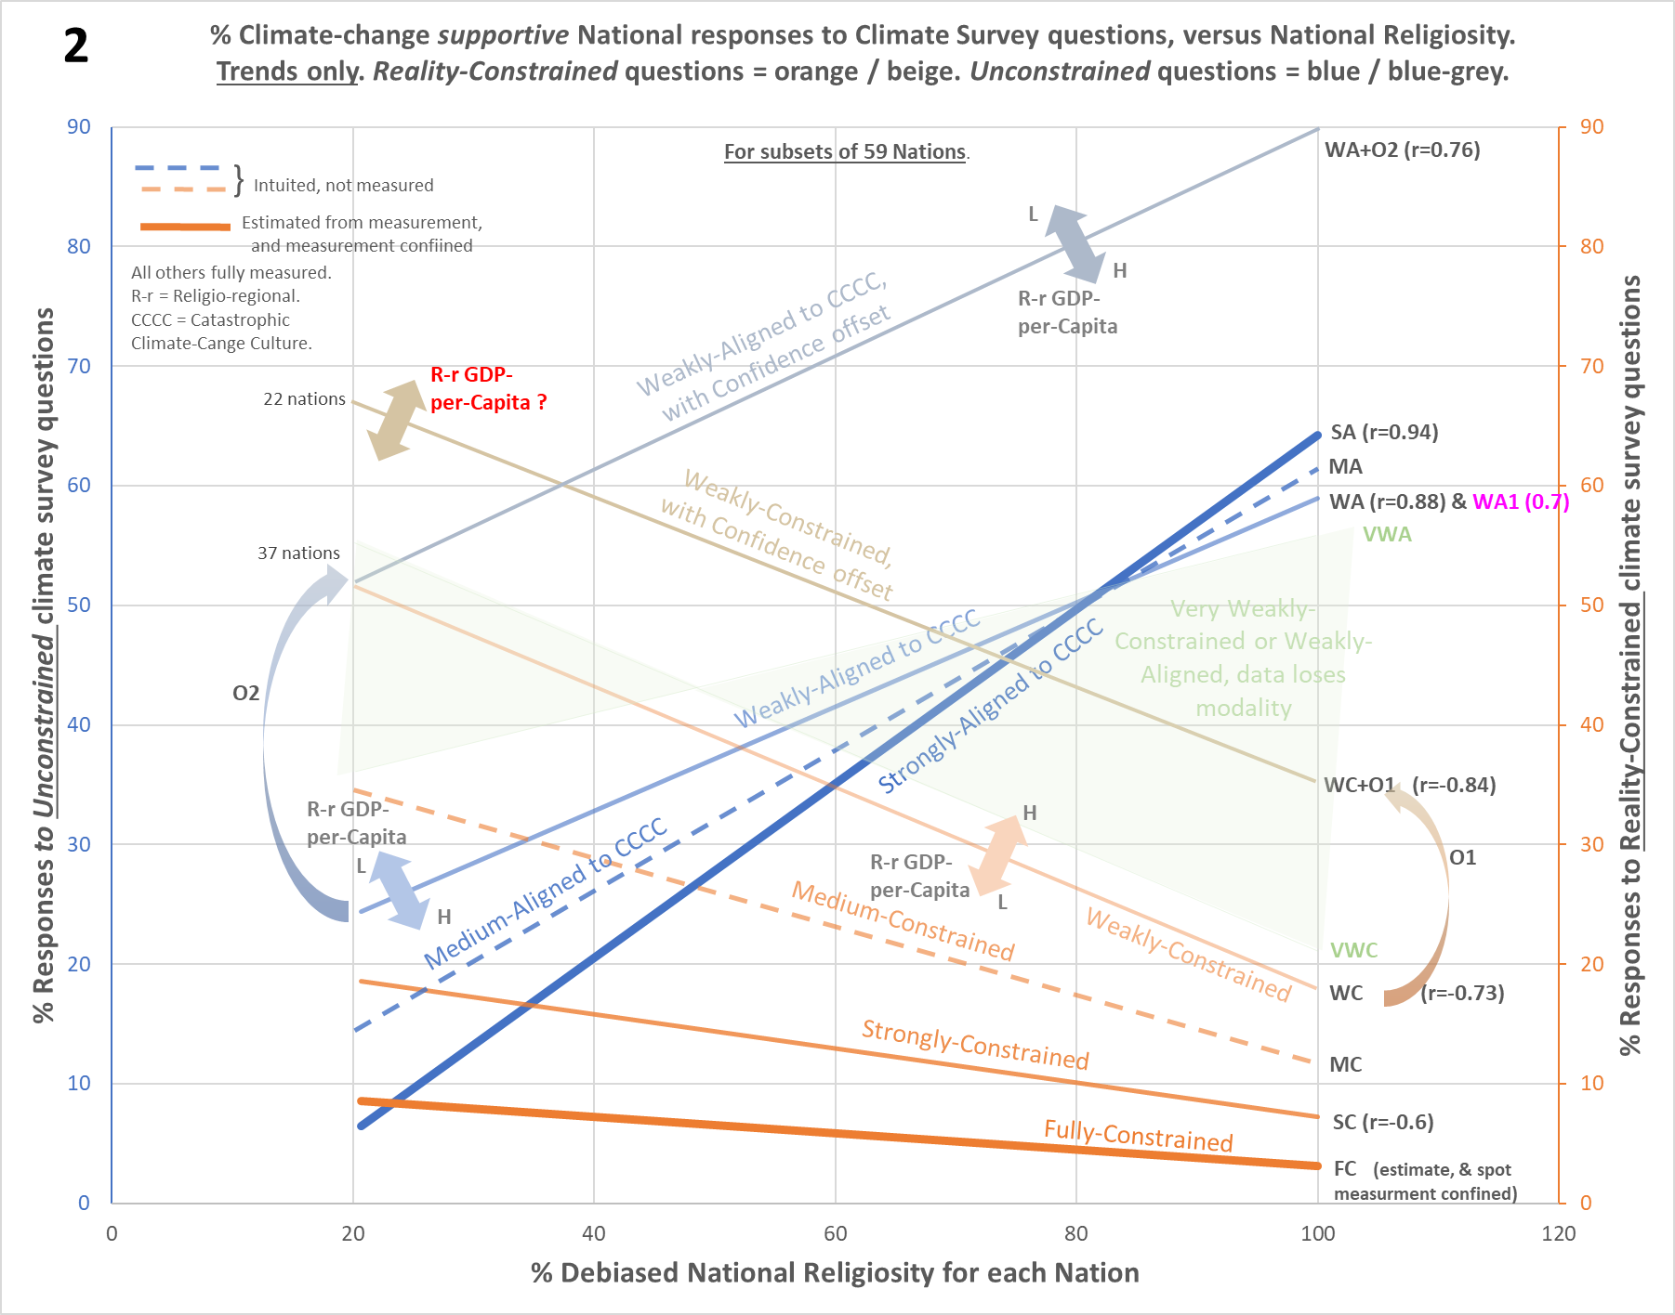
I think it’s likely that even this secondary religio-regional-GDP-per-Capita (R-r GDPpC) variable, has more effect on the prediction of national climate-change attitudes, than for instance the left-right ideology influence as reported by MacCright et al (2015). As Chart 2 attempts to indicate (with thick arrows), for responses to unconstrained questions (+ve gradient), high ranking R-r GDPpC nations are typically very close to the trend-line or below it, while low ranking nations are typically very close to the trend-line or above it. Whereas the opposite occurs for responses to reality-constrained questions (-ve gradient). High ranking R-r GDPpC nations are typically very close to the trend or above it, while low ranking nations are typically very close to the trend-line or below it.
I include full-data charts so that each of these states can be seen in detail. Footnote 3 (chart F3) shows the +ve gradient ‘WA+O2’ series, and footnote 5 (Chart F5) shows a slightly different version of the -ve gradient ‘WC’ series (having a different mix of nations I was using for an article on renewable energy motivations). Both of these, across 37 nations (28 overlapping), clearly show via the color-coding, an R-r GDPpC variance about their trendlines. See the Summary of explanations below as to why.
The ‘WA+O2’ series and ‘WC+O1’ series in Chart 2, show examples of responses lifted on the Y-axis, while retaining the expected (+ve or -ve) trend gradients. See Summary of explanations below as to why.
When questions are very weakly-framed, so for unconstrained questions, very-weakly-aligned-to-CCCC (see the ‘VWA’ edge of the pale-green cones), and for reality-constrained questions, very-weakly-constrained (see the ‘VWC’ edge of the pale-green cones), responses are non-linear. They are smeared between the two usual modes, so anywhere within the space occupied by the green cones (and in fact quite far beyond due to the additional spread caused by noise). The questions aren’t strong enough to invoke definite cultural responses, yet as the publics of nations are not climate literate, neither are the responses rational (rationality must be fed by knowledge). Responses simply drift between the available cultural options. See footnote 12 for a charted example. Note: a small minority of nations don’t conform to this pattern on some questions; see section 2 and footnote 2 of the third Climate Etc post for a fuller discussion of this non-linear aspect.
In fact, none of the series of climate supportive responses are due to rationality. For the linear cases, as demonstrated by their very strong relationships to national religiosities, which are cultural not rational expressions. Nor via the same reasoning, are these due to physical climate features or climate exposures or anything to do with climate science, none of which¹¹ should strongly correlate (or anti-correlate) with national religiosities. Nor are the climate oppositional responses (not shown in the above charts) to unconstrained questions due to rationality either; these indeed anti-correlate with religiosity, instead of correlating as do the climate supportive responses (see the orange trends in footnote 1 Charts F1a/b below for two examples). For more detail on the non-linear cases see ‘the search for rationality’ in note 2 of the footnotes file for the third Climate Etc post. In short, all the public responses to climate-change survey questions are essentially cultural in nature. They are neither rational, or to do with anything physical.
Summary of explanations. Regarding my own (challengeable!) proposals to explain the main trends with religiosity (blue correlating and orange anti-correlating on Chart 2), these hinge upon the concept of Innate Skepticism. Follow the link for much depth / detail regarding this concept, but it has nothing to do with rational skepticism. It is an instinctive reaction against an invasive alien culture, or a local cultural overreach (where a local cultural entity, e.g. a religion, has gone too far and is taking too much advantage of its adherents). Whether or not Innate Skepticism (ISk) will trigger within individuals, is cultural-value dependent. ISk is a part of the same mechanism set as cultural belief itself, the latter working via emotive commitments and the former via emotive rejection. The system is compatible with but not quite the same as for instance Dan Kahan’s ‘identity protective cognition’.
So, what is actually happening? The answer lies in the ambivalent relationship between the main long-established religious Faiths, and the new-kid-on-the-block culture that has emerged around narratives of certain climate catastrophe, aka ‘catastrophic climate-change culture’ (CCCC). All the main Faiths and some smaller ones too have issued public statements on climate-change that are replete in the narratives of imminent catastrophe (which directly contradict mainstream science). This ‘surface cultural alliance’ should easily be enough to disable any ISk to CCCC of religious adherents, as long as there aren’t any reality constraints. Religious adherents feel comfortable with climate-change catastrophe narratives as their Faiths have, on the surface at least, backed them. This explains the blue trends; as religiosity rises left-to-right, ISk falls, so less and less people express skepticism in their responses to the unconstrained climate survey questions (these questions invoking responses that have been conditioned by catastrophe narratives established over decades in the public domain).
However, the deeper attitudes of the main Faiths to climate-change are not supportive. At best, as noted by Haluza-DeLay (2014), they are ambivalent, complex, muted. Below the leaderships, on-the-ground, so to speak, the faithful don’t follow-up on the high-spoken statements; in fact, they appear to be resistive. So when reality-constraints appear (whether from a survey question or in real life), the clash with values re-enables their ISk about CCCC. And given religious adherents have strongly focused cultural values to defend, which are challenged by the societal consequences / costs exposed by reality constraints, their ISk comes in big. This explains the orange trends; as religiosity rises left-to-right, ISk rises too, so more and more people express skepticism in their responses to the reality-constrained climate survey question. So, the apparent paradox whereby nations with the most climate concerns have the least desire for action (at the RHS of Chart 2) is due to the public responses being cultural not rational (contradiction is not at all unusual regarding culturally / emotively driven attitudes). See footnote 16 for a summary characterization of responses to reality-constrained and unconstrained questions (the latter are pure virtue signaling).
Regarding the Religio-regional GDP-per-Capita variance around the weaker trendlines, at first I saw this only on the climate-change attitude series that anti-correlated with religiosity. I assumed it was merely an ‘extra’ reality-constraint. Those subject to more financial pressures relative to their Religio-regional peer group norm, were still less accepting of the ‘alien’ culture of CCCC, still less willing to invest in this as well as religious faith, or alternatively switch horses. I haven’t abandoned this idea, BUT… the same kind of variance also occurs ‘upside down’, on the weaker climate-change attitude trends that correlate with religiosity. It seems that more wealth buffers or lessens cultural behavior; leading to less Allied belief when this is enabled, or less Innate Skepticism when this is enabled instead. The above explanation may be an equivalent way of expressing the latter part of this symmetry. At any rate, for both scenarios this is not an absolute GDP-per-Capita thing, but relative to the Religio-regional peer group norm. And straight religiosity is still by far the main determinant. I haven’t fully worked out what’s going on here.
Regarding what hoists trends like ‘WA+O2’ and ‘WC+O1’ up the Y-axis on Chart 2, I have a provisional explanation (well, all the explanations here are provisional, but this one even more so). For the WC+O1 series, see note 2 of the footnotes file for the third Climate Etc post, which posits ‘rational confidence’ as the reason. Many more within national publics get the right answer for this series and yet, critically, many still have the wrong answer and the overall trend across nations is still culturally determined. Hence as culture still dominates, we can’t really call this ‘rationality’ as such, but maybe more confidence about being right, which confidence is independent of the normal cultural gradient. I think this confidence stems from respondents’ perceptions that their answer is universally ‘common knowledge’ (so also is culturally neutral). This ‘confidence offset’ effect may occur even where, due to lack of definition say, there may not actually be any ‘wrong’ or ‘right’ answer. Just a perception across all cultural parties that a particular answer is common knowledge. This perception modifies the responses accordingly (pushing them up on the Y-axis – agreement, or down – disagreement, while preserving the same gradient across nations).
Originally, I was forced to simply assume that the ‘WA+O2’ series had a similar explanation. However, I applied to Reuters for more data, which revealed that the series can be broken into 2 components, a sub-series of the same gradient as ‘WA+O2’ (and in fact forming the series WA1 in Charts 1 & 2) , plus a flat offset (no trend) that would have the effect of lifting WA1 up the Y axis to form ‘WA+O2’. I think this is exactly a ‘confidence offset’ as described above; see footnote 9 for full-data charts and more explanation.
The two thick lines on Chart 2, are the most useful for visualizing more simply what’s happening in this model, and also what the real word consequences are likely to be (next section). The thick orange line (‘FC’ series) represents ‘Core Belief’ in CCCC. I.e. this is the response line for what we’d normally think of as ‘ardent believers’ in a cultural entity (as we’re indeed familiar with from religions, but in this case the entity is CCCC, and we are only leveraging religiosity to ‘see’ it). The thick blue line represents the strongest belief in catastrophic climate-change narratives that does NOT primarily come from cultural belief, but only from the fact that, via a surface alliance with religious faith, ISk is disabled. Hence I term this ‘Allied Belief’. However, bear in mind that this blue line includes the Core Belief responses as well; but as they are much smaller across most of the chart, the trend is effectively from Allied Belief.
Whether my theoretical explanations are the best ones or not, the above strong relationships beg for some explanation. One alternate possibility is ruled out in note 13 here, along with the end of Section 7 here.

There are real-world impacts from these attitudes; this isn’t just about survey responses. At the LHS of Chart 2, the Core Belief of adherents to CCCC is at its highest (although still not breaking 10% in any nation), yet the Innate Skepticism in opposition to this (Allied Belief at its lowest point) is huge; it is in essence the rest of the population. This will lead to immense frustration from CCCC adherents that the huge majority in their countries are not taking onboard their narrative of (certain, without dramatic action) apocalypse, and salvation (with the dramatic action). Hence, an expectation is amplified climate activism within nations at the LHS. At the RHS, apparent belief is much higher (Allied Belief at its highest point, albeit being indeed Allied Belief, it is ephemeral, yet still very much on prominent display). This will lead to much less frustration, and also there are far fewer ‘core believers’ in CCCC at the RHS in order to fuel the activist activities. So one expects maximum climate activism in LHS nations, and minimum in RHS nations. Patterns do indeed appear to conform with this expectation, see footnote 6 wrt both Extinction Rebellion and Children’s Strike Weekly group presence across nations. In the latter case, an extra factor to take account of is that the religiosity for children in many Western nations is significantly less than the average for adults, and that this ‘religiosity gap’ varies per nation. The climate-change attitudes that either correlate or anti-correlate with religiosity, will follow this reduced expression for the sub-demographic of children (or indeed any other such sub-demographic differences wrt religiosity inside nations).
Still more impact, indeed very major real-world infra-structure and expenditure, flows from the charted national climate-change attitudes above that have no basis in rationality. The thick orange Core Belief line in Chart 2 (the ‘FC’ trend) reveals that even within (Western) nations occupying the LHS of the chart, less than 10% of their populations will place climate-change action above everything else when they’re forced to consider the issue in relation to all the other demands and issues in society. Yet while this suggests that policies having high costs to establish plus significant downsides to society and / or the environment (e.g. huge land area / environmental impact for renewables, and the limitations of EVs plus the major resource and environmental issues of their batteries if EV use really takes off), would never gain enough support, in reality such policies have major traction (especially renewables). This is because the public are no more engineering literate wrt emissions policies than climate literate. They’ve no idea about the downsides, and meanwhile in every nation, elites are busy converting their national climate attitudes into major policy, and hence infra-structure too (elites as a sub-demographic, like children above, likely have much greater belief in CCCC but still relative to national norms, see section 4 here).
As there is at least some reality-constraint on such policies (all nations have budgets and competition for same), the expression of say renewables as a policy should align with a reality-constrained (orange) trend, not a blue (unconstrained) trend. Albeit lack of downside knowledge makes the constraint weak. Chart 3 shows that indeed the reality of renewables commitment across (35) nations, correlates very strongly with attitudes to climate-change as expressed for reality-constrained questions. The latter on the Y-axis come from the same climate-survey responses as are used for the ‘WC’ series in Chart 2, while the renewables X-axis is a comparative measure for the average of each nation’s per-Capita Wind and Solar capacity.
In practice there’s a big back-story behind this comparison (for instance, due to social development issues on a generational timescale, religiosity anti-correlates with national wealth, plus regarding solar power there is some correction needed for each different country’s annual sunshine amount), hence the ‘GDP-per-Capita levelized’ and ‘sunshine-duration-adjusted’ terms. But fundamentally, Chart 3 reveals that across many nations, an attitude to climate-change as expressed by their publics in answer to a question having no explicit text on policy or financial commitment, an attitude that is completely cultural and not rational, indeed drives major renewables infra-structure at huge cost. [Note: even the Religio-regional GDP-per-Capita variance about trend is preserved in the renewables commitment across nations as shown in Chart 3, see footnote 7 which compares this to the same variance in the ‘WC’ series from Chart 2].

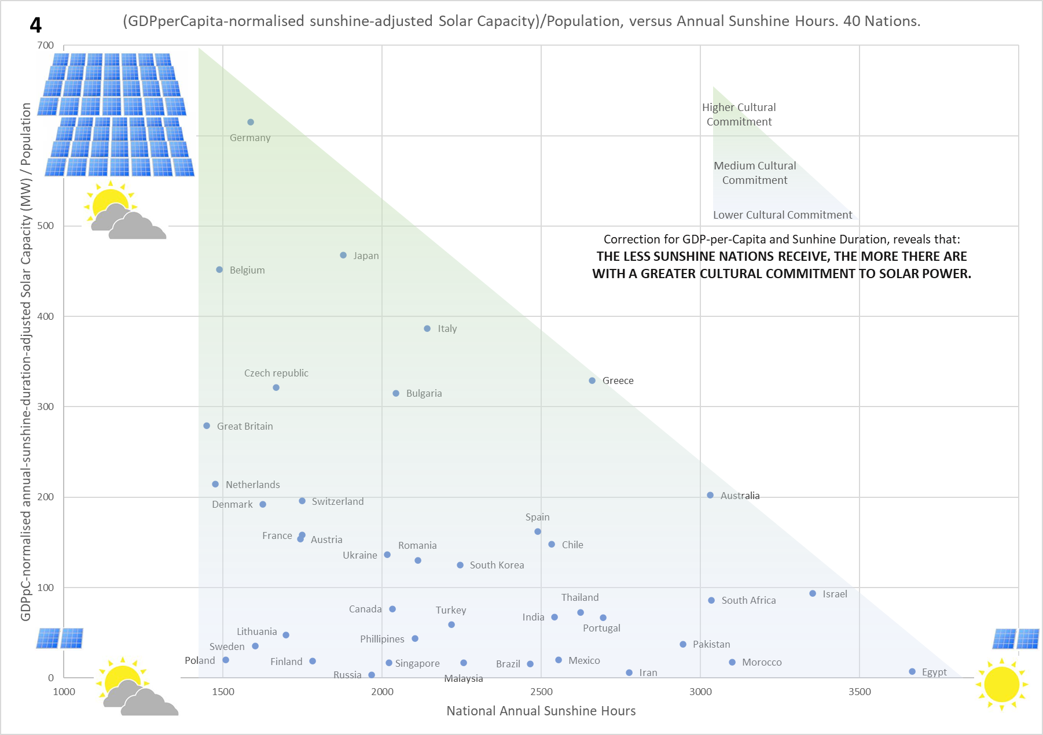
Part of that back-story, and just one irony from the cultural motivation behind Renewables, is that as the annual sunshine hours experienced by nations reduces, then more nations choose to deploy more Solar MW per capita – i.e. within exactly those geographies it is least useful. Chart 4 depicts this; Solar deployment (per capita) is levelized for GDP-per-capita, so removing differences due only to spending power, and hence getting at the motivational push relative to other national priorities. The ‘historical accident’ that is mentioned within footnote 11, is why the cultural motivation happens to align with less sunshine hours.
There’s a brief look at similar expectations for EV penetration in section 5 of the third post in my Climate Etc series, i.e. this penetration is highest within exactly the group of nations one would expect from the cultural explanation, as revealed by the relationship between CCCC and religiosity.
Even in normal times, a huge problem for those governments trying to push challenging and expensive policies, is that once the public eventually grasp the reality issues associated with implementation, their support is unlikely to get beyond the thick orange Core-Belief line (‘FC’ in Chart 2), or maybe at the most the strongly-constrained belief (‘SC’) line. Unless for special circumstances, such as immense amounts of hydro-electricity in Norway. And with a huge new reality-constraint having appeared in the form of Covid-19, this could for a year or two at least squeeze even the Core-Belief line still further downwards regarding the choice of climate-change issues / solutions as a true top priority. Policies essentially driven by cultural belief, will not and cannot stay isolated from reality forever.

And too, the citing of emergent XR and CSW protests (in irreligious nations) to justify CCCC-aligned policies, is erroneous. As can be seen from the thick orange Core-Belief line (‘FC’ in Chart 2) these protests certainly aren’t an expression of what national publics think en-masse, but extreme frustration expressed by small minorities because for sure the mass of the public around them don’t believe in certain imminent climate catastrophe. In mistakenly assuming such protests reflect popular feeling, and thus compliantly onboarding extreme demands (which also contradict mainstream science), already culturally compromised elites are marching dangerously further and further out of step with their own publics.
Footnote 13 provides a bullet-point summary of all the detailed insights revealed by this approach, with the provisional explanation for each.
Imagine trying to understand what’s happening in Chart 2, or any of the charts in the footnotes, without a religiosity axis. While there’s some conception of this axis in the US, due to Dem/Rep polarization that also has a religious weighting (for example, see Dan Kahan’s work), regarding the rest of the world, this is precisely where analysis is at now.
Main text ends, Footnotes follow…

Footnote 1. Kvaløy et al (2012) measures climate-change attitudes against religiosity by converting 4 response options regarding the seriousness of Global Warming, to a single additive scale. The 4 response options are ‘very serious’, ‘somewhat serious’, ‘not very serious’, and ‘not serious at all’, which are allocated values 4 down to 1 respectively. The authors then total the percentage of values for each nation to obtain a single variable reflecting, they believe, that nation’s average concern, to compare against their religiosity measures. However, these attitudes are cultural in nature, so as noted in the Summary of explanations above (and being from an unconstrained question) these will both exhibit correlation and anti-correlation within the same data-set. I.e. one expects the supportive / concerned attitudes about GW to correlate with religiosity, and the oppositional / unconcerned attitudes to anti-correlate with religiosity. So in this case, ‘very serious’ should correlate strongly, ‘somewhat serious’ less so, ‘not very serious’ may mildly anti-correlate or could be about neutral, and ‘not serious at all’ will anti-correlate, if the latter has large enough samples to make it out of the noise. So, combining all response types into a single scale will lose at least some of the signal! Maybe most of it, depending upon asymmetry.
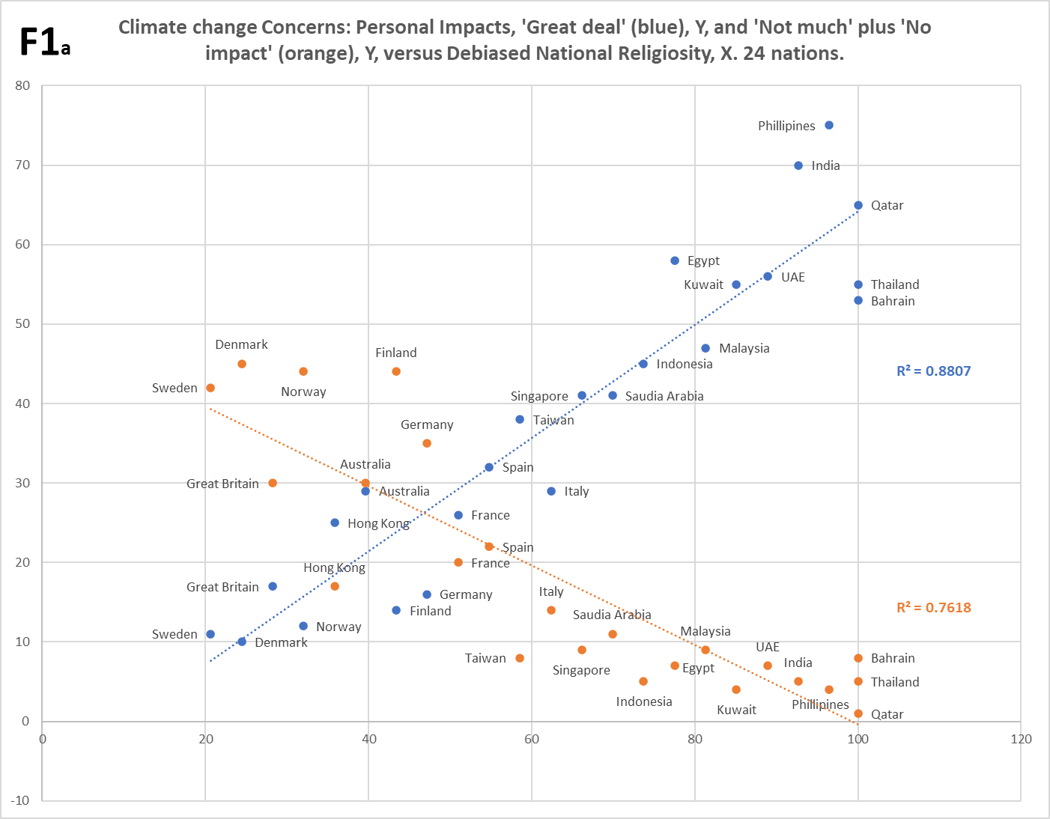
One can see how such responses work with the equivalent types ‘great deal’, ‘not much’, ‘a fair amount’, ‘no impact’ to a question asking about the personal impacts of climate-change, in Chart F1a. The blue series is the ‘great deal’ responses, the orange series is the ‘not much’ plus ‘no impact’ added together (the samples in the latter alone are too small, will be too noisy). The opposing nature of these trends is extremely obvious! The following Chart F1b shows a similar situation for response to a different (less emotive / personal) question. The gradients are somewhat less, but the principle, with opposing trends, is the same.
This likely explains the far weaker finding of Kvaløy et al (2012) for religiosity as a predictor of attitudes about climate-change. However, the other issue is that the paper’s source for climate survey data is old now (between 2005 and 2009, indeed the paper itself is 2012), which is prior to the current relationship between the cultures of CCCC and Religion being established in all countries. Religiosity data can be older (unless results are sensitive to the religiosity-gap been adults and children in Western nations), as religiosity is slow evolving. But climate-changes attitudes must be relatively fresh. Kvaløy et al (2012) claims no better results when allocating ‘1’ for both of ‘very serious’, ‘somewhat serious’ responses, and ‘0’ for the others, which ought to rescue somewhat more of the total signal, but the ‘somewhat serious’ will dilute the maximum, the anti-correlating half is still lost, and the data age may finish the off the rest.
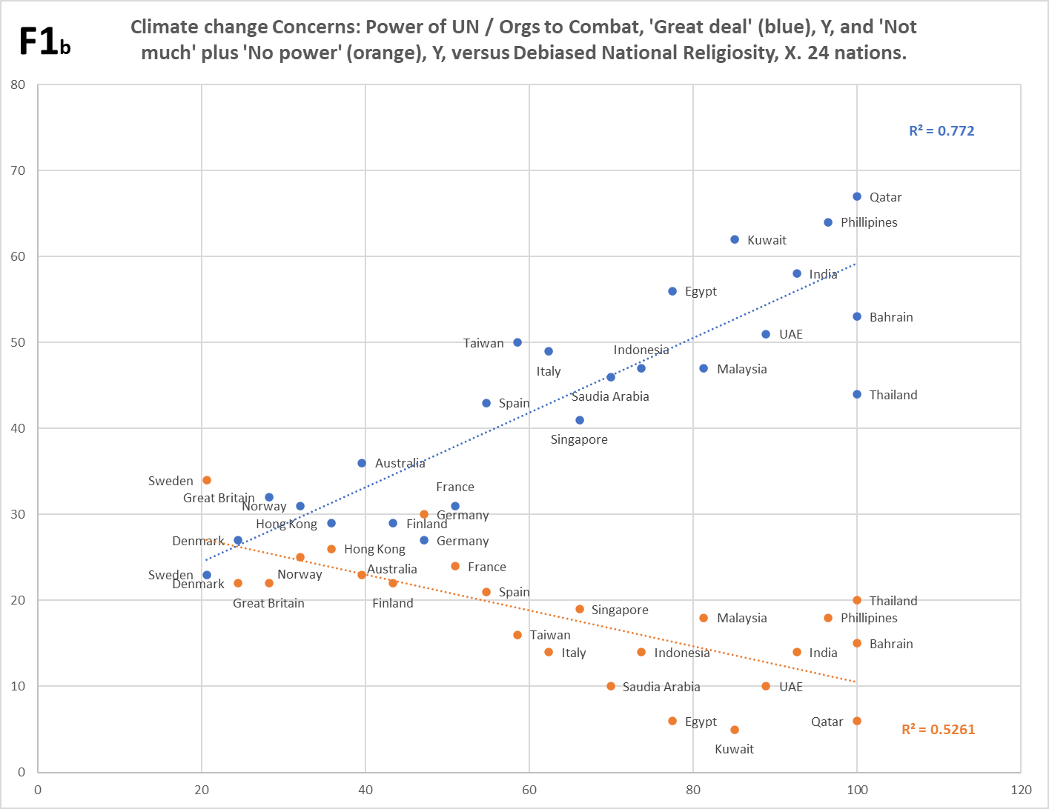
The approach highlights that this paper, along with pretty much all the literature as far as I can see, hasn’t really grasped the cultural mechanics that drive the effects they’re attempting to measure here. The cultural nature of religiosity seems to be acknowledged, but not so much that skepticism can create ‘anti-cultural’ behaviors. Plus, religiosity is not biasing an otherwise rational view on climate change. What’s happening here is a reaction between two cultures. And not only do cultures tend to polarize attitudes, two interacting cultures may also reverse the attitudinal poles for different scenarios (e.g. reality-constrained, and unconstrained).
Footnote 2. I build my own very straightforward religiosity scale by combining public surveys on same that probe from opposite angles (this increases robustness and minimizes bias effects). For a truly generic picture, nations are needed from various world regions and of different faiths (Christian, Islamic, Hindu, Buddhist etc.) There is sufficient cover for this diversity. The two mainstream sources for religiosity are conveniently linked by wiki. The first probes religiosity in about 150 countries via the question: “Is religion important in your daily life?” Unfortunately, the data is rather old; it’s a Gallup 2009 survey. However, religious commitment tends not to turn on a dime, so this is not a major concern (the climate survey data has to be fresher). The second source is a composite covering about 100 countries, probing irreligiosity via the sum of responses for ‘not a religious person’ and ‘a convinced atheist’. The main content comes from Worldwide Independent Network / Gallup International Association (WIN / GIA) surveys done in 2017, 2015, and 2012. Older surveys (Dentsu, Zuckerman), contribute data from 2006 and 2005 respectively. The great majority of needed data is at the modern end of this range. The wiki data was sampled in December 2019. To form a single scale, I converted the irreligiosity percentages into religiosity, then averaged the two lists. See note 3 here for further nuance / explanation.
There is a slight ‘S’ shaped skew in this combined data when plotted against a straight line (i.e. without any reference to climate or other data). Probably due to self-assessment bias. See notes 7, 7a, and 12 in the Footnotes file for the first post in the Climate Etc series, for ‘debiased national religiosity’, which takes out the ‘S’ shaped skew. Note, ‘r’ values for climate data plotted against the debiased scale barely change from equivalent plots against the raw scale, because the ‘S’ shape straddles trends about evenly.
Footnote 3. This ‘WA+O2’ series (see Chart 2) is provisional and I don’t have a version of it on the web yet. Below is an image of the chart from Excel. The series shows the Religio-regional GDP-per-Capita (R-r GDPpC) variance around trend. For the paired shades (light / dark) of each color-code, the dark represents high R-r GDPpC ranking, and the light represents low R-r GDPpC ranking. Nations with black label text are those which conform to the normal R-r GDPpC pattern, and those with red label text do not conform; there’s probably just too much measurement noise for full conformance. The greyed-out nations don’t have near Religio-regional peers to compare with. See the ‘mirror image’ pattern in F5, footnote 5.

Footnote 4. Chart F4 below is the ‘WC+O1’ series (see Chart 2). It appears here as ‘F7yx’, but without the r value added to the chart, and with the non-linear response cones superimposed for comparison. The series shown alone here is clearer. See the Summary of explanations section above for why this series is offset upwards on the Y axis in Chart 2. Or see an initial and longer discussion in note 2 of the footnotes file for the third Climate Etc post.

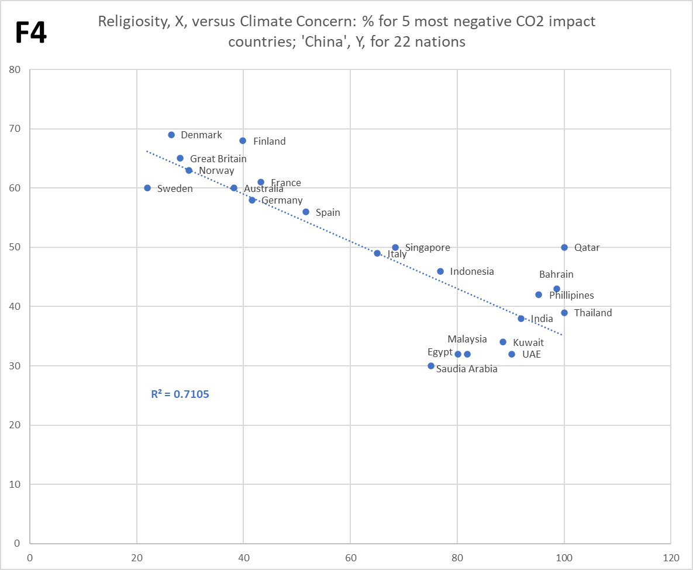

Footnote 5. This ‘WC’(variant) series (see Chart 2) shows the Religio-regional GDP-per-Capita (R-r GDPpC) variance around trend. For the paired shades (light / dark) of each color-code, the dark represents high R-r GDPpC ranking, and the light represents low R-r GDPpC ranking. Nations with black label text are those which conform to the normal R-r GDPpC pattern (which is the mirror image of the pattern for the chart in footnote 3, where there is +ve overall correlation with religiosity), and those with the red label text do not conform; there’s probably just too much measurement noise for full conformance. The greyed-out nations don’t have near Religio-regional peers to compare with. (Note: I don’t have this variant of ‘WC’ with 37 nations, on the web yet).
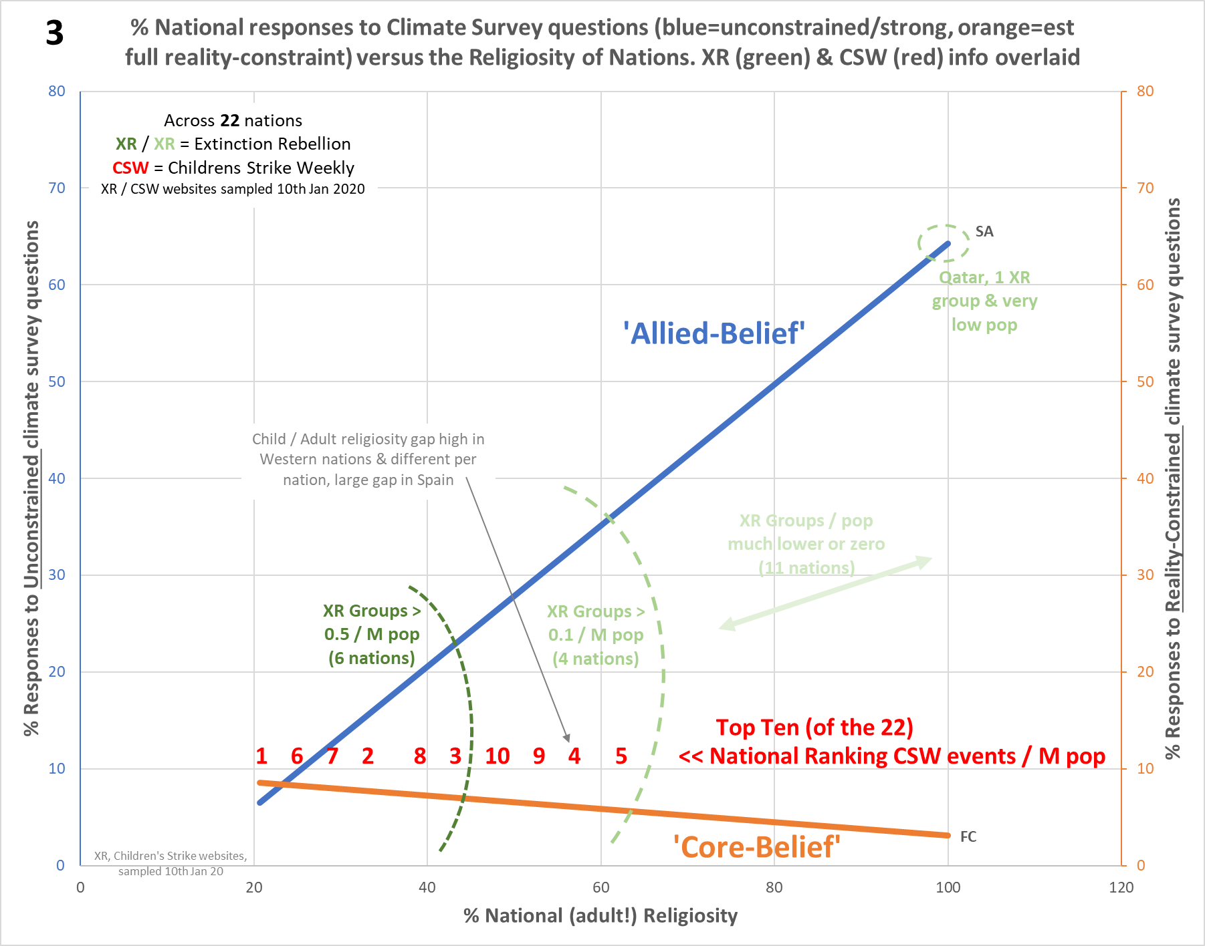
Footnote 6. Regarding Extinction Rebellion (XR) group presence per million of national populations, the 6 nations above 0.5/M are as expected at the leftmost of Chart F6 (simplified to show trends only). The 5 nations above 0.1/M are at the next leftmost, except for Qatar, which nation has a lucky hit of a single XR group and a very low population. The remaining nations either have a very much lower presence than 0.1/M, or zero presence. [These XR tiers marked in green]. Similarly, the top-ten ranked nations for Children’s climate Strike Weekly (CSW) events per million of national populations [red text], are likewise as expected at the leftmost side of the chart.
Given these organizations aren’t actually in equilibrium but still expanding, this is at least consistent with the expected pattern of activism per above. Note though, the exact ordering of nations in the two XR tiers, compared to CSW ranking and also expectation from trend, doesn’t match. This is not likely considering the rough data culled from the XR / CSW websites. However, there is a valid reason why CSW ranking should differ somewhat from adult data (the trendlines are exclusively from adult data, and XR presence will be ‘mostly adults’). This reason is that in Western nations (inclusive of all the CSW top-ten), not only are children are less religious than adults, this ‘religiosity gap’ is different per nation. Hence children generally will behave as though they’re from a nation somewhat more left on the chart than their actual home nation, but different religiosity-gap sizes will also change their national ordering relative to adult ordering. While there are very few surveys involving children, projections from young-versus-older adult data point to an unusually large gap for Spain, which likely explains its high CSW ranking (4) relative to (adult) religiosity. But not likewise for Italy (CSW rank 5), unless a similar sized gap hasn’t yet emerged from children into (measurable) younger adults.

For a more detailed explanation of the above activist angle, see sections 4, 5 and 6, plus Chart 3yx, from the second post in my series at Climate Etc. This more detailed chart includes all the nation data-points.

Footnote 7. The two charts below show nations averaged into color-coded Religio-regional data-points, for UN vote shares for ‘Action on Climate Change’ (left hand graph) and Renewables Capacity (right hand graph), on the Y axes, both plotted against National Religiosity (X-axes). While absolute position varies (not surprising considering the completely different paths to these charts), relative positioning of the Religio-regional GDP-per-Capita pairs (all dark shading high, all light shading low) is consistent over both charts. [I think charting this way reduces statistical significance (though surprisingly p still < 0.05), but we know the trends from the expanded versions anyhow; only the R-r GDPpC pairing matters here].

Footnote 8. And there is other strength ordering, for instance national issues are stronger than global issues (typically closer to people’s real day-to-day concerns).
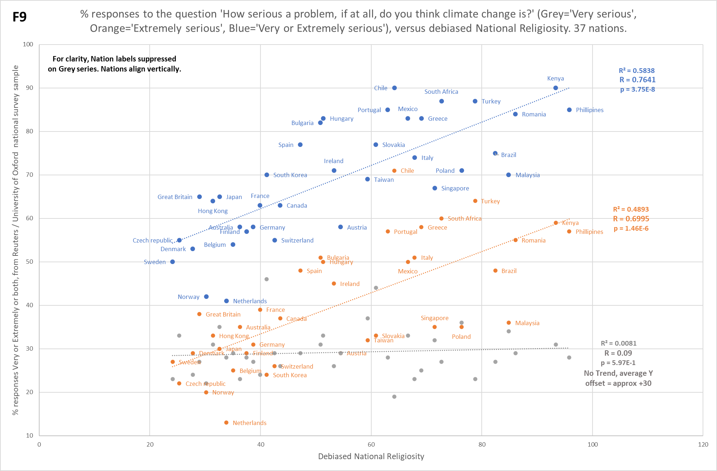
Footnote 9. Chart F9 below shows 3 national responses to the Reuters / Oxford university survey question: ‘How serious a problem, if at all, do you think climate change is?’ The 3 responses are ‘Very serious’, ‘Extremely serious’, and the former two combined, i.e. ‘Very or Extremely serious’. The latter response is in the publicly released data for the survey and is all I originally had. This is shown as the ‘WA+O2’ series in Charts 1 & 2, i.e. a ‘Weakly Aligned to CCCC’ trend with a ‘confidence offset’ that lifts it on the Y-axis. However, I was simply assuming (through knowing something about why the ‘WC+O1’ trend was similarly raised) that this characterization of the series was correct, i.e. that it was made from two contributions, the weakly-aligned contribution and the offset contribution. But as there are two responses combined in this data, I figured knowing the individual responses should provide more insight. Reuters kindly provided the data, hence enabling individual plots per Chart F9. (Note: I don’t have a version of this chart on the web yet).
‘Confidence offset’ O2
WA1
WA(1)+O2
And it seems indeed that my assumption was correct. The response ‘Extremely serious’ corresponds almost entirely to the ‘Weakly-Aligned to CCCC’ component, hence having a cultural gradient with religiosity, and the ‘Very serious’ response corresponds almost entirely to the ‘confidence offset’, hence having no statistically significant trend but an (average) offset of about +30 on the Y-axis. This may not seem intuitive, but the word ‘serious’ in isolation does not necessarily cross any threshold of emotive / personal concern (hence not invoking a cultural response). Very many things in our world are regarded as ‘serious’, but most people don’t pay any attention to most of them. As far as the publics of the surveyed nations are concerned, ‘serious’ is accepted by all points on the measured cultural spectrum; hardly surprising given the dominant public narratives over decades. It seems however that the word ‘extremely’ does cross an emotive threshold, so indeed does invoke a cultural response, albeit this is only weak, because the context is such that it does not have an explicit emotional or personal context (e.g. like the ‘SA’ series, which is generated from a question about the personal impact of climate-change).
It is fortunate that in this case the 2 responses correspond so well to the 2 different contributions, but this won’t always be the case. Indeed, the question that generates the ‘WC+O1’ trend cannot similarly be broken down, as it is only a single-word answer, which nevertheless invokes both the confidence offset and a cultural trend. Incidentally, try to imagine figuring out what is going on here, without a religiosity axis. You’d have no chance; religiosity is the key to revealing the nature of climate-change attitudes.
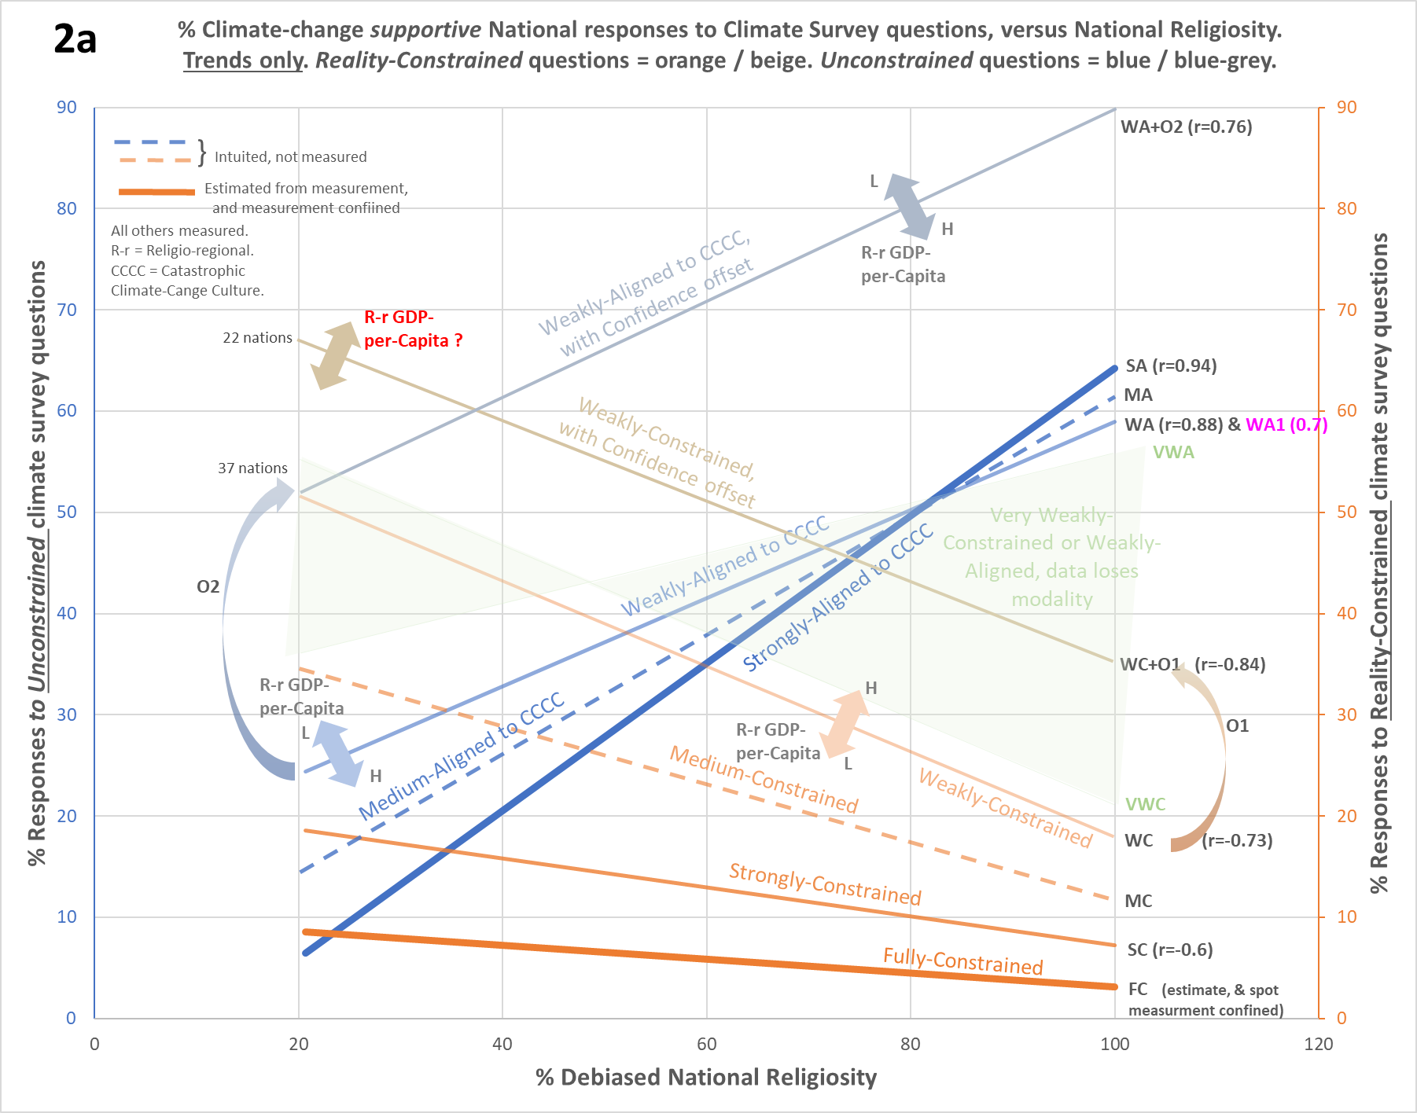
An altered Chart 2 below, Chart 2A, shows the orange (‘WA1’) and grey (‘Confidence offset’) series from F9 above, both superimposed (in bright pink) on all the previously presented trends. Chart 2A is rather crowded with lines, yet nevertheless it can be seen that ‘WA1’ is indeed just a ‘Weakly-aligned to CCCC’ series (within measurement error).
‘Confidence offset’ – no trend!
WA1
So for less clutter, the pale-blue line simply represented both ‘WA’ and ‘WA1’ in Charts 1 and 2.
Adding together the ‘WA1’ and the ‘Confidence offset’ series, gives the WA+O2 series in blue-grey, at the top of the chart.

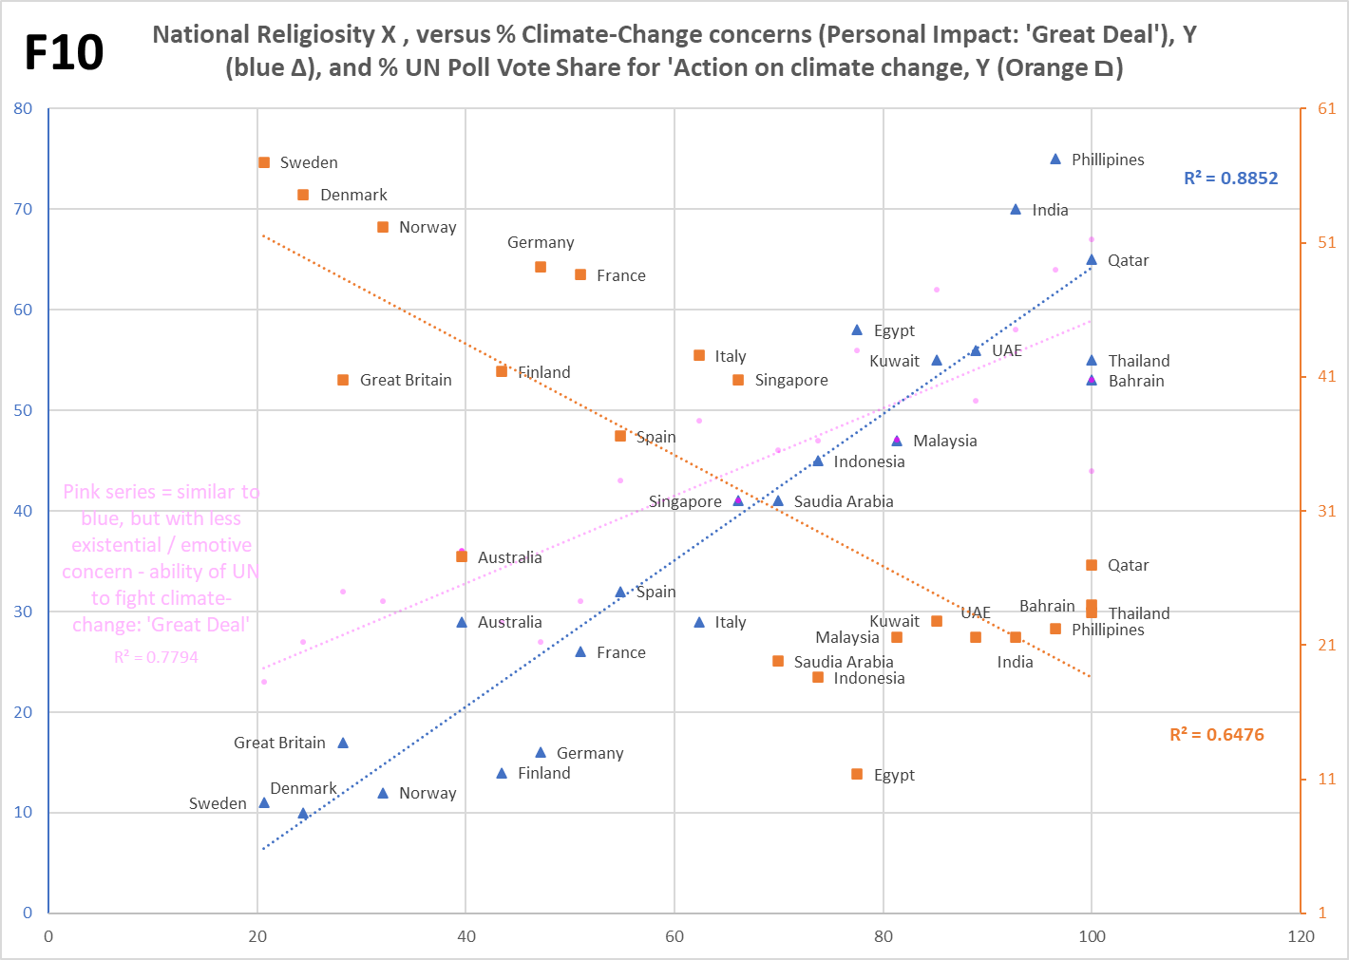
Footnote 10. Chart F10 shows the full data for the ‘SA’ (blue), ‘WA’ (pink, partially suppressed for less clutter) and ‘WC’ (orange) series (from Chart 1 & 2) combined, as examples of what these kinds of series typically look like. Bear in mind per text above, that the orange trend particularly, will have a Religio-regional-GDP-per-Capita variance around the main trend, which accounts for much of the scatter. Note: the orange and blue Y scales are different on this chart! Note: This chart depicts only 22 nations common to all three series. See Table 1 and the associated links immediately below, for these series with 24 nations (blue and pink), plus 48 nations (orange).
Footnote 11. Actually, there is one exception. By the historical accident of atheism spreading outwards from NW Europe and hence some of the most-cloudy countries in the world, the annual sunshine duration of countries does have a pretty decent correlation with national religiosity, albeit some major individual exceptions. However, this is not causal regarding any of the trends above, although when probing the cultural motivations behind renewable energy deployment, annual sunshine duration needs anyway to be taken into account regarding relative benefits of solar energy capacity to each nation.
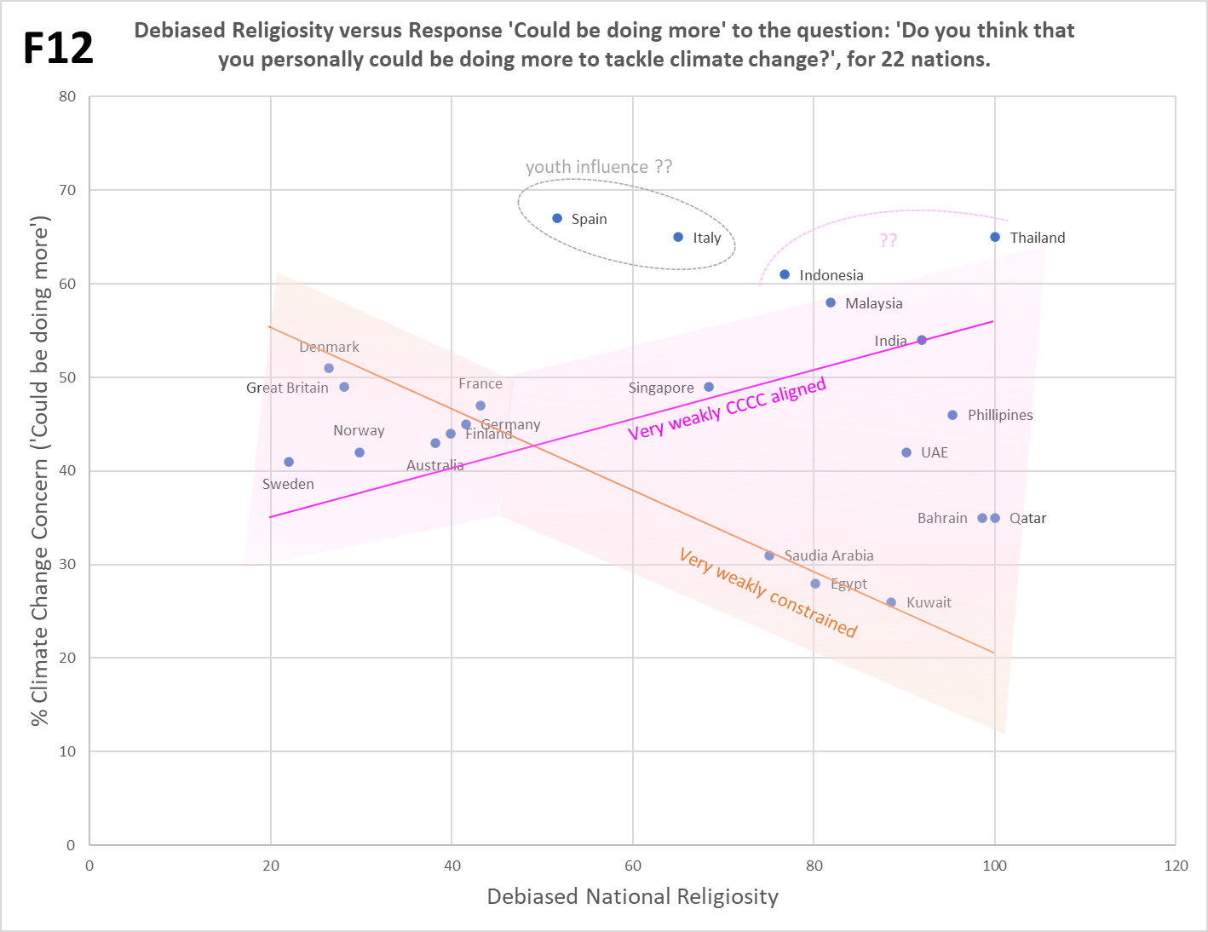
Footnote 12. The question ‘Do you think you could be doing more to tackle climate change’ is very weakly framed, invoking neither an emphatic reality-constrained type of response, or an emphatic unconstrained type of response. The response, with no climate literacy to inform it, is nevertheless still cultural in nature, simply drifting between the two aforementioned response modes as Chart F12 shows.

The drift is within the pink / orange cones (represented, minus a noise margin, by the green cones in Charts 1 and 2. The pink and orange lines are respectively the green VWA and VWC edges). While CCCC via various means including guilt invokes the sentiment of ‘doing more’, very many people who think there’s a climate issue but aren’t ardent cultural believers in catastrophe, share such a sentiment. Emphatic cultural responses are further diluted as ‘doing more’ also has a vast range of interpretation, from the ardent considering a life off-grid, to those considering a switch to public transport, to those only considering changing light bulbs, or less. Due to very mixed messaging and domain ignorance, there’s also a wide range in perception of how much each of these things may help. Such considerations are also conflated with a large range of other reality and cultural domains, some of which pre-date climate catastrophism. So for instance health (e.g. ‘cycling more’) or pro-animal rights (e.g. ‘eating less meat’). To top all that, those people who are more highly concerned about climate-change, are likely less invested in personal action (See Hall et al 2018, ‘Believing in climate change, but not behaving sustainably: Evidence from a one-year longitudinal study’, Journal of Environmental Psychology Volume 56, April 2018, Pages 55-62. From the Abstract: ‘the “Highly Concerned” were most supportive of government climate policies, but least likely to report individual-level actions, whereas the “Skeptical” opposed policy solutions but were most likely to report engaging in individual-level pro-environmental behaviors.’ [Highly Concerned and Skeptical are both in respect of climate-change]). The exception of Spain and Italy may be caused by unusually high youth influence; see section 2 here. As the envelope is a by-eye estimate regarding VWA, VWC and noise, Thailand and Indonesia might be inside.

Footnote 13. Summary of insights.

Abbreviations: CCC[C] = Catastrophic Climate-Change [Culture]. CBel = Core Belief (in CCCC). ABel = Allied Belief (belief via a cultural alliance, in CCCC). ISk = Innate Skepticism. CSW = Children’s Strike Weekly. XR = Extinction Rebellion. GDPpC = GDP-per-Capita. Rr-GDPpC = Religio-regional GDP-per-Capita, i.e. this metric relative to the average or norm for a nation’s religio-regional group. Provisional explanations in blue. Examples in brown. Assuming confirmation…
a) Across nations, national attitudes supportive of climate-change concern or policies to combat climate-change, which have been harvested via open-ended or unconstrained climate-survey questions, are correlated with national religiosity. Because via a (shallow) cultural alliance, and in the absence of reality -constraints, religious belief disables ISk about the narratives propagated by CCCC. This is ‘Alliance Belief’ in CCCC, ABel. E.g. Chart 2 trend ‘SA’.
b) Regarding the climate-survey questions in a), those having a stronger existential / emotive / personal angle that is aligned to CCCC narratives, produce a steeper correlation trend of supportive attitudes with national religiosity. These elements increase cultural response. E.g. Chart 2 trend ‘SA’ v trend ‘WA’.
c) Across nations, national attitudes supportive of climate-change concern or policies to combat climate-change, which have been harvested via reality-constrained climate-survey questions, are anti-correlated with national religiosity. Because the reality-constraint breaks ABel, i.e. it exposes the deeper cultural loyalty of religious adherents to their Faith. Their ISk about CCCC is ‘re-enabled’, and it comes in big as religious adherents have strong values to protect from this competitive culture. E.g. Chart 2 trend ‘SC’.
d) Regarding the climate-survey questions in c), those having a stronger reality-constraint, produce a shallower anti-correlation trend of concern / support with national religiosity. At the strongest constraint, ISk about CCCC is engaged for the huge majority of both religious and irreligious populations. So as strength increases, the less the difference between these matters. E.g. Chart 2 trend ‘SC’ v trend ‘WC’.
e) Across nations, national attitudes skeptical to climate-change concern or policies to combat climate-change, which have been harvested via open-ended or unconstrained climate-survey questions, are anti-correlated with national religiosity. ISk is effectively ‘anti-belief’, which will trend oppositely to ABel. E.g. orange trends on Charts F1a and F1b.
f) Across nations, those who are still supportive of climate-change concern or policies to combat climate-change even above the strongest of reality-constraints, never exceeds 10% of national populations. [This ultimate reality-constrained trend, which per c) anti-correlates with religiosity, represents a ‘Core Belief’ in CCCC, CBel]. Cultural belief in certain and imminent global climate catastrophe (absent drastic FF cuts) is everywhere minor, and proportionally less still as religion competes more strongly with CCCC. Chart 2 trend ‘FC’.
g) The points a) to f) concern responses to Strongly-Framed questions. Regarding responses to Weakly-Framed questions (i.e. for unconstrained, a very weak existential / emotive alignment to CCCC, or for reality-constrained, a very weak constraint), these produce responses that occupy a wide envelope, the shape of which is nevertheless still determined by the cultural interaction of CCCC and religious faith. Because the public are not climate literate, then even in the absence of cultural prompts they’re unable to apply rationality; responses simply drift between available cultural modes. Green cones in Chart 2.
h) There’s some indication that systemic exceptions outside of the envelope cited in g), for a minority of nations, may be a result of influence from the cultural position of (less socially served / more irreligious / more liberal / more disaffected) youth. Requires confirmation. Examples, Spain and Italy in Chart F12.
i) Responses to some reality-constrained and unconstrained questions may be ‘lifted’ on the (climate concern / priority) Y-axis. Where significant numbers in national publics are confident that their answer is ‘common knowledge’, and whether or not that confidence is justified. Those perceiving that their answer is common knowledge won’t respond from a cultural context; hence their responses will have no gradient wrt the religiosity of nations, but will nevertheless have an average Y value which provides the ‘lift’. Those who do still respond culturally, will impose a gradient appropriate to the question type on the lifted series. In practice, this effect should only occur for the weaker series (i.e. where alignment to CCCC is weaker, or constraint is weaker), as it’s unlikely that any question invoking stronger cultural contention would be seen as common knowledge by anyone. Chart 2 series ‘WC+O1’ and series ‘WA+O2’. See Footnote 9 for a breakdown of series ‘WA+O2’ into sub-series for exactly the 2 described components.
j) Systemic variability around the weaker trends (i.e. where alignment to CCCC is weaker, or constraint is weaker), is due to the GDP-per-Capita of nations. But not the absolute GDP-per-Capita, instead, for each nation the measure of this metric relative to the average or norm for its Religio-regional group. For trends from unconstrained questions positively correlating with religiosity, the high ranked Rr-GDPpC nations tend to be below or near the trendline, whereas the low ranked Rr-GDPpC nations tend to be above or near the trendline. Oppositely, regarding trends from reality-constrained questions negatively correlating with religiosity, the high ranked Rr-GDPpC nations tend to be above or near the trendline, whereas the low ranked Rr-GDPpC nations tend to be below or near the trendline. Provisionally: more national wealth makes for less emphasized cultural mechanisms, whether these be actual cultural belief, or ISk rejection. As though the wealth is buffering the cultural action somewhat, but only relative to the Religio-regional peer-group norm. Oppositely, less wealth means more emphasized cultural mechanisms, but again only relative to the Religio-regional peer-group norm. For variance around a positively correlated trendline (‘WA1+O2’), see Chart F3, and around a negatively correlated trendline (‘WC1+O1’), see Chart F5.
k) More climate activism occurs in nations to the LHS of Chart 2. Motivation for climate activism is stronger where Abel is lower, and CBel is higher (albeit still a small minority). Core believers are defending their culture of apocalypse from enormous national skepticism of said apocalypse, i.e. low ABel / high ISk (and good defense is attack; cultures are often aggressive). For high religiosity nations, there’s far less motivation and also many less core believers to sustain activism. XR and CSW activity are consistent with this, see Footnote 6 and Chart F6.
l) Consistent with k), other real-world phenomena follow cultural expectations. For instance, Renewable Energy commitments across nations are highly correlated with a (weak) reality-constrained trend (which like all the trends in Chart 2a, is cultural anyhow). If the true costs and downsides of such policies were appreciated by publics, a strong or full reality constraint would likely apply, severely hobbling policies. However, the public are no more engineering literate than climate science literate, plus elites as a sub-demographic likely foster greater belief in CCCC than their corresponding publics anyhow, overriding a true consideration of net cost / benefit whether fiscal, human or environmental. See Chart 3.
m) Cultural responses dominate the answers to all climate-survey questions. As evidenced by their strong relationships to religiosity, a purely cultural phenomenon. See Chart 2 and Table 1.
n) While there’s variability in all nations, the charted nations statistically follow the ‘rules’ a) through m). However, where the 2-way cultural dance that is behind these rules does not hold, there will be major exceptions. In the US, there is a 4-way cultural dance (strong public polarization towards Reps or Dems provides the extra 2 dancers), and in Vietnam a 1-party state represses religion, and hence also the 2-way dance. The latter means that countries like China or North Korea wouldn’t conform either. Vietnam and the US are shown to be exceptions in the first post of my Climate Etc series. See below for more insight on the case in the US, where despite the extra complication, the exact same cultural principles apply.
Footnote 14. US Addendum.
The relationships (and cultural explanations) regarding religiosity and attitudes to climate-change, as derived above for different sub-sets of about 60 nations, also grant insight into the exceptional case of the United States. As noted above, there’s a four-way not two-way cultural dance in the US, the extra dancers being Rep / Con and Dem / Lib cultures. The cultural gradient with respect to climate beliefs is also far stronger across the range of US political expression, than it is across the ‘Rest of World’ (RoW) religious expression. In the US this political gradient dominates, whereas in the RoW, religious gradient dominates. Nevertheless, not only do the same principles of cultural interaction remain valid, where appropriate the exact same ratios for responses to a series of ‘standard’ climate-survey questions, are preserved too.
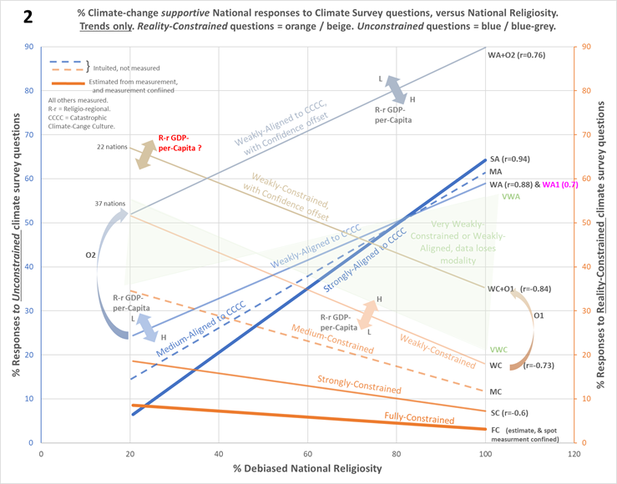
Chart 14a below depicts the US national responses to various strengths of both reality-constrained and unconstrained climate-survey questions, but plotted against a Democrat-to-Republican political X-axis, rather than a religiosity axis as used so far for the other charts in this document. Remarkably, the Y-axis values at the black vertical line (in the grey outlined box) on Chart 2 (repeated at left), once rescaled, exactly fit the Y-axis values for Democrat responses to similar ‘standard’ (wrt RoW) type / strength climate-survey questions. The same grey box content and black line are shown at the left of Chart 14a, to illustrate this alignment.
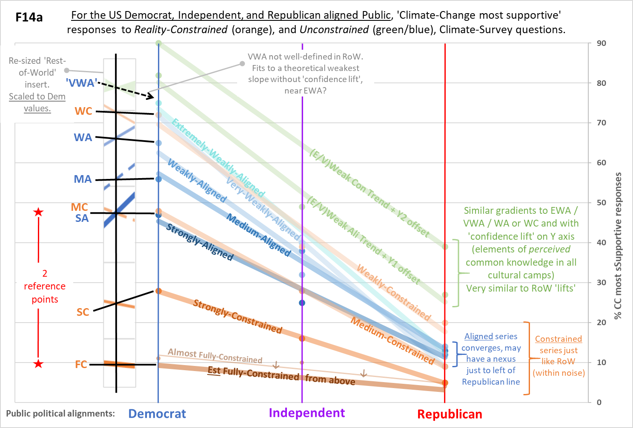
Regarding the generic features of Chart 14a, there are three main categories of responses that match the same categories within the RoW Chart 2. These are responses to unconstrained questions having various strengths of emotive / personal / existential Alignment to CCCC (so ‘Aligned series’, in shades of blue). Then the responses to unconstrained questions having various strengths of constraint (so ‘Constrained series’, in shades of orange). And lastly the ‘confidence lifted’ series (green), corresponding to the blue-grey (Y1 offset) and the beige (Y2 offset) trends at the top of Chart 2. Note: the climate-survey questions that generated all these series (which have only 3 data-points each; their trends are just useful signposts), are shown in Table 2 at the bottom of this footnote, complete with source links to original survey data. Note: Question components causing ‘confidence lift’, will not be the same as in the RoW.
Although religiosity happens also to increase left to right on Chart 14a, both US political parties are pretty religious and this aspect creates less difference in their attitudes to climate-change than political lean. The Aligned series all slope downwards instead of upwards as Rep/Con culture, opposed to climate-change values because their opponents support same (and vice versa), collapses the Allied Belief that would otherwise be present due to religiosity. Or in other words, enables Innate Skepticism (ISk) about CCCC. Given the strength of the Republican opposition, this is an expectation. There is tentative indication of a nexus point within the Aligned series, just to the left of the Republican red line, beyond which the more emotive / personal narratives (stronger alignment to CCCC) cause more support (from the small minority of relative CCCC believers) within the Republican camp, presumably because ISk is already max’d out.
The Constrained series all look much more similar to Chart 2, again an expectation, and in theory they cannot converge or cross-over (excepting potentially due to noise in values that are already very close together), because each represents the intrusion of different actual realities rather than arbitrary beliefs alone, albeit beliefs compress or expand them. The observed compression is expected for the case of the Republican supporters, because in this group two cultures are reinforcing ISk and the social values that CCCC challenges, which challenges in turn are exposed by the clash with a list of other important issues. For Democrat supporters both Aligned and Constrained series are expanded on the Y axis, because two cultures are helping to prevent ISk in CCCC from being expressed (and hence creating Allied Belief plus less reality clash). Ironically, this means that the same religious belief which helps to reduce Republican-aligned public support for climate-change issues, especially via the collapsed Aligned (to CCCC) series, is also helping to increase the Democrat-aligned public support for climate change issues! Note: the trend for US ‘Core Believers’ in CCCC (FC line), looks very similar to RoW, and doesn’t exceed it anywhere.
Note: the trends from RoW provided by the inset at the left of Chart 14a, are approximately matched (by the black lines) to the actual values of Democratic responses (circles), not to the ends of the trendlines (except for ‘FC’, which is estimated to be a bit lower than the ‘Almost Fully Constrained’ measurements). The fact that the Democrat data for SA and MC are in practically the same place, was a lucky break that provided a clue about exactly where the alignment point matching the RoW would be. Because of the collapse in Allied Belief for the Republican case, there can’t be a match for all series anyhow, and for the Constrained series I can’t deduce the right point using just religiosity, because I don’t have an equivalent religiosity (same scale) measurement for each politically defined demographic, only for the whole US.
*If*, as seems plausible from the matching Democrat-aligned response values, religiosity has the same impact on climate-change attitudes in the US as the RoW (i.e. the co-existing political culture has merely added to this) then religious-cultural and political-cultural effects can be separated, as Chart F14b shows.
Chart F14b overlays a predicted gradient of climate-changes attitudes onto the previous Chart 14a, for Democrat supporters alone, which stretches from sub-groups who would only score 20% religiosity (on the RoW-defined scale), at the LHS, to those who’d score 100% religiosity, at the RHS. I don’t know of data that could validate this prediction, religiosity on the same scale would be needed for Dem-aligned responders to all Table 2 questions, and data post-Covid will be different. Simply assuming validation…
While political lean dominates, religiosity still plays a big part in US attitudes to climate-change. For instance, if Democrats had a similar average religiosity as the Swedish population (~22% on the scale derived across RoW, one of the lowest for any nation), their Aligned series responses would be lowered by about 20% (for SA), to about 7% (for EWA), while their Constrained series responses would be raised from merely 1% or so (for FC), to about 12% (for WC). These are overall modest but certainly significant amounts. Across the entire range of Democrat supporters’ religiosity, i.e. from atheists to 100% religious, the impact of religious faith is more starkly demonstrated. The largest jump (upwards) in Aligned series responses (SA) across this religiosity range, is about 65%, and the equivalent (downwards) for the most impactful Constrained series (WC), is a bit less than 40%. While the whole US and hence most of those who support both parties are pretty religious in RoW terms, these big figures suggest that in an absolute sense, religiosity makes about the same cultural contribution to climate-change attitudes as political lean.
Because Rep/Con culture collapses Allied belief, and hence their responses are all squished pretty close together, plus there’s no exact reference point to help translate Rep-aligned US public religiosity to the RoW scale, it’s very hard to make equivalent predictions across the range of Rep-aligned religiosity.
Unconstrained questions |  |  | Reality-constrained questions
CCCC alignment Strength | Question  (underline = emotive /personal hooks) | Measured  (CC most supportive) response | Constraint Strength | Those who choose… | Comment
Strongly Aligned | ‘How worried are you that you or your family will be personally harmed by climate change in the next 50 years?’ ¹ | ‘Very worried’ | Almost Fully Constrained | ‘Environment / Climate Change’ as single issue from list of 19 to: ‘What is the most important issue facing the nation today?’. ⁴ | ‘Environment’ dilutes, but very little at this strength, where CC dominates. Nice long list & national issues.
Medium Aligned | ‘Climate change is best described as…’ ² | ‘A crisis’ | Strongly Constrained | ‘Climate change’ as 1 of 2 issues from list of 14 to: ‘…which two issues are the most important to your vote? ⁵ | Nice long list & national issues, the ‘vote’ being for the 2020 presidential election.
Weakly Aligned | ‘How worried are you that the United States will be harmed by climate change in the next 50 years?’ ¹ | ‘Very worried’ | Strongly Constrained
Very Weakly Aligned | How concerned are you about climate change? ³ [‘concern’ is more personal than ‘serious’, but weaker than ‘harms’] | ‘Very concerned’ | Medium Constrained | ‘Climate change’ as 1 of 3 issues from list of 12 to; ‘which 3 of the following issues should be top priority for US foreign policy in the next 5 years? ⁶ | Long enough list & while not national issues exactly, at least US foreign policy rather than global issues; will dilute strength a bit.
Extremely Weakly Aligned | ‘How serious a problem do you think climate change is?’ ¹ [very many issues indeed are considered ‘very serious’] | ‘Very serious’ | Weakly Constrained | ‘Climate Change’ as ‘very’ important, from list of only 5 ‘personal issues’. ⁷ | Also, have 3 other options to allocate, including ‘somewhat’.
Weaker Aligned trend with Confidence offset (1) | ‘On the subject of climate change do you think?’ ¹ | ‘The world’s climate is changing as a result of human activity’ | Weaker Constrained trend with Confidence offset (2) | ‘Government doing too little to reduce effects of climate change’, from list of only 5 environmental only issues. ⁸ | Single topic list and can pick all. Very weak constraint indeed, and invokes some ‘care for environment’ across all cultural positions.
Table 2 | Type / Strength of questions in US Climate-Change surveys
1. Climate Survey Data-source: The Economist/YouGov Poll, March 2019.
2. Climate Survey Data-source: The Kaiser Family Foundation/Washington Post Climate Change Survey, Nov 2019.
3. Climate Survey Data-source: Quinnipiac University National Poll, Dec 2018.
4. Climate Survey Data-source: The Hill / HarrisX Poll, most important issues facing (US) nation, Dec 2019.
5. Climate Survey Data-source: Climate Nexus poll pr1922 for US, Aug 2019.
6. Climate Survey Data-source: The Centre for American Progress / GBAO poll ‘America adrift’, Jan 2019.
7. Climate Survey Data-source: CBS News Poll Climate change an issue for most voters in 2020 (by YouGov, tables), Sept 2019.
8. Climate Survey Data-source: Pew Research, U.S. Public Views on Climate and Energy, Nov 2019.

Footnote 15. Some reasons why current literature has missed such strong (non-US) trends.

There’s a raft of reasons why the strong (and dual) relationship between Religiosity and climate-change attitudes has been missed in the current literature that focuses on (many) nations outside the US. It would seem that these mainly amount to the lack of realization that public responses to climate-survey questions are cultural in nature, and not rational. This perception changes how one would best go about measuring the responses. Plus, it means that a far greater diversity of responses to different classes of question will result, but not only are some classes essentially munged together, clouding the results, others, even if they are common within public surveys from mainstream orgs, aren’t typically included within academic work as they weren’t perceived as important. And, unfortunately, different questions perceived as important by academics, don’t show much cultural gradient with religiosity because they are not culturally contentious, but treated as ‘common knowledge’ across publics (and whether or not they really are). All this hugely dilutes and confuses the real picture. Some examples of these problems follow…

a) Properly capturing climate-change supportive and skeptical responses.
Regarding responses to an unconstrained question on climate-change concern, there is a problem with combining options of the form (via whatever specific wording) ‘very concerned’, ‘concerned’, ‘not too concerned’, and ‘not at all concerned’ onto a single scale, as then mapped across a cultural (religiosity) axis for nations. This might be appropriate if the expected responses were largely rational, albeit also influenced by religious faith. However, as the responses are cultural to start with (so when mapped on a religiosity scale reveal a reaction between two cultures), in practice the CC very concerned and concerned responses correlate with religiosity across many nations, while the CC not too concerned and not at all concerned responses anti-correlate. Hence if the responses are combined onto a single scale (with scores of say 1 to 4 or 0 to 3 in terms of supportiveness [high = more supportive] or some-such), much or most of the signal with change in religiosity, will be lost. Because, depending on symmetry, the correlating and anti-correlating signals will partly or mostly cancel. However, this kind of combining is indeed done in academic studies employing unconstrained questions. A detailed example is provided in footnote 1. This approach is bound to miss the kind of effects documented here, and is presumably adopted because it is not realized that the responses are cultural in nature in their own right, as well as via an interaction with the religious faith of respondents, the latter of which is used here to see what’s going on. What values are not actively accepted by one culture of another, will be actively rejected; so the two options with ‘not’ in, will attract different strengths of Innate Skepticism, which is anti-culture, and hence the anti-correlation. These responses are different in nature to the responses generated by the very concerned and concerned options. They are not of similar type but just showing ‘less concern’ for climate-change issues; they will be actively resistive, or skeptical.

b) Reality-constrained and unconstrained responses.
It doesn’t appear to be common for surveys to use both reality-constrained and unconstrained questions together. And even less common for academic studies, which tend to use only the latter. And there’s also a pretty modest number of surveys / studies that span many nations using the same methodology, relative to those conducted only within particular nations, or only spanning just a few (so making it harder to see generic patterns, especially if the nations covered all belong to a similar subgrouping, such as ‘Western European’, or ‘Middle Eastern’, or whatever). Neither are there too many studies / surveys (outside of the US) that deeply probe the relationship between religiosity and climate-change attitudes, so when the other requirements above are included too (i.e. reality constrained and unconstrained together, many nations with diverse geographical / religious / political representation), then while my search is not exhaustive, it’s hard to find any. It appears that this has helped to keep obvious relationships and factors hidden, of which one is that the responses to reality-constrained and unconstrained questions are systemically very different (see footnote 16), in a manner that becomes very obvious when mapped across a wide range of nations upon a religiosity axis, but which would be very hard to identify from the many fragmentary efforts that seem to characterize existing literature plus surveys. And this issue is made worse by some such efforts suffering from a) above, plus c) below.

c) Religiosity scale issues.
A further issue is that the use of behaviors to form a religiosity scale, e.g. how often people pray or attend their place of worship, produces less comparable results across different main Faiths, and even within a single main Faith may not reflect emotive commitment so much (which is what we want), but community norms. A simpler scale based upon responder’s self-assessment of the importance of religion to them (see footnote 2), not on particular behaviors that will vary with Faiths, is less subject to systemic differences between those Faiths. And is also more representative of emotive commitment. Some highly complex academic scales are likely much more accurate within a particular faith, but the higher the complexity the more difficult is the translation between Faiths. And we don’t need accuracy in absolute terms, rather, the best comparative figure across all of the nations / Faiths, no matter what that might mean in terms of lived experience and associated behaviors within any particular nation / Faith.

In principle, one doesn’t actually need a religiosity axis to at least realize that there are highly significant differences between responses to climate-change questions that must be systemic across nations. E.g. that in some nations (which happen to be highly religious), the most climate-change supportive responses to reality-constrained questions amount to a very small percentage of the populace, while the most climate-change supportive responses to unconstrained questions amount to a high (indeed majority) percentage of the populace. While in other nations (which happen to be very irreligious), responses of these two types straddle each other, and mainly in-between the former extremes. However, again due to the fragmentary approach, and also because it typically appears to be assumed that responses to questions about climate-change are largely rational, albeit also influenced by religiosity, the realization of systemic differences, or at least their full scope and what drives them, seems to be missing in action.

d) Poor appreciation of strength in the above classes.
In the same manner that a fragmentary approach has helped to hide the systemic difference between responses to reality-constrained questions and unconstrained questions, it has likely also caused the issue that different strengths inherent in the forms of these questions, appear to be very under appreciated. It’s pretty obvious that picking climate-change (or a specific climate-change issue) as a single top priority out of say 10 options, is a stronger constraint than picking the same issue to be in a group of 3 ‘top’ priorities, out of say the same 10 options. However despite this, there seems to be little appreciation of the systemic grading in responses according to constraint strength, over all the various survey options (e.g. 1 of 5, 3 of 7, 3 of 10, 5 of 17, 6 of 19 etc. A very large range, and other constraints such as personal $ commitments). Why so many analyses seem not to have grasped (or at least think it isn’t too important) that responses are bound to come back in relative proportion to the question strengths, is a mystery to me. That said, at least there is more appreciation of strength for reality-constrained questions, than for unconstrained questions.

The unconstrained climate-survey / study questions have strength grades too, which will determine the level of response. Strength reflects the level of emotive / personal engagement of the question, and too the level of existential concern, all of which are expressed within the cultural context of the dominant public and authority narratives about climate-change, these being about imminent and certain catastrophe (absent drastic action). Strength of this kind has just as fine a grading as that expressed in the reality-constrained questions. But this won’t be recognized unless it’s also appreciated that responses to these questions are indeed largely cultural in nature. And a strong question will not only invoke more cultural loyalty (and hence more +ve responses) from those who believe in the cultural narratives, but also more resistance or skepticism from those who don’t. Plus, even where strength is recognized, one needs an axis to map it across, in order to fully see the nature of a strength scale. This in turn falls into the problems above if a religiosity axis is not used or not optimally used, or reality-constrained / unconstrained classification is also not appreciated. Where all factors are properly considered, as can be seen from Chart 2, the various strength grades are obvious, with trendlines steeper for responses to the stronger unconstrained questions, and shallower for responses to the stronger reality-constrained questions.

‘Confidence lifted’ responses.
Part of an appreciation of the reality that answers to climate-change survey / study questions are cultural in nature, is also an appreciation of what elements might not be visible across a particular cultural (say, political or religious) axis. So, where questions contain an element that is perceived to be common knowledge across all measured cultural parties (e.g. nations), i.e. it is not culturally conflicted knowledge for these parties, then the response to this element of the question will have no cultural gradient, but may still augment or reduce the whole set of responses. If such an element occurs within the same question as also invokes a cultural gradient of responses, then that gradient will be lifted or lowered on the Y-axis. See Chart 2 for examples. The existence of common-knowledge components doesn’t necessarily mean that this knowledge is true, only that it is perceived to be true across the measured cultural parties. And indeed, it appears that common knowledge components are different in the US than the Rest-of-World. Nor does it mean that publics are being rational in response to any such common knowledge components (whether or not mixed with cultural components), only that they are not responding culturally / emotively. But true rationality needs knowledge that wrt climate-change, publics typically haven’t got; they are not climate literate. The common knowledge component may only represent what has become accepted across all measured parties, not what is actually true.

If this effect is not appreciated, then yet more confusion will tend to obscure the real nature of public responses to climate-change surveys / studies. As I can’t call these responses rational (and because the examples on Chart 2 are lifted up, not lowered, on the Y-axis), I called them confidence-lifted responses, in the sense that they represent increased public confidence that (this element of) the answer is correct, across all cultural parties (nations), whether or not it’s actually correct.

Footnote 16. Summary difference in response for reality-constrained and unconstrained questions.

Unconstrained questions elicit virtue-signaling responses, appropriate to the net cultural loyalties and emotive strengths of same as invoked by each particular question. Reality-constrained questions elicit responses correspondent to actual behavior that would occur in a real-world scenario, insomuch as the constraints of different strengths mimic the nature of true reality choices (e.g. as though the responders were actually voting on competitive policy options funded by a hard-limited overall budget). This is not to say that actual behavior can’t also be largely or wholly culturally driven, but this nevertheless exhibits systemically quite different trends across nations to virtue-signaling, and for any particular nation these two types of responses can be very different. For instance, the former can be climate-change supportive, exactly where the latter are also climate-change resistive / skeptical. Indeed for ~60 nations not including the US, the climate-change most supportive responses to unconstrained questions strongly correlate with national religiosity, while the climate-change most supportive responses to reality-constrained questions strongly anti-correlate with national religiosity. In the US, the strong Dem / Lib versus Rep / Con public polarization disrupts this symmetry, yet these two response types are still systemically different in a way that is consistent with the unique overall US cultural situation. Note: The responses to reality-constrained questions are still cultural, yet not really virtue-signaling, in the sense that responders will likely stand by these answers in real-world situations having similar constraints.

Generically speaking, the trends of responses to different strengths of unconstrained questions across a cultural gradient (e.g. religious or political) spanning nations, can cross over. This is because emotive support both for and against climate-change narratives (whether the latter comes from loyalty to another culture or is just stand-alone Innate Skepticism), exists in all nations. So, as emotive strength increases, there is a potential pivot point in some nation where increased engagement with supporters equals the increased resistance from skeptics. However, trends of responses to all the different strengths of reality-constrained questions, do not cross over. While there is indeed still a cultural gradient (e.g. religious or political) spanning nations, by definition a lower strength of reality clash cannot outbid a higher strength clash within any nation, no matter where it sits on the cultural gradient.

