Globally, can Religiosity predict Cultural Climate Beliefs? - Footnotes File
For Post 1 of the ABel/CBel series of 3: ‘Globally, Religiosity predicts Cultural Climate Beliefs’.
1. Strong public endorsements on anthropogenic climate-change concern by the mainstream faiths, from various leadership individuals or organizations:
[POPE FRANCIS] i] Asked if the U.N. climate summit in Paris (2015) would mark a turning point in the fight against global warming, the pope said: “I am not sure, but I can say to you ‘now or never’. Every year the problems are getting worse. We are at the limits. If I may use a strong word I would say that we are at the limits of suicide.” ii] Via Reuters (June 2018): ‘“Civilisation requires energy but energy use must not destroy civilisation,” the pope told top oil company executives at the end of a two-day conference in the Vatican.’
[PETER TURKSON] Cardinal, Catholic Church. Via The Telegraph {see 10.41am} (Jun 2015): ‘Signalling that Pope Francis is placing the issue [climate change] at the centre of the agenda for his papacy, to build a “poor church for the poor”, Cardinal Turkson told a packed press conference in Rome: “We have a serious responsibility to do everything we can to reduce its impact on the environment and the poor. It is a responsibility for the whole of humanity.” But as he outlined dire warnings about the consequences of inaction, he insisted there is still hope of averting catastrophe. “Not everything has been lost,” he said. Human beings can also overcome this”.’
[ROWAN WILLIAMS] Ex Archbishop of Canterbury (leader of the Anglican Communion, the 4th largest Christian Communion). Master of Magdalene college, Cambridge. Via Envisionation (2015): Rowan Williams: …The timescales suggested at present for radical change threatening the stability, the viability, of humanity on this planet becomes more alarming the more research appears and that’s why we just need to be aware of all the options that might be available to us... Nick Breeze: Why is tackling climate change a moral issue? Rowan Williams: It is crystal clear to me that we are talking about moral issues here. We are not merely talking about how to make ourselves feel more comfortable. We are talking about what we owe to our fellow human beings. Given the scale of the threat, given the fact that it weighs most heavily on those least able to protect themselves, my inclinations is to say that if this question of whether carbon emissions is not a moral question then I do not know quite what is.’
The Jesuits, and six bishops representing episcopal conferences on five continents, the Papal Encyclical, the Church of England.
The Hindu Declaration on Climate Change. Extracts: ‘Rapacious exploitation of the planet [has] caught up with us… A radical change in our relationship with nature is no longer an option. It is a matter of survival. We cannot destroy nature without destroying ourselves… …We must base our response to climate change on a number of central principles, expanding on the truism that the Divine is all and all life is to be treated with reverence and respect: Internalising vasudhaiva kutumbakam (the family of Mother Earth), promoting sarva bhuta hita (the welfare of all beings), and acting with an understanding of karma and the cycle of birth, death, and rebirth. Climate change creates pain, suffering, and violence. Unless we change how we use energy, how we use the land, how we grow our crops, how we treat other animals, and how we use natural resources, we will only further this pain, suffering, and violence. On a personal basis, we can reduce this suffering by beginning to transform our habits, simplifying our lives and material desires, and not taking more than our reasonable share of resources. Adopting a plant-based diet is one of the single most powerful acts6 that a person can take in reducing environmental impact. In doing all of this, we help maintain the ecological and cosmic order, an order that allows life and existence to flourish.’
The Islamic Declaration on Climate Change. Extracts: ‘Our species, though selected to be a caretaker or steward (khalīfah) on the earth, has been the cause of such corruption and devastation on it that we are in danger ending life as we know it on our planet. This current rate of climate change cannot be sustained, and the earth’s fine equilibrium (mīzān) may soon be lost. As we humans are woven into the fabric of the natural world, its gifts are for us to savour. But the same fossil fuels that helped us achieve most of the prosperity we see today are the main cause of climate change. Excessive pollution from fossil fuels threatens to destroy the gifts bestowed on us by God – gifts such as a functioning climate, healthy air to breathe, regular seasons, and living oceans. But our attitude to these gifts has been short-sighted, and we have abused them. What will future generations say of us, who leave them a degraded planet as our legacy? How will we face our Lord and Creator?
…
- God created the earth in perfect equilibrium (mīzān);
- By His immense mercy we have been given fertile land, fresh air, clean water and all the good things on Earth that make our lives here viable and delightful;
- The earth functions in natural seasonal rhythms and cycles: a climate in which living beings – including humans – thrive;
- The present climate change catastrophe is a result of the human disruption of this balance
He raised the heaven and established the balance, so that you would not transgress the balance. Give just weight – do not skimp in the balance. He laid out the earth for all living creatures. Qur’an 55: 7-10.
…
- Global climate change, which is our present concern, in addition to:
- Contamination and befoulment of the atmosphere, land, inland water systems, and seas;
- Soil erosion, deforestation and desertification;
- Destruction, degradation, and fragmentation of the habitats of the earth’s communities of life, with devastation of some of the most biologically diverse and productive ecosystems such as rainforests, freshwater wetlands, and coral reefs;
- Impairment of ecosystem benefits and services;
- Introduction of invasive alien species and genetically modified organisms;
- Damage to human health, including a host of modern-day diseases.
Corruption has appeared on land and sea by what people’s own hands have wrought, that He may let them taste some consequences of their deeds, so that they may turn back. Qur’an 30: 41.’
Eastern Orthodox Christianity; Messages and Encyclical from His All-Holiness Ecumenical Patriarch Bartholomew. Extract from COP24 address: ‘We wonder when the leaders of our world will realize how late we have left our response to the climate crisis. A few years ago, we wrote of reaching a point of no return. This was neither euphemism nor exaggeration. Scientists have long warned - and most recently in Inchon, Korea, they forcefully reaffirmed - that we have reached several tipping points; governments seem reluctant to respond, preferring to delay. Of course, as a religious leader, we profess that God's grace offers forgiveness and opportunities - indeed, many chances - for reconciliation. But Scripture also underlines that the time will come when we are obliged to face the consequences of our actions. The Gospel of Matthew describes a judgment where we will not be asked about our success and prosperity, but about our response to suffering and poverty. Indeed, in a parable of the same gospel, the rich man ignored the poor Lazarus and, upon pleading forgiveness, was told it was too late.’
Buddhist declarations on Climate Change. Extract from main declaration (2015): ‘Many scientists have concluded that the survival of human civilization is at stake…There has never been a more important time in history to bring the resources of Buddhism to bear on behalf of all living beings. (Buddhism’s) Four Noble Truths provide a framework for diagnosing our current situation and formulating appropriate guidelines—because the threats and disasters we face ultimately stem from the human mind… Our ecological emergency is a larger version of the perennial human predicament. Both as individuals and as a species, we suffer from a sense of self that feels disconnected not only from other people but from the Earth itself. As Thich Nhat Hanh has said, “We are here to awaken from the illusion of our separateness.” We need to wake up and realize that the Earth is our mother as well as our home—and in this case the umbilical cord binding us to her cannot be severed. When the Earth becomes sick, we become sick, because we are part of her.’
Many more including minor religions and Indigenous Tradition statements are linked here, and an older summary (2012) can be found here.
1a. I characterize the net support of CCCC by the mainstream faiths as ‘modest’, because while most of the public statements in Footnote 1 above are actually very strong, the mainstream faiths do not appear to be throwing their real weight behind these statements as though they’re literally true. And indeed, as we shall see from the sampled attitudes later within this series, underneath the surface alliance and posturing, the mainstream faiths appear to react to CCCC as though to (cultural) competition.
Given each of the major faiths is a huge enterprise, the reaction to climate change within such enterprises was never going to be completely consistent. And indeed, across multiple faith-brands there are fringes of outright resistance to climate-change policies; even disbelief in its validity. For instance, the Evangelical Cornwall Alliance has long opposed what they see as climate change extremism, as can be seen from their potted history. Disquiet about climate extremism has also been expressed by some authoritative Catholic figures, e.g. a Bishop and Cardinal who interestingly back in 2008 were very explicit about the movement being competitive to their own: ‘Right now, the mass media, politicians, many church figures, and the public generally seem to have embraced even the wilder claims about man-made climate change as if they constituted a new religion.’ As far as I recall there’s some kind of organization for Catholics against climate extremism, but I’ve lost the link. However, this does seem to be fringe stuff. But of far greater importance is the lack of mainstream push on the topic within the billions of followers of the major faiths, and the apparent unwillingness of priests on the front-line (of whatever faith) to squander their political capital on this issue. This is noted by Haluza-DeLay (2014): Religion and Climate Change: Varieties in Viewpoints and Practices, a few years old now but a comprehensive overview. The paper also notes: ‘while there is mobilization around climate change among religious groups, there is discontinuity as well. Any analysis of religious engagement with human-induced climate change must take account of such ambivalence.’ And: ‘…the Presbyterian (Christian) Church USA has extensive statements about climate change, but it [sic] quite unclear what that means at the scale of the local church or individual Presbyterians. The same is true of the Roman Catholic Church. Despite the declarations from the Holy See that climate change is of profound moral signiﬁcance, the effect in the parishes of the world is more complicated and muted.’ No fundamental cause for this widespread weakness in support is sought; this series points at the contradiction between (very) high ABel and low CBel [Post 2] as the source of the above ambivalence / complexity / muting in (highly) religious nations, and hence also the lack of action.
In turn, the ABel / CBel contradiction is a consequence of two major cultures engaging, and where at the moment, that engagement is tentative. As can be seen from the data in these posts, underneath a virtue-signaling exterior which allows religion to reap all the benefits of a powerful ally, lack of true follow-up means it doesn’t have to pay most of the costs for those benefits. Indeed, preserving its own core message and political capital / adherence safe from a newer culture that could yet turn out to be more competitive than cooperative. Cultures are adept at such games. If the relationship should develop and become much closer, then we should see a much stronger exchange of core narratives, as has been the case with CCCC and Lib/Dem culture within the US, e.g. via the Green New Deal initiative promoted by both. Then, there would also be much more mutual support at the operational level.
2. Direct clashes can occur between CCCC and other cultures; the latter are not religions, but via their indirect relationships with religion, such a situation can potentially distort or obliterate the ‘default’ relationship between CCCC and religion. The classic case is within the US, where the culture of climate catastrophe has a very strong alliance with Lib/Dem culture. This means Rep/Cons are largely triggered to opposing catastrophic climate culture, instead of fostering the mild alliance which is the default condition for most nations. Especially considering the Rep/Cons have a larger proportion of religious followers, this distortion is enough to completely change the net CCCC/faith relationship for the whole US as a nation.
3. The two mainstream sources for religiosity indexes that come from different angles, are conveniently linked by wiki. The first probes religiosity in about 150 countries via the question: “Is religion important in your daily life?” Unfortunately, the data is rather old; it’s a Gallup 2009 survey. However, religious commitment tends not to turn on a dime, and free data that covers so many nations is highly convenient. The second source is a composite, covering about 100 countries (which turned out to almost be enough), probing irreligiosity via the sum of responses for ‘not a religious person’ and ‘a convinced atheist’. The main content comes from Worldwide Independent Network / Gallup International Association (WIN / GIA) surveys done in 2017, 2015, and 2012. Older surveys (Dentsu, Zuckerman), contribute data from 2006 and 2005 respectively. Wiki data was sampled December 2019.
My climate cultural survey data (Section 3 in main post) covers 28 countries. Of these the first source above, despite its large coverage, misses China and Oman. Considering the problems regarding China as mentioned within the main post, and that regarding Oman there is other representation of Islamic / Arab nations, I just dropped these 2 nations. For the 26 remaining, I used the second source (irreligious) data having the latest date: 17 nations from 2017, 1 from 2015, 1 from 2012, and 1 from 2005 data. Singapore is covered by a 2015 addition (see the Wiki ‘details’ / Statistics Singapore), which left Egypt, Kuwait, Bahrain, Qatar and UAE. Egypt is another difficult country regarding accurate measurement; a law was recently proposed (though not passed) to make atheism illegal, despite estimates of 3 million atheists especially among the young. I filled in a second source from Pew 2012 (see 2nd table) in the early Arab Spring, when attitudes were maybe more realistic and religiosity admitted to be lower (like source 1 it’s a religiosity not irreligiosity question). The other 4 (highly religious) Islamic nations do not seem to have easily available alternate coverage. I left these single-sourced (generally, they all have some religious reinforcement but also, apparently, nothing like the large Egyptian skeptical underground; small-scale skepticism too oppressed to see won’t I guess make much difference anyhow).
To form a single scale, I converted the irreligiosity percentages to religiosity, then averaged the two lists. Note: while figures from 12 pairings are reasonably close (10 points or less), 7 are further apart than this, and 3 more are further than 20 points apart. So, blending in the second-source based upon irreligiosity is definitely having a significant effect. This second source reduces religiosity in 7 cases, increases it for 14, and has no effect for 1. See column H next to Chart 1 in the Excel file, for the gaps between the averaged main two sources of data. Footnotes 3a and 3b below provide more info on generic religiosity assessment.
3a. There are many more sophisticated religiosity scales, and indeed mine above is almost as basic as one can get – I guess apart from using only 1 of the main sources. Apparently, even back in 2007 at least 177 scales were recognized. Presumably rather more now. Yet the more sophisticated they become, the more they’re likely to be tailored to particular religions or religious aspects and / or cultural regions. And I need something universal. Some of the sophistication is designed to pull out particular features of religiosity, making some scales specific and likely at the expense of knowledge about generic commitment, which I think is what I need. These scales are not without their problems too, as the abstract at the above link points out. Navigating complex religious systems and self-reporting biases to obtain something that truly represents a population, is not at all easy. There’s plenty of literature (which I haven’t plumbed!) on Google Scholar, of which some discusses difficulties (for instance just one from here: merely reporting membership of a religious group is not necessarily helpful as an indicator of religiosity; the affiliation may be nominal or just an identity label distinguishing from other communities [once] based upon religion). While studies implementing scales such as The Duke University Religion Index (DUREL) or The Centrality of Religiosity Scale (CRS), abound, and claim to be generic, the examples all focus on narrow investigations of say college students or medical staff or whatever. Standard reference lists of ordinary public responses culled via these religiosity tests, don’t seem to be freely available, at any rate not for anything like enough nations. Hence the easy option of using the large public survey providers.
Directly asking participants how important religion is to them, is wonderfully generic. A host of complex specifics is neatly avoided, such as what activities or theological details of faith or social interactions are considered important or not for any particular religion, or sub-flavor thereof. The downside, is that there will almost certainly be bias in the self-assessment, which ought to be less in a more sophisticated survey that probes the former activities / faith details / interactions etc. Albeit people can misreport such factors too, exterior expressions of this kind should be less subject to subconscious bias. Averaging the responses to the religious importance question with the irreligious survey, should help to combat self-assessment error. But in the end the latter survey harvests a personal judgement of self too, albeit from the opposite angle. As explored in Footnote 7a below, systemic self-assessment error has likely occurred in my scale, although it fortunately appears to be minor and about net zero across the trend, meaning the scale should still be fine for the purpose of establishing religiosity relationships with cultural climate beliefs.
3b. Error range in religiosity surveys. The first source says regarding error range: ‘Results are based on telephone and face-to-face interviews conducted in 2009 with approximately 1,000 adults in each country. For results based on the total sample of national adults, one can say with 95% confidence that the maximum margin of sampling error ranges from ±5.3 percentage points in Lithuania to ±2.6 percentage points in India. In addition to sampling error, question wording and practical difficulties in conducting surveys can introduce error or bias into the findings of public opinion polls.’ Who knows what the extra error / bias will be? If we take 6% as a generic guide, given some nations are almost at this already, it’s pretty unlikely many would be less than this. Unfortunately the second source, which is a composite, says regarding the survey contributing by far the most data, nothing about error range. But I guess it’s unlikely to be less than above, and while that would mean confidence increases with two similar surveys, there’s way more assumption than data here. Far too much for safety. I’m still inclined to guess 6% at absolute minimum, though 10% wouldn’t surprise me. And the ‘S’ shaped skew does represent an ‘extra’ error in fact, which even though we can estimate it back out (see Footnote 7), isn’t as reliable it not being there in the first place.
4. Reality-unconstrained and reality-constrained surveys. Generically, the latter force respondents to consider questioned issues in the context of other real-world issues. Typically, by asking respondents to pick their most important X issues out of Y other (hopefully) important choices. The strength of the constraint rises as X becomes a smaller subset of Y, but also depending on what the whole Y set actually is compared to what issues actually matter to respondents (there can be good or poor alignment regarding these). Questioning the personal financial commitment of respondents to an issue, is an alternate way of introducing reality constraint. Reality-unconstrained surveys ask open-ended questions that don’t force the respondents to measure the questioned issues against other real-world issues. These two survey types typically produce completely different results where there is a gradient of belief in a strong culture (like a religion or CCCC, or both) across the respondents. Post one in the series deals with reality-unconstrained questions only. Post two of the series introduces reality-constrained questions also.
5. A very brief comparison of the unique US polarization on CC, to other countries. Footnote 2 outlines the path via which this US polarization occurred. Cultures form alliances opportunistically, which is also to say locally, unless and until global success brings about harmonization (hence re-alignment in some localities – nations). The situation in the US appears not to have occurred anywhere else. In Germany, for instance, climate policies were pushed most not by the left but by the center-right; Merkel was known as ‘the climate chancellor’. For a long time there was no real political opposition, but as problems of the Energiewende emerged, so also did opposition from both the further right and to some extent the left, particularly regarding wind-turbines, which it appears many Germans are rejecting in their countryside. While the centre-of-gravity for climate support seems also to have shifted somewhat to the left (partly due to the coalition of Merkel’s CDU with the SDP, perhaps also to the global harmonization above), causing (along with economic realities) cracks or at least dragging of feet in the CDU itself, this overall fractured situation is very far indeed from tribal polarization. The recent promotion of opposition to climate change policies / support by the AfD (more right-wing than CDU), seems at the moment modest and far short of mass support. Germany doesn’t seem out of place in any of the charts of this series. In the UK, the only main political party to oppose climate policies is the Brexit Party, which has zero MPs in the UK parliament. Hence such policies have had near universal support across the political board, and the UK was the first country to announce a legal net-zero (by 2050). In France, a modest / sporadic resistance to climate policy by the right-wing National Rally, has been undermined by recent scrambling for Green votes, which reports note even this party has taken part in. Both nations are conformant on the charts.
On the surface there appears to be significant polarization in Australia too, especially over more recent years. However, rather than neatly separating left and right-wing parties, the dividing line of pro and anti-climate-change policies, runs inside of the right wing, a significant cause among other factors of two recent swaps of leader / prime-minster in the Liberal party (a party of the right). Nor does most of the anti-faction appear to be as firmly opposed as the Rep / Cons in the US. In practice, although there is frequent controversy and especially since the alignment of factions on bush-fire issues, climate change policies appear to have garnered majority acceptance, while serious opposition appears to achieve only intermittent / modest political representation (albeit any such assessment is subjective, many Oz greens no doubt consider the Liberal and National parties to be utter betrayers of the planet even with pro-climate Turnbull in charge let alone the current incumbent, Morrison). So, while the controversy does appear to spread out into the population more than is the case in the UK, say, this bears little resemblance to the deep tribal battle-ground of the US. And indeed, Australia doesn’t seem out of place in any of the charts of this series. Within the generic rules, I’d say; although (subsequent posts) its XR and CSW ranks look high compared to the lower-than-trend Core Belief in CCCC as reported in Charts 2 and F6 of Post 2. Maybe a hint that this level of climate activism is artificially high (possible due to some polarization).
6. US meta-estimate. From this Gallup US poll (2014), which includes a nice breakdown of religiosity within US political affiliations, ‘very religious’ Reps / Leaners (‘religion is an important part of their daily lives and that they attend religious services every week or almost every week’), and ‘moderately religious’ Reps / Leaners (‘religion is important in their lives but that they do not attend services regularly, or that religion is not important but that they still attend services’) sum to 32.4%. This is out of a total of 70% of the whole US population for these 2 categories (which agrees pretty well with the 65% US data-point already in Chart 2 regarding religion being ‘important’). [Dems / Leaners are 28.7% and No Leaners are 8.9%, for these same two categories summed]. So, if we subtract the Reps / Leaners for whom ISk about CCCC is not disabled by religiosity, due to opposing political culture, from the 70% total of ‘moderately religious’ and ‘very religious’, we get 37.6%. This is the apparent religiosity of the US in respect of a disablement of ISk regarding CCCC narratives, i.e. it is much less due to the political polarization. Note, this does not reflect reality, it is a meta-position useful for insight. Note as well, that the Rep side has further resistance to CCCC over and above merely innate skepticism, and likewise on the Dem side there is further support over and above merely disablement of ISk; both caused by opposing political cultures. But in sampling the whole population such furtherance on each side likely cancels in respect of any potential relationship with religiosity. Whereas the asymmetrical disabling / enabling of ISk by religiosity remains. Also Note: this is a very rough and ready estimate!
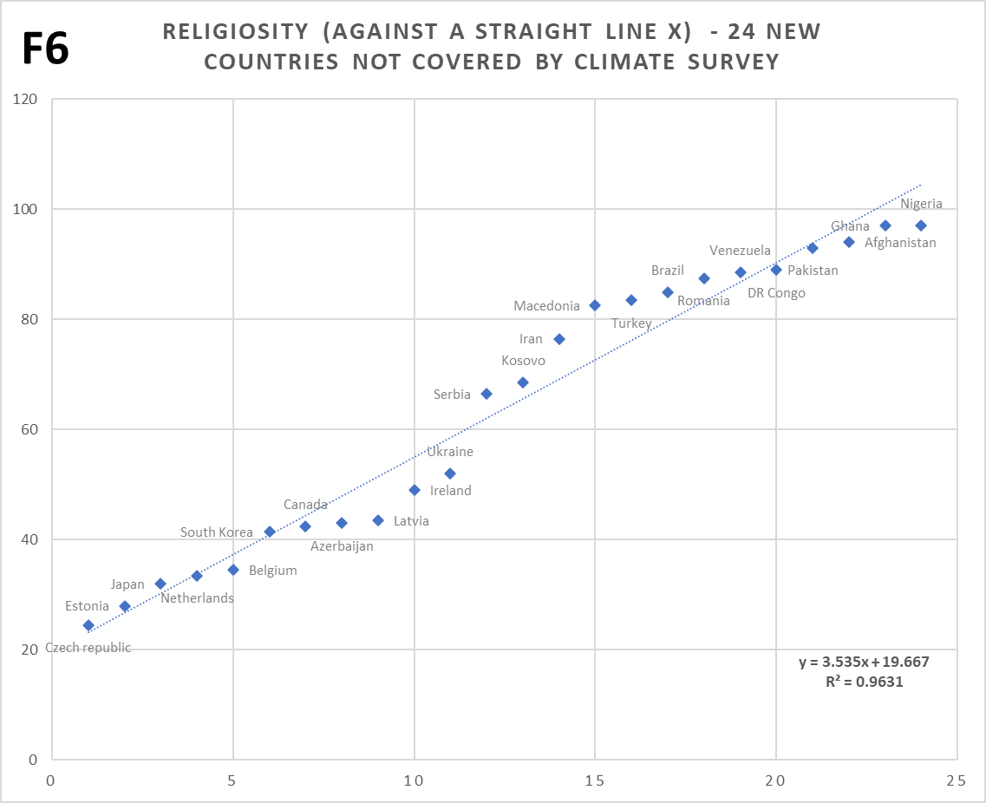
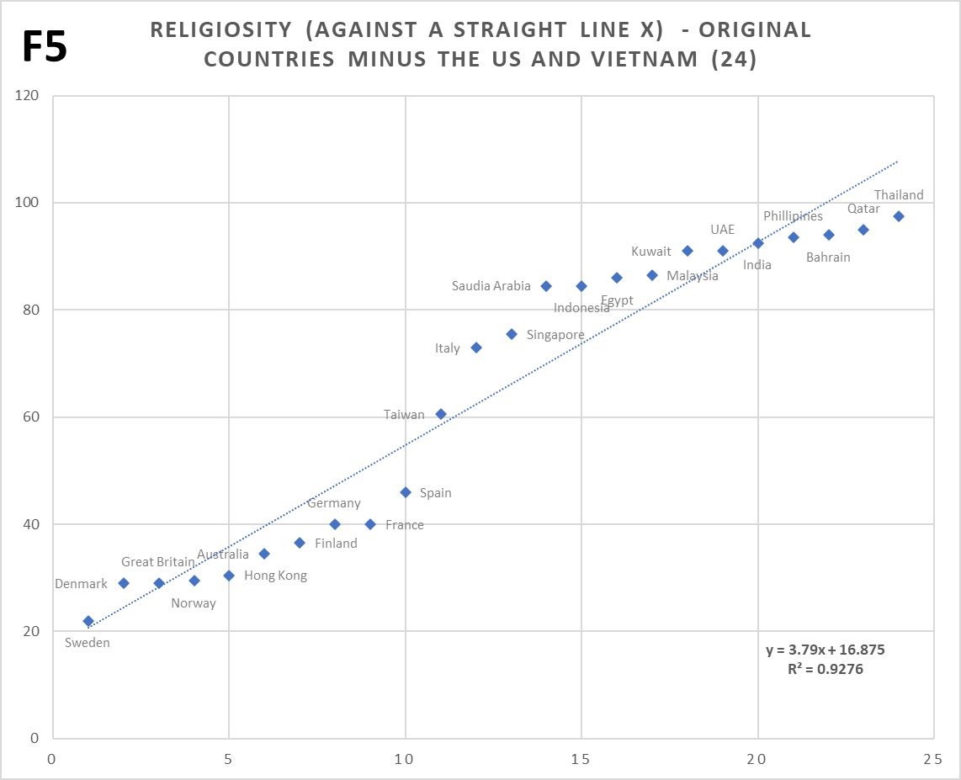
7. The ‘S’ shaped straddle of religiosity about its own linear trend (orange line) on Chart 2 (where the distribution of blue climate concern data-points also happens to be more linear than for Chart 1), strongly suggests that this shape has nothing to do with climate concerns. I figured that it’s very likely an inherent feature of my religiosity scale, in isolation. Note, the same type of skew appears on all of the Charts 1 to 4 (although it is harder to see for example in the much looser Chart 3 – look at the straight x/y plot version, and delete Vietnam and US rows). And indeed, when religiosity values are simply arranged in strict order (Chart F5, repeated below) i.e. with no reference at all to any other variables, the same ‘S’ shape appears. Not only that, but an entirely different set of nations covered by the two main religiosity sources, shows a virtually identical shape too (Chart F6, repeated above). Thus, this ‘S’ shape isn’t just a random feature of the original set of nations, and must emerge generically from the combined religiosity scale.
[For the second chart I worked through the alphabet from Afghanistan, Brazil… through to Ukraine and Venezuela, picking a country not on the first chart and having good data coverage in both main religiosity sources. Some letters of the alphabet yielded no choices, so this produced a list of 18 nations. However, low religiosity nations were very underrepresented. So, I added the Czech Republic, the Netherlands and Belgium, plus shifted the ‘E’ bucket from Ecuador to Estonia (from high to very low religiosity), which pretty much exhausted the low religiosity choices. Then to fill to 24 nations (matching the number from the original chart), I added South Korea, Ireland and Azerbaijan (the most secular of all Islamic nations), thus also giving the number of medium-low religiosity nations a boost. [Note: I avoided Bangladesh as I wanted to re-use this data in the second post of the series, and given that country has been a poster-child for climate-change / SLR over decades, it might suffer from anomalously higher concerns about such in relation to its religiosity than would normally be the case].
7a. The first candidate for the ‘S’ shaped skew of the religiosity scale, is reality. I.e. the religiosity scale from the combined survey responses accurately reflects the real religiosity and associated behaviors in nations. So for instance, religiosity in the 45 to 75% region could somehow be unstable, transitioning rapidly to above or below this region, where a gentler linear gradient becomes dominant. Hence, we’d only see a snapshot of unusual nations or ones that happen to be en-route through this region. If nations can stably occupy positions within this 45 to 75% region long-term, they ought to have the same even distribution as those outside of the region. A problem with this candidate, is that although there can be exceptions, things involving religion do not tend to change very fast. Another problem for my exercise here would be that, if the ‘S’ shape reflects reality, and whatever is driving the relationship between cultural climate concerns and religiosity, why wouldn’t the climate survey responses also produce the same ‘S’ shape? We do get a general linear correlation, but without the secondary ‘S’ shaped skew. The chance of climate concerns exactly offsetting a real effect of this kind (the noise is also too small to hide it), must be negligible, which itself is evidence that the second candidate is far more likely…
The second candidate for this shape is self-assessment bias. i.e. not just bias caused by formal pressure from authority in some nations (against faith, or against a lack of faith). Though the latter occurs, a more widespread effect would likely be biased assessment by individuals themselves, due to a social need to conform to perceived norms and peers (a subconscious effect). So in highly religious nations, individuals would likely over-assess themselves compared to the reality of their actual behavior and beliefs, while oppositely where low religiosity is the accepted norm, they would likely under-assesses relative to their actual behavior and beliefs. Such bias would likely be worse nearer the switch point between high / low religiosity, because cultural defensiveness / aggression is likely greatest when a majority is threatened or (going the other way) in reach. I’ve no idea why this isn’t symmetrical about the 50% mark though; the balance-point seems to be about 60% religiosity. In the very highly religious nations, the level of bias must tail off as ‘actual’ religiosity approaches 100%, because obviously no individuals or nations can exceed this level. In practice, even the most highly religious nations will have 2 or 3% of disbelievers, unless this is indeed forbidden by law or highly discouraged. See also the last paragraph of Footnote 3a.
See the invented climate concern versus religiosity chart below, where the ‘religiosity data’ is actually the same as the (Chart F2) climate concern data, but lifted / lowered within bands per the legend on the chart (some identical data points are also altered by 1 point, so that they don’t end up on top of each other). The straight x/y version of Chart 2 (minus the US and Vietnam) is provided for comparison. This invention is just to get a visual idea of the right kind of shape produced by particular bias levels, if self-assessment bias is the primary explanation.
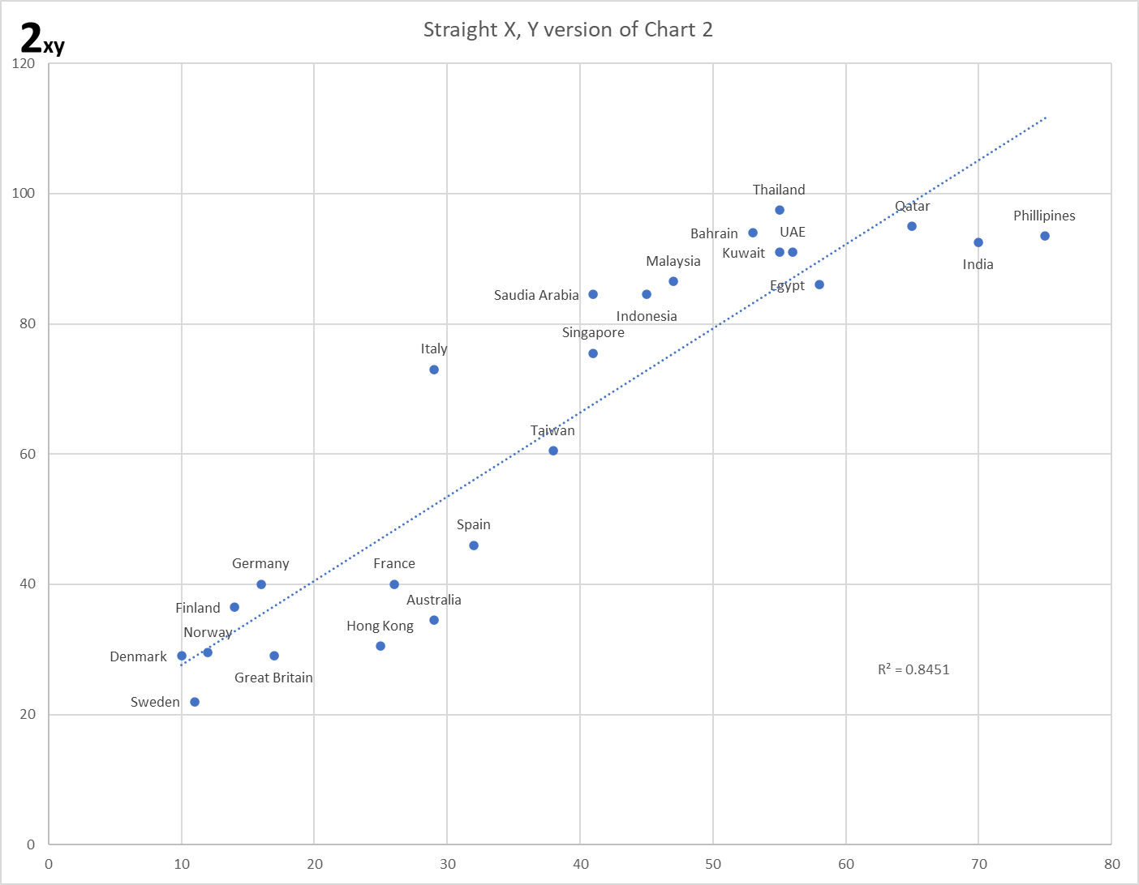
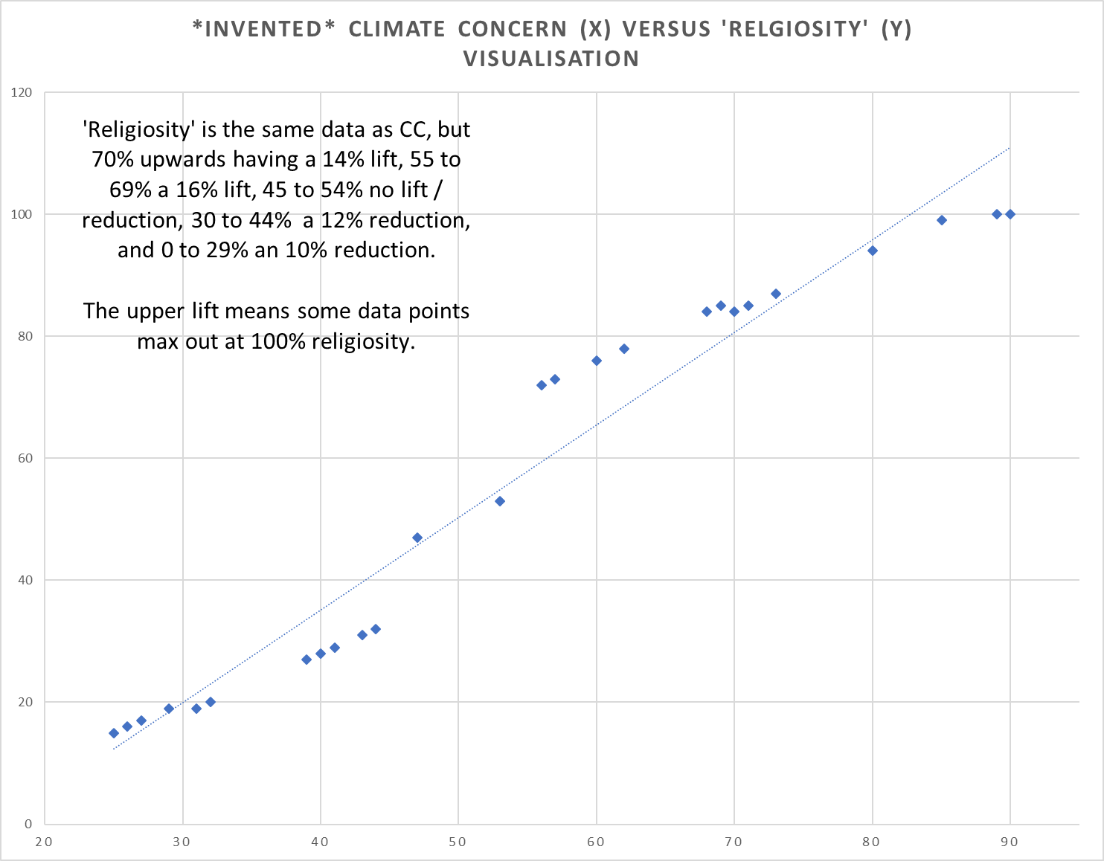
There may well be further candidates, notwithstanding which I’m assuming self-assessment bias is likely the best one. See Charts 7 and F7, for what Charts 2 and 4 look like with this bias ironed flat.

7b. Below is Chart 2 (in its straight x/y form) shown both with (LHS) and without (RHS) the exceptional cases of the US and Vietnam. This provides for a direct by-eye comparison of the improved fit, but also that the ‘S’ shaped straddle still exists with these exceptional nations removed. As expected, given it turns out to be a feature of the religiosity scale itself.
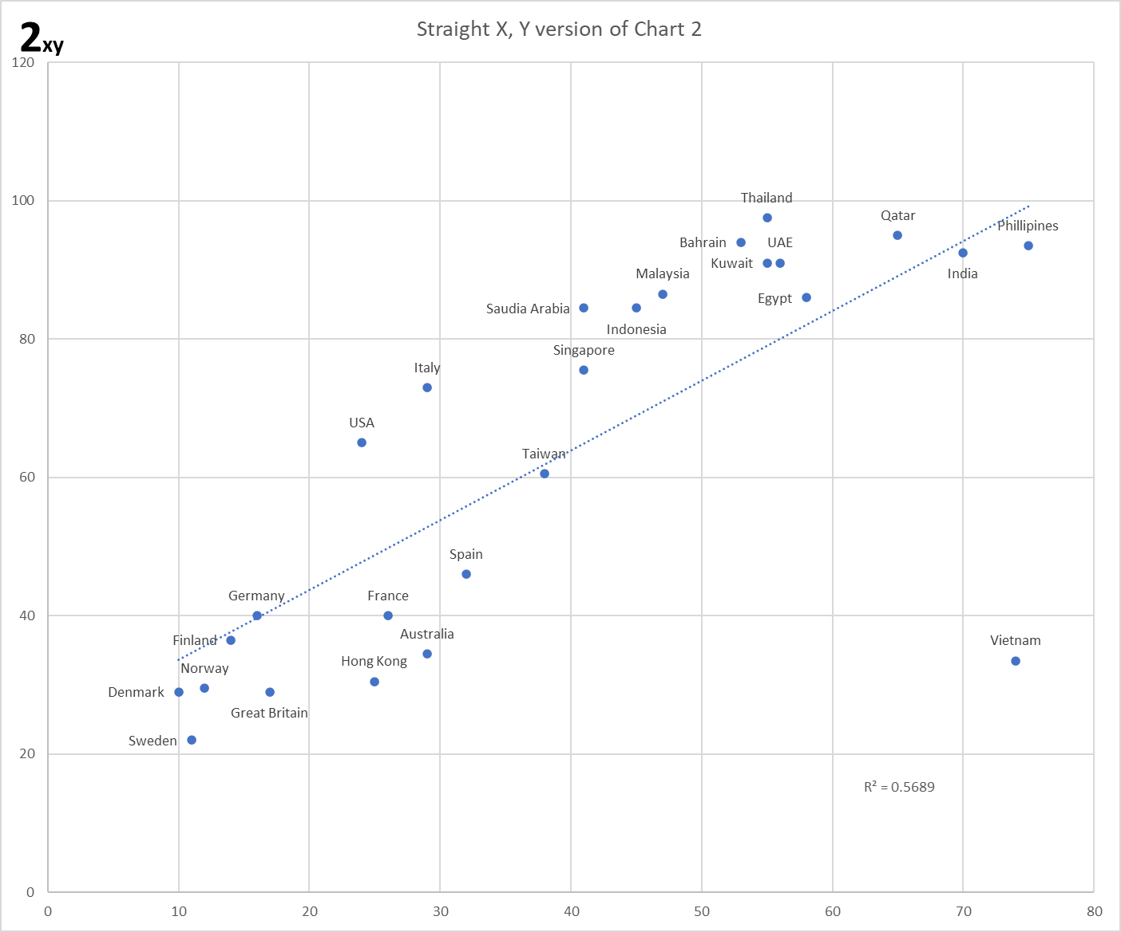
Candidates explanations for this drawn out ‘S’ shape, which occurs on the religiosity scale in isolation, are given above in Footnote 7 above. You can generate the RHS Chart by deleting the US and Vietnam rows for the Chart 2 data in the Excel file.

8. The more highly concerned about climate-change are likely less invested in personal action. See Hall et al 2018, ‘Believing in climate change, but not behaving sustainably: Evidence from a one-year longitudinal study’, Journal of Environmental Psychology Volume 56, April 2018, Pages 55-62.
From the Abstract: ‘the “Highly Concerned” were most supportive of government climate policies, but least likely to report individual-level actions, whereas the “Skeptical” opposed policy solutions but were most likely to report engaging in individual-level pro-environmental behaviors.’ [Highly Concerned and Skeptical are both in respect of climate-change].

9. The question of which nation had ‘most negative impact on climate change’, as framed and within the context of the whole survey, implicitly assumes that AGW is causing ‘bad’ and highly impactful climate change. Yet the engagement of rationality to answer this question, based upon unconflicted common knowledge about population sizes and economic rankings, doesn’t validate or invalidate that assumption. There are also options for “some other country”, and “don’t know”, which are possible escape clauses for those who may not think climate change is so adverse, but the question framing will likely lead to some people deploying such knowledge as they have regarding the aforementioned factors, whatever they actually believe. I.e. whether or not they have some significant cultural belief in imminent global climate catastrophe / salvation. Publics aren’t climate literate, and engagement of rationality in this way doesn’t mean they’re able to judge that impacts are indeed going to be seriously adverse (or catastrophic) or not. In practice, as post 3 in the series demonstrates, it turns out that cultural influences seem to have far more effect regarding responses than any rational wielding of common knowledge. But not as a simple linear correlation. Participants do end up giving answers that depend more upon what they believe (which in turn is about who, culturally, they are), rather than what they know. This is consistent with Dan Kahan’s Identity Protective Cognition. See Footnote 2 of Post 3.

10. Likely correlation with religiosity of excess blame apportioned by each nation to itself. The anomalously high concern (blue data) of India itself on Chart F2, plotting against religiosity the national perceptions of India as having a most negative climate impact, alerted me to a likely correlation with religiosity of excess blame apportioned by each nation to itself, this being a reflection of culturally invoked guilt. This ought to be a good candidate, and a series for this ‘excess guilt’ can be obtained by subtracting the average perception of all nations regarding the negative climate impact of nation X, from nation X’s own perception of its negative climate impact, for X being each of the nations on which there is data. However, the procedure is extremely data challenged, a) because the results of the subtraction are low numbers which are nevertheless now subject to a larger error range, and b) there are only 25 choices of nations within the question about negative impacts, of which unfortunately only 10 overlap with the religiosity scale. Hence there are only 10 data points, but one is the exceptional US, so really only 9!

Despite these severe limitations, to my surprise Chart F4 (replicated below) does show familiar features. There’s some RHS religiosity undershoot and LHS overshoot from the usual religiosity scale bias (despite with very religious nations being especially under-represented, the center of the ‘S’ is now very shifted, around Australia and India positions), and indeed there’s a not insignificant correlation; ‘r’ = 0.56. Yet with a poor significance (p=0.11) this correlation isn’t too meaningful. I guess one really couldn’t hope for too much with only 9 data points! Saudi Arabia has drifted to the rightmost position; as on charts 1, 2 and 4, Saudi Arabia is the furthest right of all the Islamic nations, given the severe data challenges this drift is I guess possible without contradicting the main cultural correlation proposal. Incidentally, if the US is added back in (see the Excel datafile), this nation appears in its ‘normal’ exception position (also cutting ‘r’ to 0.47). Anyhow, we can’t rely on this chart for much. But I am at least counting it as positive that similar structure re the religiosity scale bias (which per Footnote 7a likely means an underlying linear relationship) and US exception, survives, plus that Chart F4 isn’t inconsistent with my proposal, albeit it is tantalizingly short of actual confirmation regarding the angle of culturally invoked guilt.

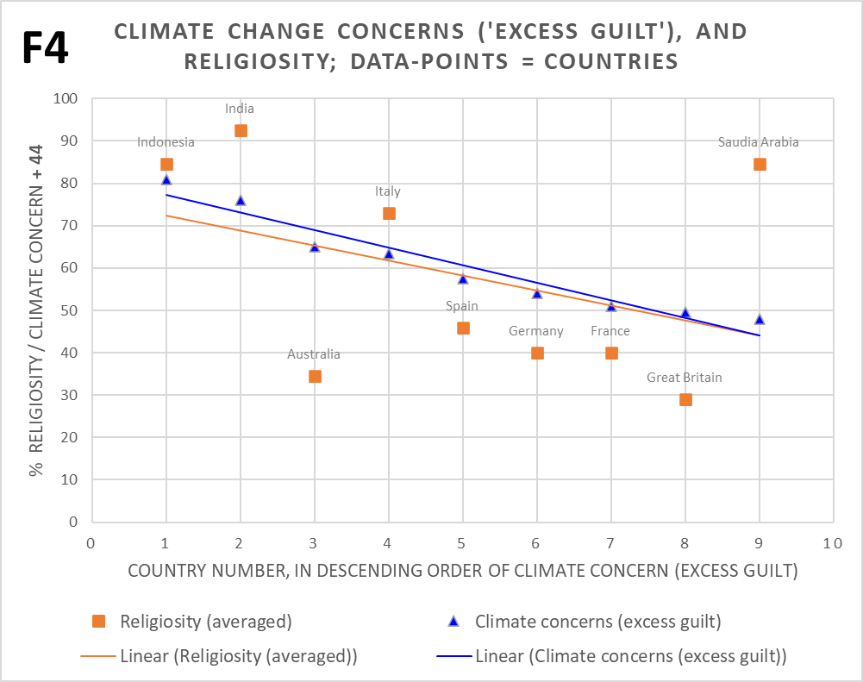

11. The main thrust of intersectional literature with religion appears to be on figuring out how to use the main faiths as tools to drive emissions reductions policies. For instance, Morrison et al (2015), ‘Religion Does Matter for Climate Change Attitudes and Behavior’, says: ‘Research conducted, principally in the United States (US) and Europe, has indicated that religious affiliation is a key factor to take into account in developing climate change policy and designing messages about policy^{[3]}. Based on an examination of teachings of nine major religions, covering issues such as other-person centeredness and environmental stewardship, Posas^{[4]} argued strongly that religions from Bahá’í to Buddhism and from Islam to Christianity should be able to influence their members to bring an ethical dimension which is sympathetic to climate change policy’, and stresses in their Abstract the ‘importance of engaging denominations to encourage change in attitudes and behavior among their members.’ [See original for a resolution of the references]. This angle is even acknowledged as the focus of the literature in the literature itself. E.g. Haluza-DeLay (2014), ‘Religion and Climate Change: Varieties in Viewpoints and Practices’: ‘…the focus of such scholarship is to draw on resources internal to the faith in order to make the case to adherents about the duty to attend to climate change.’ Coupled with a failure to perceive that affirmative public attitudes to climate-change are largely due to cultural mechanisms (however religious or otherwise are responders), this focus appears to have blinded many researchers to the straightforward and powerful generic cultural interaction between religion (i.e. any brand) and the above attitudes, which sits beneath the plethora of detail they examine (the latter are by comparison, very minor). [Post 1 only characterizes part of this interaction, the rest is covered by the subsequent Posts 2 and 3].

12. Debiasing the religiosity scale of the ‘S’ shaped straddle about trend. SEE FOOTNOTES 7, 7a, 7b. This is simply achieved by finding the residuals of the plot of religiosity against a straight line (Chart F5 in the Exel datafile), and subtracting these from the religiosity figures for Chart 2 (to give Chart 7), and Chart 4 (to give Chart F7). Note: this process drives Qatar, Bahrain and Thailand over 100% religiosity, which is clearly not real so these nations are capped at 100%. Because the ‘S’ shape straddled the trend fairly evenly, this exercise has little impact on r (slight increase 0.92 to 0.94 for Chart 2 to 7, and slight decrease 0.89 to 0.88 for Chart 4 to Chart F7).

13. Alternate explanations for the CCCC / Religiosity correlation are possible, e.g. IHDI. In fact, this is the only alternate candidate explanation I have, although there could be others that I’m unaware of. It has been known for a long time that the Human Development Index (HDI), and even more so the newer Inequality-adjusted HDI (IHDI), has a strong anti-correlation with Religiosity (despite some exceptions, again the US being one). Hence IHDI will also have a strong anti-correlation with climate concerns of the type plotted in Charts 1 to 4 (see Chart F8a/b verifying this for ‘personal impact of climate change: great deal’). The relationship of IHDI to religiosity is generally held to be because over the long-term, strong religious belief in society holds back education and economic development, with poorer people generally being more religious. However, it’s not a simple equation because more religious people tend also to feel greater life satisfaction than non-religious people. See here and here for general discussion So, could this factor be causal in some sense regarding the correlation between religiosity and (reality-unconstrained) CCCC beliefs demonstrated in the main post?
While this looks somewhat intuitive at first blush (roughly equates to poorer / less educated nations having more concern), large problems appear upon deeper examination. The first being that only the climate survey questions that are culturally aligned to catastrophic climate change, evoke the strong correlation with religiosity. If IHDI was the ultimate cause, we’d expect all climate-change affirmative responses to correlate in this manner, because in and of itself IHDI isn’t a cultural-entity thing, only possessing such an aspect via its relationship to religious faith. Hence, it’s far more likely that religiosity is a common driver of both IHDI (via longer term social development or lack thereof), and the climate-change affirmative attitudes from reality-unconstrained surveys (via the relatively new relationship with up-and-coming CCCC). A second major difficulty arises with the proposition that IHDI is causal, when reality-constrained attitudes are considered, which is covered in the next post of the series. This evidence also points to religiosity as root cause, not IHDI. So, while I can’t rule out IHDI as causal, the case for this appears very weak.

14. The climate change / religion intersectional literature does acknowledge this cultural clash and the unique scenario it generates in the US. Albeit in a roundabout way due to the principle focus always being on trying to leverage religions to serve climate change policy. E.g. Haluza-DeLay (2014): Religion and Climate Change: Varieties in Viewpoints and Practices. ‘But the potential utility of religions engaging the issue of human-induced climate change is compromised by perceptions that religions are anti-climate change and anti-science. Much of this perception is due to the ‘culture wars’ in the United States. This stance is not representative of all the world’s religions, and certainly not of all Christians.’ In practice, religions globally simultaneously embrace (so, increasing ABel with increasing national religiosity, due to ISk disablement) and resist (so, decreasing ConBel / CBel with increasing national religiosity, due to ISk enablement) catastrophic climate culture. [ABel / ConBel / CBel terms introduced in second Post].

