Globally, can Religiosity predict Cultural Climate Beliefs?
Probing the relationship between religiosity globally, and cultural beliefs in the narrative of imminent / certain global climate catastrophe: Post 1 of 3.
1. Introduction
The main narrative of catastrophic climate-change culture (CCCC) contradicts mainstream (and skeptical) science. Yet widespread lack of belief in / commitment to CCCC across many nations cannot stem from rational consideration, because national publics simply aren’t climate literate enough for rationality to gain any meaningful grip on the issue (plus the narrative itself claims an impeccable science pedigree). It’s much more likely that most disbelief stems from Innate Skepticism (ISk). As described here, ISk is very different to rational skepticism, being an instinctive reaction against invasive alien (to established local conditions) culture, or major over-reach by a dominant local culture. Whether or not individuals get triggered into ISk depends upon their long-established cultural values; so, this means we can probe THE PROPOSAL that indeed ISk is the primary driver of bulk skepticism about CCCC, via of all things, the religiosity of nations.
The detailed interaction between CCCC and the mainstream faiths is mixed. Lack-luster action fronted by often strong public endorsements¹, appears to result in net modest support in all cases^{1a}. This apparently universal yet mild cultural support, should nevertheless be strong enough to disable ISk about CCCC in religious believers; even approval ‘by default’ should be sufficient for this. Absent hard reality constraints or direct cultural clashes², most religious adherents will sense CCCC narratives as ‘allied’, or possibly neutral, not as assaulting their long-established main values (so not triggering ISk). Conversely and for most national scenarios, i.e. where very strong political cultures don’t interfere, ISk in irreligious people (we all have potential ISk), won’t have a suppressed trigger regarding CCCC encroachment. Especially as established value sets in low religiosity nations are more dependent upon secular law and science, which enterprises have over generations eroded the emotive beliefs / behaviors associated with strong cultural entities. Hence if my proposal (capitals above) reflects reality, correspondingly less belief in (so greater skepticism of) the emotive narratives propagated by CCCC, should be reported within the less religious nations. On occasion, I’ve noticed individual reports that seem consistent with such a pattern.
Despite thinking about this proposal for some time, I never actually investigated it. I wasn’t confident that I could get access to the right data or even methodologies required, plus I might lack the necessary skills to tease the relationship out from multiple effects. In avoiding the former problem by going with readily available public surveys, another worry loomed in that such blunt tools not designed for this task might produce very noisy data. Also, due to other (not CCCC or religious) cultural influence, plus the possibility that the major faiths each react too differently, I wasn’t sure of consistency across nations (though the US should behave differently). I thought the results might be too mushy; but I finally got around to looking.
2. A religiosity scale
Simple public surveys assessing religiosity can produce wide ranging results, varying not only on factors such as precisely what questions are asked, but external constraints too. The latter includes for instance, significant bias towards less or more belief in regimes that respectively punish faith, or punish a lack of faith. In some countries, e.g. China, this makes realistic measurement extremely difficult. However, per above I’m committed to public surveys for this exercise. So, to reduce variance I constructed a religiosity scale by merging two different surveys from mainstream providers, each probing via a different angle. I needed both sources to cover many nations (to match all those in climate surveys), and fortunately cover is wide, although 4 high-religiosity Islamic nations remain single-sourced. Footnote 3 provides details.
3. Climate cultural belief data
For this I use a September 2019 YouGov survey (full pdf) of attitudes on climate-change issues in 28 countries spread across world regions, of which I can match 26 from the religiosity scale above. This includes countries featuring a large range of religiosities within the context of majority Christian (both Catholic and Protestant), majority Islam, majority Hindu (India), majority Buddhist (Thailand), plus mixed (Singapore, Taiwan, Hong Kong) faiths. The survey features a significant number of questions / options, providing for various tests against religiosity including the responses that should not correlate. Indeed, as this survey isn’t designed to get at the cultural nub of climate catastrophism (inclusive of hope of salvation), while it happens to contain questions that reasonably should get close, there are also many that won’t. Determining which is which is a subjective exercise at the moment, albeit explained per case, unless I can ever figure out how to codify it. Note: for sound reasons explained later, the US should not conform to the Section 1 proposal; I included it nevertheless to confirm this is so, because otherwise there’d be something wrong with the theory.
The questions in this survey are largely reality-unconstrained; for what that means and why we need to avoid it until the next post of the series, see Footnote 4. So according to the proposal, for this type of survey higher national religiosity should correlate with higher affirmative scores for those climate survey questions which dominantly engage belief in CCCC narratives. And there shouldn’t be correlation where survey questions align only weakly to CCCC, which will lose the signal in noise (e.g. of conflated beliefs from other domains), or secondary interactions (dealt with in later posts). So for instance, “The climate is changing and human activity is mainly responsible”, won’t invoke a dominant cultural engagement. Many responders could answer this affirmatively without being emotively committed to climate catastrophism’s core tenets (i.e. a high certainty of imminent catastrophe yet with the concurrent hope of salvation). The question is effectively a technical one too, which weakens emotive response. [Throughout this post it’s worth bearing in mind that cultural beliefs not only support logical contradictions, their entire existence is based on doing so, for which purpose emotive conviction bypasses our reason. Finding what is culturally critical sometimes requires imagining what illogicalities might best support the culture]. So, let’s look at a question that should correlate…
4. Attitudes on ‘Personal Climate Impact’ versus Religiosity
“How much of an impact, if any, do you believe climate change will have on your life?” This is a great question for cultural correlation, because narratives of CCCC strongly emphasize impact on everyone, rich or poor, any nation, albeit the poor have less means to mitigate impact. Plus ‘your life’ matches the relative imminence (in fact ‘happening now’) also stressed by the narrative. Only a minority of elderly believers might expect to miss out on personal impacts. The question would’ve been better mentioning ‘unless drastic fossil-fuel curtailment’, but I figured should work anyhow if anything does, plus featuring a personal angle increases the emotive response. The total of responses ‘a great deal’ and ‘a fair amount’ charted against religiosity, are below.
[Note: some comparisons in this post are shown as two separate series with an arbitrary x-axis and offset, rather than a straight x/y plot; I’m unfamiliar with both data-sets and this visualization seems to show me what’s going on within both at once, so to speak. Especially oddities. Just a preference, but all charts are supplied in this format plus straight x/y plots as well, via the Excel datafile linked below. But beware this visualization introduces its own minor characterizations].
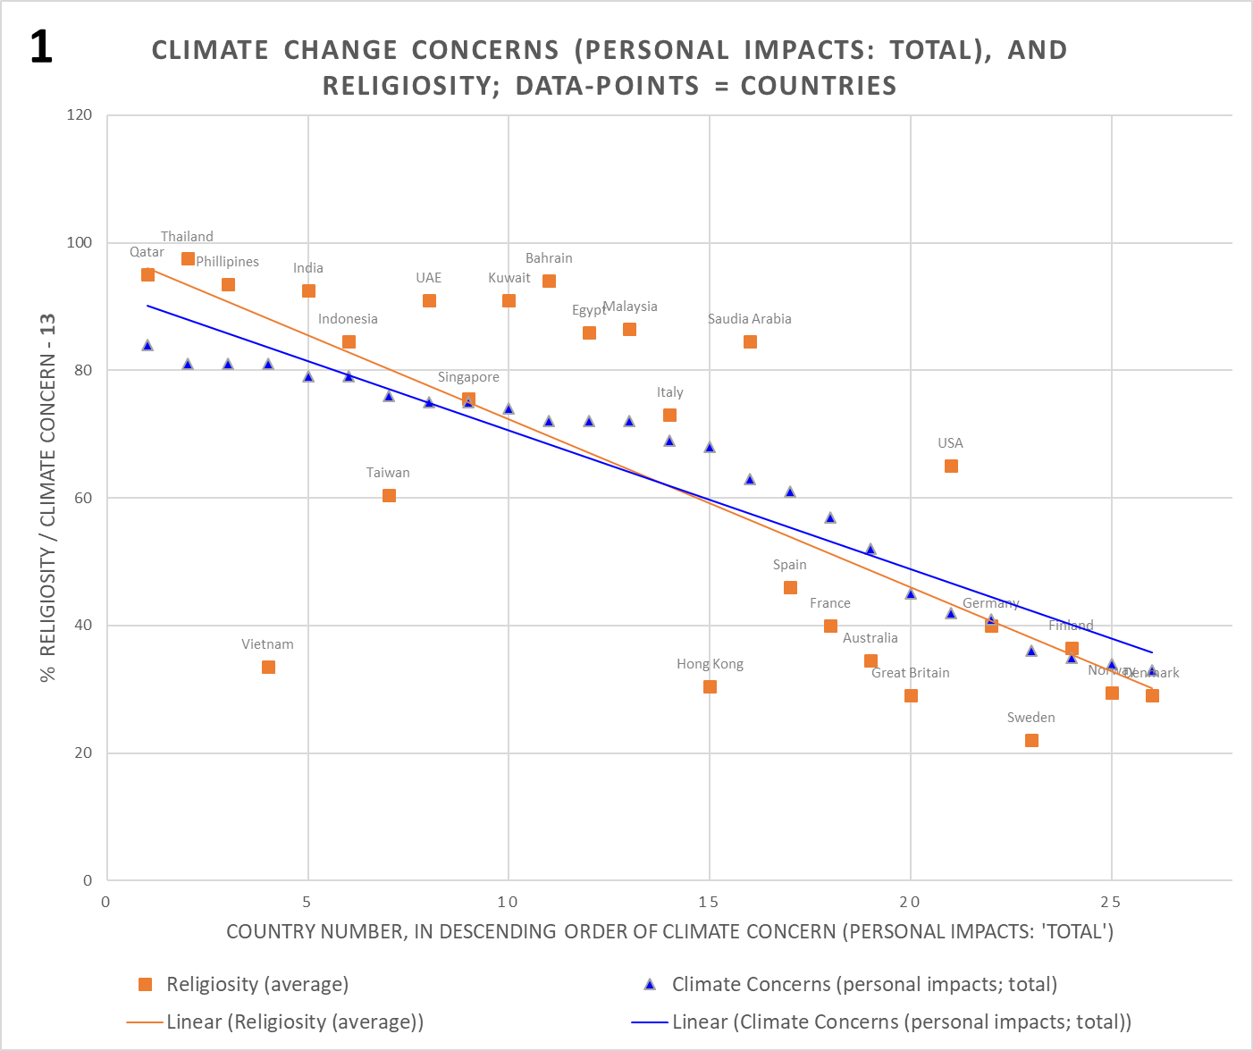
For a first shot in the dark, this surprised me. For social data this is pretty decent, not too mushy at all. The blue triangles represent the % climate responses per nation, arranged in descending order of concern from left to right (yeah I know, but it just came out that way and ended up in several charts I didn’t want to redraw), and the orange squares are % religiosity. To reduce clutter, I only added country labels to the latter; data points correspond vertically. I added linear trendlines; the blue series has an arbitrary offset to conveniently align these.
After the favorable first impression, I noted the apparently non-linear religiosity undershoot on RHS nations and overshoot on LHS nations relative to climate concerns (same in the straight x/y plot). Then I realized that two of the most straying nations from a correlation PoV, which are also opposite to those skews, include Vietnam plus my expected exception of the US. It then occurred to me that Vietnam’s position could well be a legitimate exception too (i.e. explainable via unusual cultural circumstances). While pondering these matters, I also realized that charting only the ‘great deal’ response alone might get a rather more distilled, as it were, cultural response, although I didn’t expect a dramatic difference. So, Chart 2 is the result for that:

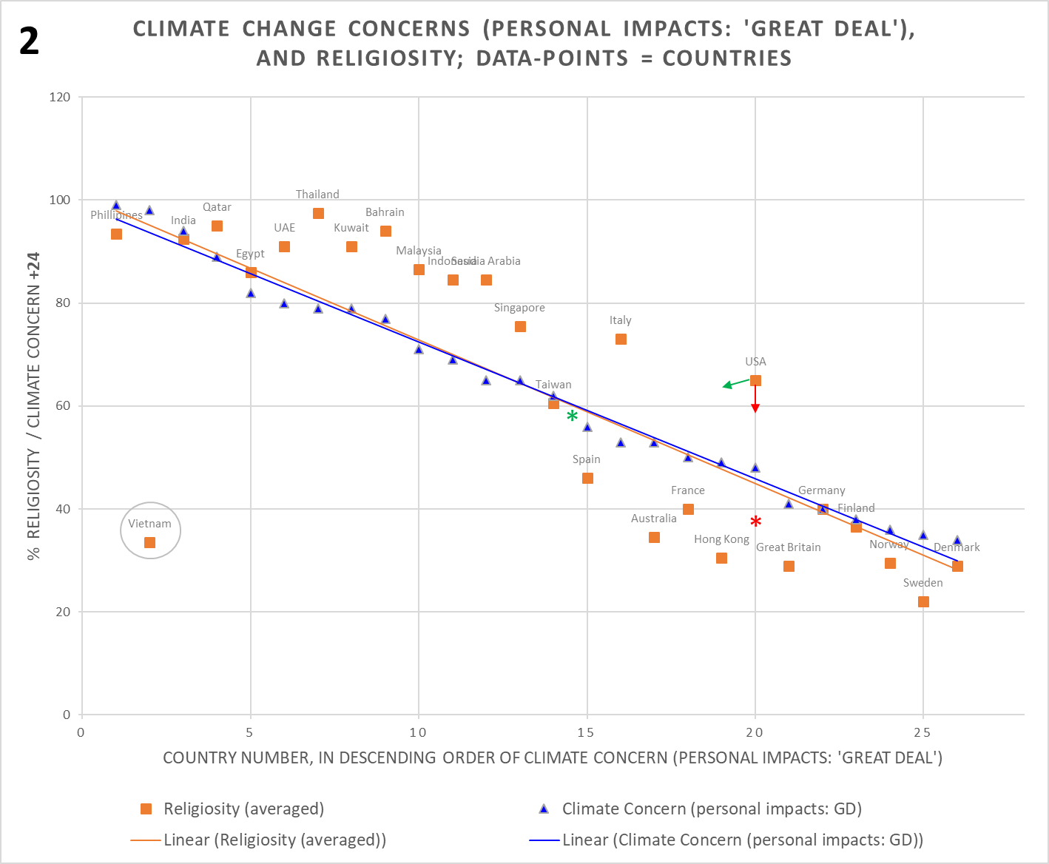
This is appreciably more uniform. While the stretched ‘S’ shape of religiosity undershoot / overshoot remains, I figured the reason for such a (now) well-defined shape should be traceable. Plus, I felt more confident regarding the clearer US and Vietnam exceptions, and justification thereof. Potential non-linearities notwithstanding, ‘r’ is 0.75, but 0.92 without those two nations; very healthy indeed.
It is hard to over-emphasize just how unusual the US is compared to other nations regarding the social psychology of climate-change. This is due to cultural belief / opposition on the issue¹⁴ neatly aligning to an existing very high polarization (i.e. on many other issues) of political parties, which afaik occurs nowhere else. A very brief comparison to the situation in a few other countries is given in Footnote 5. As within the US religion itself also has a partisan lean (both Reps and Dems are majority religious parties, but with significantly more, and more fundamentalist, believers supporting the former), the religious and climate-change domains have a more complex entanglement. Graphical depictions plus an explanation of the cultural alliances / oppositions within each domain, here, are helpful. The US also appears to have by far the most research into attitudes on climate-change, which unfortunately helps to make this highly unusual scenario (for nations globally) look like a norm.
So, one way of looking at the US in Chart 2, is as though only the net religiosity for the climate domain counts. So religious belief disabling ISk about CCCC, won’t happen for the religious Reps / Leaners, due to opposing political culture, but will happen ‘as normal’ for religious Dems / Leaners [and No Leaners], due to supportive [neutral] political culture. This effect may cut the apparent US religiosity to under 40% (see Footnote 6 for a rough estimate). Note: this doesn’t reflect reality because a smaller net contribution on this issue alone, isn’t the same as the whole US being less religious to start with. But it lends insight and will align regarding some measurements. The red asterisk shows where the US sits with such a cut. Another way of perceiving the situation is to see where the US sits in Chart 2 if the political polarization entangling climate-change and religion was far less, e.g. similarly to the UK. The green asterisk marks an estimate of this, derived by averaging the 4 nations nearest and sandwiching the US in religiosity, being Singapore, Italy, Taiwan, and Spain. Again, this meta-positioning is a useful insight, not a reality. A potential third way to portray the US in this chart, is to break it into separate Rep and Dem ‘nations’, but that’s a challenge for another day.
While communism in Vietnam has moved hugely from its classic position of decades ago, especially regarding economics, the system survives in far more than just spirit and with unbroken threads such as idealism wrt its crucial role in throwing off French and US control / influence, plus single-party political power and propaganda. Regarding the exercise here, this not only means a very likely biased-low measure of religiosity (which is monitored and frowned upon), but a strong cultural belief especially in the older population, which isn’t religious but secular. If that secular belief is also aligned to CCCC, or at least doesn’t oppose it, the sum of (actual) religiosity and secular strong belief, could make Vietnam act like a highly religious country in terms of disabling ISk about CCCC for most of the population - maybe!
The exceptional US and Vietnam are thus removed from the next two charts, leaving 24 nations. Their data remains within the Excel file – use delete / undelete row to see the Charts with these out or in.
I then diverted into what became Footnote 7 regarding the ‘S’ shape of religiosity under / overshoot (it’s still present even without the US and Vietnam, see Footnote 7b). In summary, not only is this a feature of the religiosity scale in isolation, it isn’t due to the particular set of charted nations, also occurring with a completely different set. Given religiosity against a dead-straight-line plots similarly, then whatever is causing this shape (systemic self-assessment error is my main candidate in Footnote 7a), the underlying relationship of religiosity with CCCC is highly likely also linear. In which case, the ‘r’ value noted above is more than just a tentative wet finger.
5. Attitudes on ‘Human Extinction’ versus Religiosity
Correlation-wise this exercise was going well thus far, but multiple comparisons are needed and as you might guess, reality isn’t always so compliant. While there’s an issue with the question on attitudes to human extinction, I figured this shouldn’t matter and responses should also correlate robustly. The issue is that, much like for religion, the core narrative for climate-change includes a fear of catastrophe and hope of salvation (via the touted dramatic emissions reduction). For a question probing into the more deeply existential, both of these aspects should really be invoked to capture a central swathe of believers. However, the relevant question asks only: ‘How likely do you think it is that climate change will cause the extinction of the human race?’ Not mentioning the hope / salvation aspect means picking up mostly the doomsters, the too late already brigades, for strong affirmatives. Yet while engaging a limited part of the belief spectrum, a sub-flavor as it were, this should still indicate cultural conviction, should still work. After the experience above I used only the ‘most distilled’ response, i.e. ‘very likely’.
Chart 3 shows the result. While correlation hasn’t disintegrated and there’s surviving structure like Chart 1 and 2, it’s quite a lot weaker. ‘r’ is 0.61.
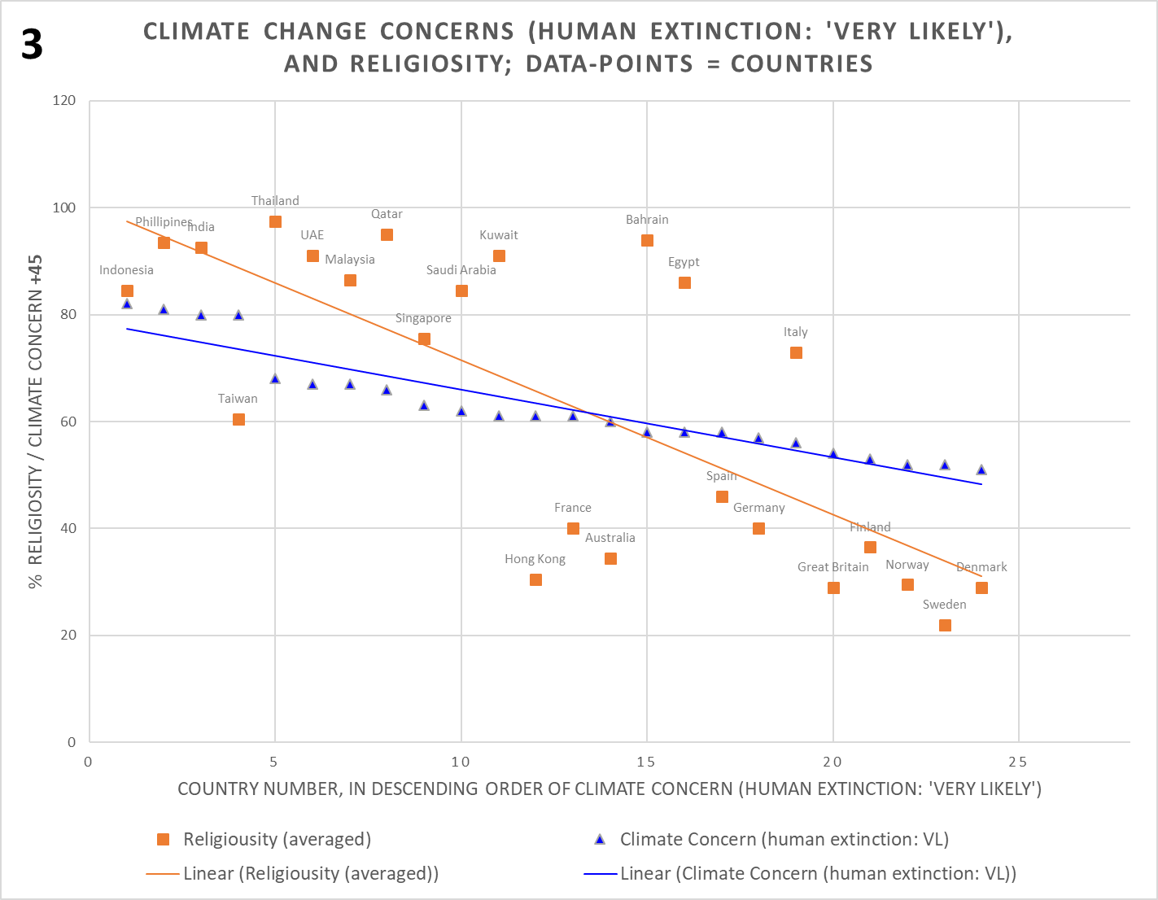
The ‘S’ shaped skew adds to apparent scatter, but per above this is distraction. However, Hong Kong and Taiwan are back to similar places as for Chart 1, while France and Australia have moved left to approach Honk Kong. Italy has shifted very rightwards, along with Bahrain and Egypt. Relatively, why do the latter nations worry much less about human extinction, and the former more?
Then I realized that low responses for the blue data, as indeed might be expected for bias to a doomster-only core, could push up measurement error effects. Only 7 points separate all the nations from Italy left to Singapore; they might be in almost any order (this issue looks obvious to me in the above visualization, yet not the straight x/y plot; no doubt my idiosyncrasy). The climate survey pdf doesn’t address an error range. Religiosity has partial info, I guess ~6% min^{3b}. It also occurred that, while exploding recently with XR, the explicit notion of ‘human extinction’ is new and maybe not established. A big raft of catastrophe narrative variants such as ‘save the planet’, ‘end of life’, and ‘no planet B’ plus many terminal metaphors (see here for a big list of CAGW narrative variants) have implied human extinction for decades; yet as noted already, cultural narratives harbor gross contradictions and belief isn’t via rationality but emotive conviction, so logic doesn’t predict beliefs. I don’t know whether these issues are valid or big enough to explain the wider scatter in Chart 3; I guess it’s possible. The time horizon is also open-ended, there’s no mention of when extinction will occur. Does that matter? (the culture implies not long, generationally).
Despite these issues, this statistically significant correlation (p=0.0016) isn’t devoid of meaning. I guess the narrow context of human extinction alone, just scrapes through the cultural alignment test. However, moving onto another question plus a couple that shouldn’t correlate, ought to reveal more.
6. Attitudes on ‘UN Power to Combat CC’ versus Religiosity
This question moves away from core existentiality, yet still invokes some fear and hope. And the UN elite aided by older generation NGOs have written their organization indelibly into the catastrophic climate-change narrative as the orthodox priesthood (despite more fervent nouveau prophets like Greta and XR) plus originator of solutions (via coordination of science / policy and pressuring nations to comply). If the promise of strong correlation with religiosity as offered by Chart 2 is real, then the response ‘a great deal’ to this question, should also be robustly correlated across nations.
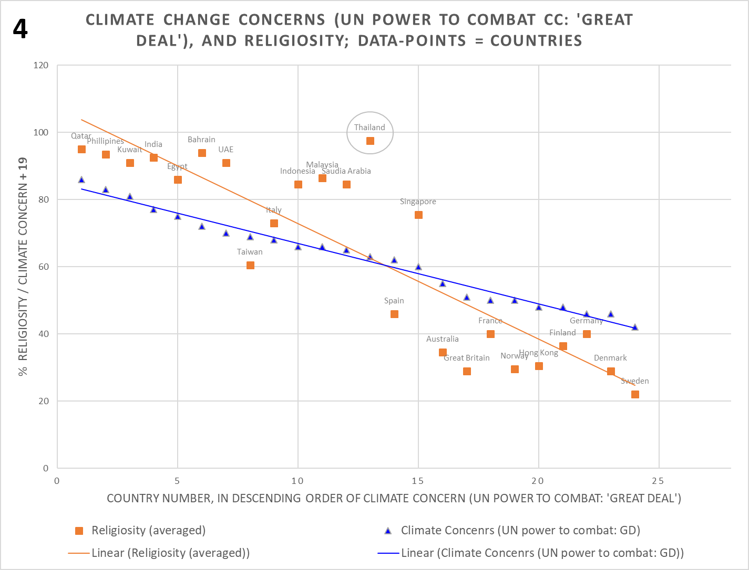

Albeit not quite as tight as Chart 2, this is so. ‘r’ is back to 0.89. Although in this case it’s easier to see on the straight x/y plot, the familiar and expected ‘S’ shaped skew of the religiosity scale is also present. As the question is less personal and emotive than the one producing Chart 2, a narrower ‘concern’ data-range with less signal-to-noise is expected, see the next post in the series regarding such expectations. Yet this correlation is anyhow strong enough to regard as great support for my Section 1 proposal.

However, an apparently new exception here is Thailand (while mainly staying to the LHS some of the Islamic nations wander a fair bit, but the non-Islamic-majority Philippines, India and Thailand, all stay pretty stable through Charts 1 to 3). The question actually asks about belief in the power of ‘international bodies’ to combat climate-change, but the UN is the only example body given. Thailand has generically supported the UN, although ~7 years back the UN court of justice ruled against Thailand regarding an important border dispute with Cambodia, which included armed conflict and deaths. Despite significant political / public fallout, this seems a weak factor to so reduce faith in that body as critical for combatting climate-change. So, I couldn’t grant Thailand ‘official’ exception status 0: Without a robust case I’d be guilty of simply pruning charts into conformance. But my wobbling confidence regarding a strong correlation was nevertheless largely restored, so onward…

7. Climate-Change attitudes that shouldn’t have a simple relationship / correlation with Religiosity
Positive responses to ‘do you think that you personally could be doing more to tackle climate change’, shouldn’t be particularly correlated with religiosity, because cultural belief in an imminent climate catastrophe won’t dominate responses. While the culture via various means including guilt invokes the sentiment of ‘doing more’, very many people who think there’s a climate issue but aren’t ardent cultural believers in catastrophe, will share such a sentiment. Strong cultural responses will be further diluted as ‘doing more’ also has a vast range of interpretation, from the ardent considering a life off-grid, to those considering a switch to public transport, to those only considering changing light bulbs, or less. Due to very mixed messaging and domain ignorance, there’s also a wide range in perception of how much each of these things may help. Such considerations are also conflated with a large range of other reality and cultural domains, some of which pre-date climate catastrophism. So for instance health (e.g. ‘cycling more’) or pro-animal rights (e.g. ‘eating less meat’). To top all that, those people who are more highly concerned about climate-change, are likely less invested in personal action⁸. Chart F1 (see Excel file-link below) shows results for the ‘could be doing more’ responses; as expected, correlation is lost (‘r’ = -0.17). [Note: as discussed in the third post of this series, there’s some revealing non-linear structure in Chart F1, but an expected lack of strong correlation is all we’re concerned about for now].

A question in the climate survey asks: ‘Which countries, if any, do you think have had the most negative impact on global warming and climate change?’ Followed by a list of 25 countries, where up to 5 can be chosen. This is a weakly CCCC-aligned question, which is to say it does not have a strong existential / emotive / personal engagement (excepting responses for the participants’ own nations), and is relatively objective in that responses ought to stem from the context of widespread and unconflicted knowledge about the sizes of national populations and economies. This doesn’t mean all answers will be correct, and indeed responses are scattered across all the 25 countries. Nor does any semblance of rational engagement validate or otherwise the question’s framing⁹. But responses regarding any particular country whether right or wrong, say India, shouldn’t robustly correlate with religiosity. Chart F2 for this test (using India, at the Excel file link) is pretty scattered and there isn’t +ve correlation.

There’s actually minor anti-correlation. I’d assumed that if rationality could be found anywhere in these climate survey responses, this multiple-choice question offers the best chance of finding it. However, the third post of the series reveals non-linear structure due to secondary cultural effects, plus that rationality provides a very limited contribution indeed. [Note: the anomalous response of India itself also suggests the likely correlation with religiosity of excess blame apportioned by each nation to itself, this being a reflection of culturally-invoked guilt. Footnote 10 and chart F4 follow this up; despite a severe dearth of data means no conclusion can be drawn, the relationship looks tantalizingly possible].

8. Consistency checks

Section 7 is helpful. If expected, negative results can be as useful as positive ones. This doesn’t avoid the need for independent verification of course, albeit it’s highly unlikely that any of the relevant disciplines are looking at this area or will do so, because the affirmative public attitudes to climate-change aren’t viewed as largely cultural in the first place. Hence the main thrust of intersectional literature with religion appears to be on figuring out how to use the main faiths as tools to drive emissions reductions policies¹¹. But I digress; while only a minor check on consistency, there are some easy things to do here and now.

The responses to questions that strongly engage climate cultural belief, should correlate with each other whether or not they also have a systemic relationship with religiosity (of any kind). And there shouldn’t be material correlation between responses of this type, and responses to questions like the two in section 7. Chart 5 below plots responses to the climate survey question used in Chart 4, against responses to the climate survey question used in Chart 2; they indeed have very strong correlation. [*If* Thailand is truly a valid exception only in Chart 4, this would remain the case in Chart 5 also. But all other nations should correlate, including the US and Vietnam given their exceptional nature – also due to culture – should be consistent across these questions.] Note, there are now 28 nations as the 2 not covered for religiosity can also be reinstated. Plot is straight x/y, ‘r’ = 0.92.

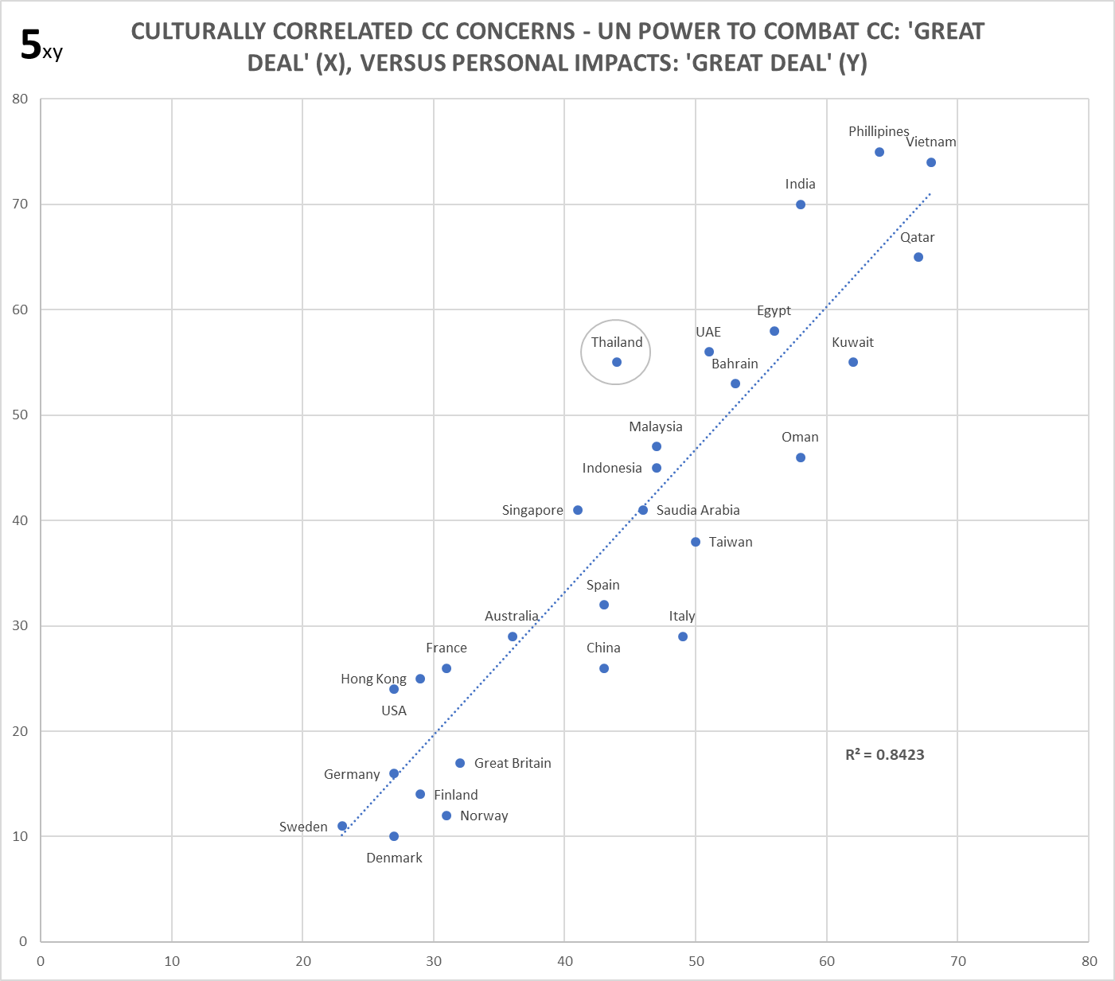

Chart 6 similarly compares responses to the climate survey question used for Chart 4, and the non-cultural responses to the question used for Chart F1. As expected, there isn’t correlation; ‘r’ = -0.017.

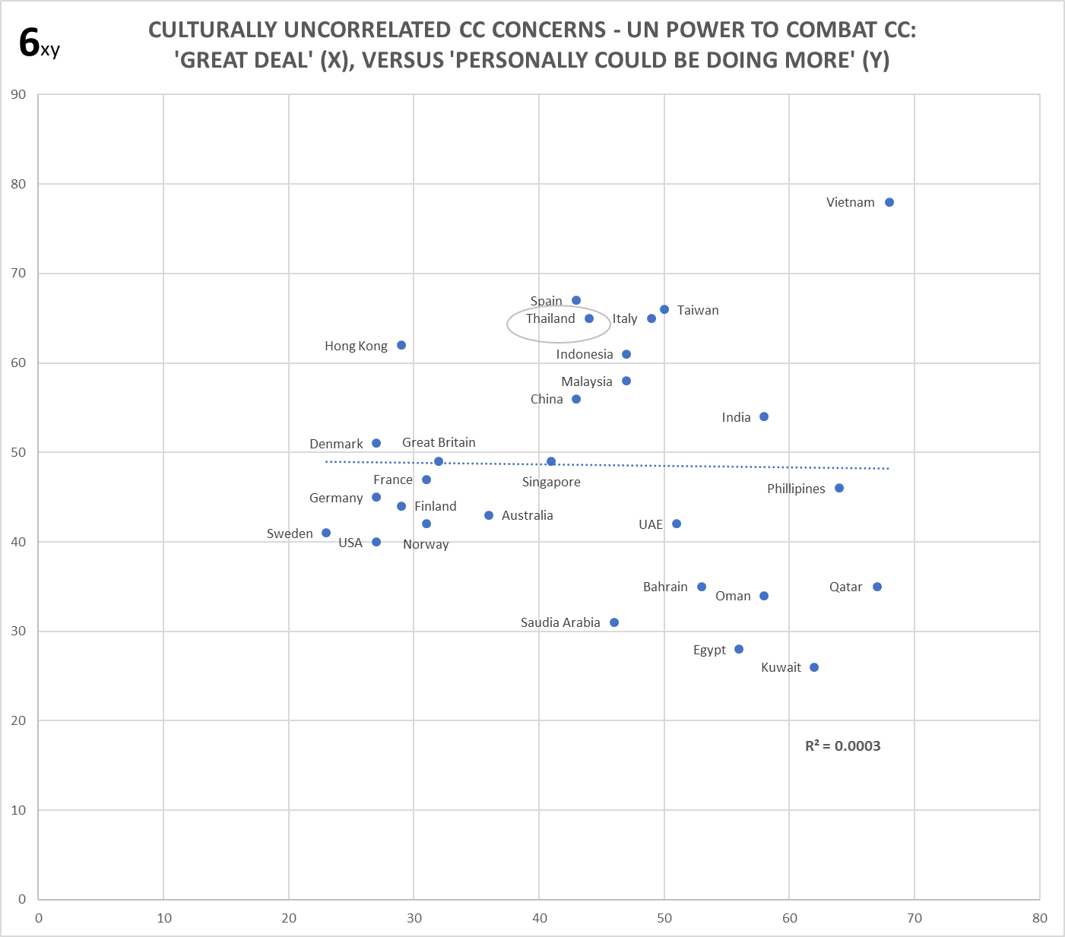

The set is completed by plotting the 2 non-cultural responses from Section 7. As expected, they also don’t correlate (and look very different to Chart 6 too). See Chart F3 at the Excel file link below.

While these minor checks do not circumvent the problem that codifying the climate cultural engagement of questions is very difficult, we know from else-where that there’s a strong cultural drive in the climate-change domain, and that it isn’t rationality driving these correlated responses. Consider for instance the response ‘a great deal’ to the question: ‘How much of an impact, if any, do you believe climate change will have on your life?’ Not only do national publics have no knowledge of what 10 to 60 year impacts will be within national (or for the larger geographical countries, sub-national) boundaries, even climate experts have little (and conflicting) knowledge about this (yet) regarding most nations / regions. [Nor can we rule out some responders having prescribed policy impacts in mind rather than direct climate-change impacts, such as giving up gas-heating or their petrol car]. Nor is ‘a great deal’ physically bounded; it’ll have a huge range of interpretation across and within various publics. So, it’s essentially impossible that rationality can be determining the responses of these publics. The response is cultural, driven by emotive extremes within climate-change narratives, and if it wasn’t, no strong correlation with religiosity should be observed anyhow. [The third post of this series probes what appears to be a very modest contribution from rationality across nations, even to the most objective survey questions].

9. Sharpening the picture

Knowing that the ‘S’ shaped skew is an intrinsic feature of the religiosity scale in isolation, and indeed is almost identical for an alternate set of nations⁷, means it’s reasonable to iron out this bias (whether it’s due to self-assessment error^{7a} or any other measurement issue) so we can better see the true relationship between religiosity and climate concern without it. Footnote 12 provides detail. Chart 7 is the resulting picture for Chart 2 redrawn in this manner. Seeing each series independently is no longer necessary, so the plot is straight x/y. [Chart F7 in the Excel datafile, is the equivalent for the redrawn Chart 4].

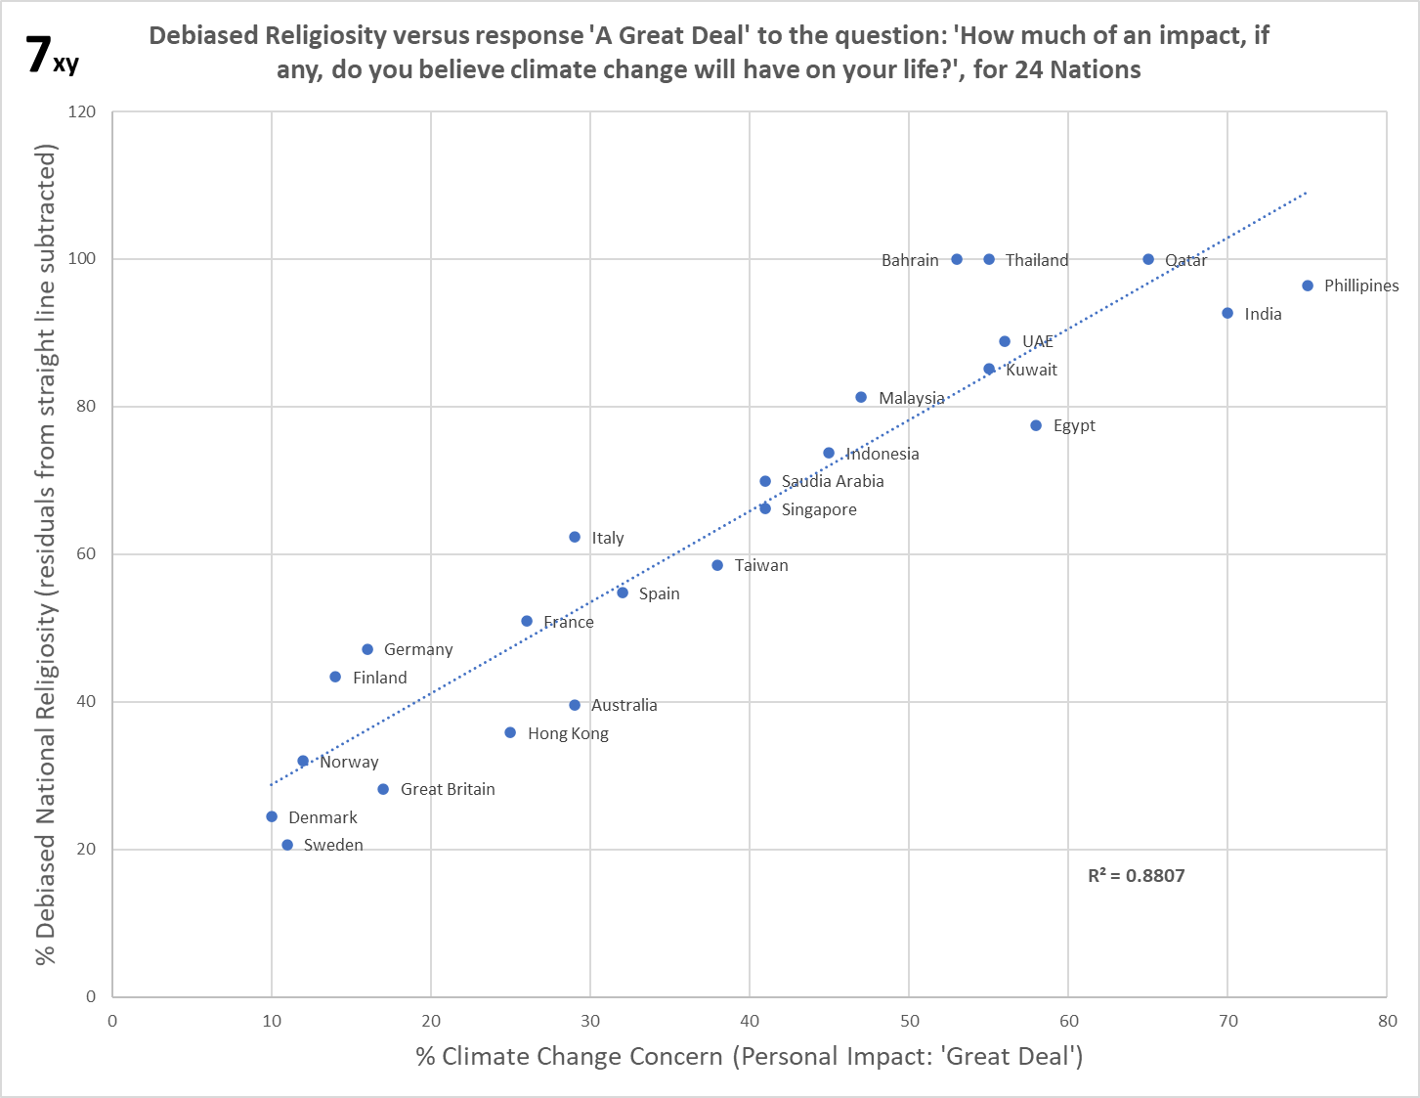

Note: Because the ‘S’ shape straddled the trend fairly evenly, this exercise has little impact on r (0.92 to 0.94, for Chart 2 to 7). This view also allows us to see that Bahrain and Thailand, which along with Qatar maxed out at 100% religiosity via the debiasing process, are now the biggest outliers. Bahrain is one of 4 Islamic nations for which religiosity is only single-sourced³, and Thailand has a naughty mark from Chart 4 (only); these aren’t reasons for removal, just cautions to stay watchful on those nations.

10. Taking stock

Affirmative belief in personal impact from climate-change is culturally aligned. So is belief in the power of the UN to save us from climate-change. Opinion on whether India or whoever has emitted the most ACO2, loses direct cultural alignment. Likewise, for personally could be doing more to tackle climate change. The first two angles are more fundamental than the second two, and cultural belief will similarly dominate public opinion on other CC fundamentals. Per Chart 5 the former views are easily the most cohesive too, exactly because they’re cultural / emotive. And cohesive + fundamental, emerges as most important. Primary affirmative views are driven by culture [in Post 3 – those lesser views mostly too!]
However, the robust relationship depicted above doesn’t prove that the main cultural mechanism is the disablement of Innate Skepticism to CCCC. Alternate explanations for the correlation are possible, albeit given the nature of religion any such can’t avoid a cultural dimension. Footnote 13 outlines a (weak, imo) candidate, and there could be others I’m unaware of. However, I believe the case is strong, and also gels with further data in the coming posts. Regarding the US and Vietnam exceptions, the same principles can theoretically map the greater complexity for the former, hopefully the latter too.

Notwithstanding such cautions / exceptions, via a simple relationship: Globally, can Religiosity predict Cultural Climate Beliefs? Well, Chart 7 (and F7) could hardly be more supportive of this, and even the ‘doomster only’ response scrapes the test. But… cultural effects are rarely intuitive. So for instance, if one assumes that nations in Chart 7 which have high levels of climate concern (and religiosity), are also those with more climate-change activism, and / or stronger / more emissions reduction policies, this is very wrong! The Scandinavian nations or the UK, say, at the bottom, score very high for both of these areas, and Europe generally scores more than the higher religiosity nations at the top. So, do climate surveys not reflect reality? What is going on?

Well, it turns out that the surveys very much reflect reality. But there’s two strong relationships between CCCC and religiosity, which are very divergent and supported by two different types of belief. Of which this post demonstrates only the first. To get into the prediction game (of both beliefs and the behaviors they drive) we must also characterize the second relationship, which as hinted at the beginning comes from reality-constrained surveys. From which in turn, the apparent paradox above and others too, are explainable via the total cultural effects in play. So…

11. The next post

Is…
“Apparent Paradoxes in the relationship of Climate ‘Concerns, Skepticism, Activism, and Priority’, explained by Religiosity’: Reveals the presence of Allied and Core belief in the culture of climate catastrophe, and the relationships of these to religiosity plus Climate Change Activism (XR and Children’s Strikes for Climate)”.

…which covers the introduction of more data (and nations, up to 48 for the second relationship), but which also gets deep into paydirt, so what these relationships mean for real-world phenomena such as climate activism, and (in the third post) elite attitudes plus policy penetration.

