Apparent Paradoxes in the relationship of Climate ‘Concerns, Skepticism, Activism, and Priority’, explained by Religiosity – Footnotes File
For Post 2 of the ABel/CBel series of 3: ‘Globally, Religiosity predicts Cultural Climate Beliefs’.
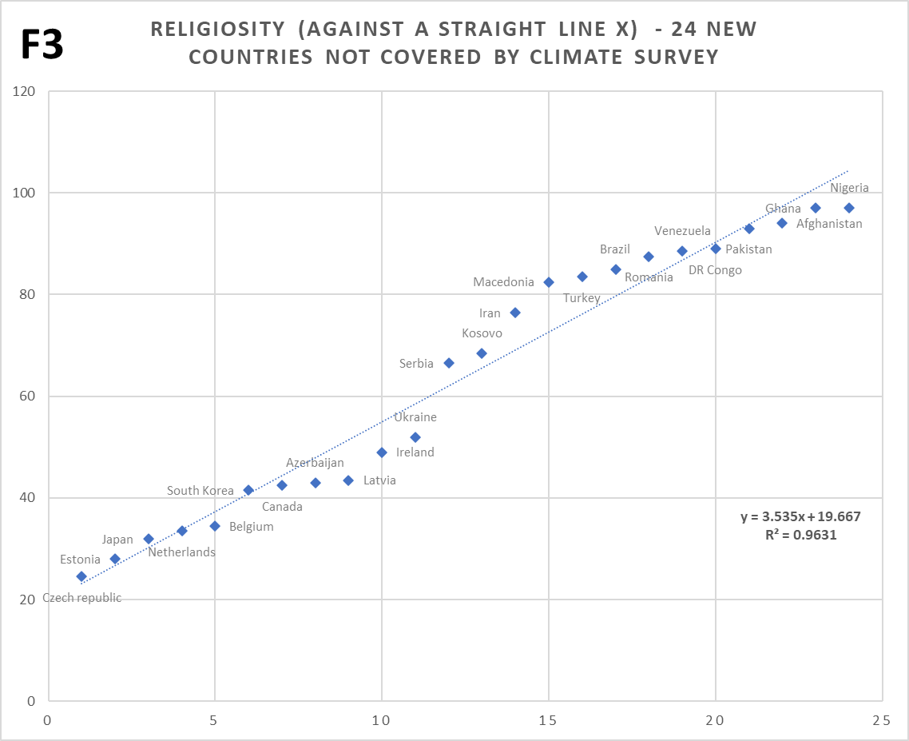
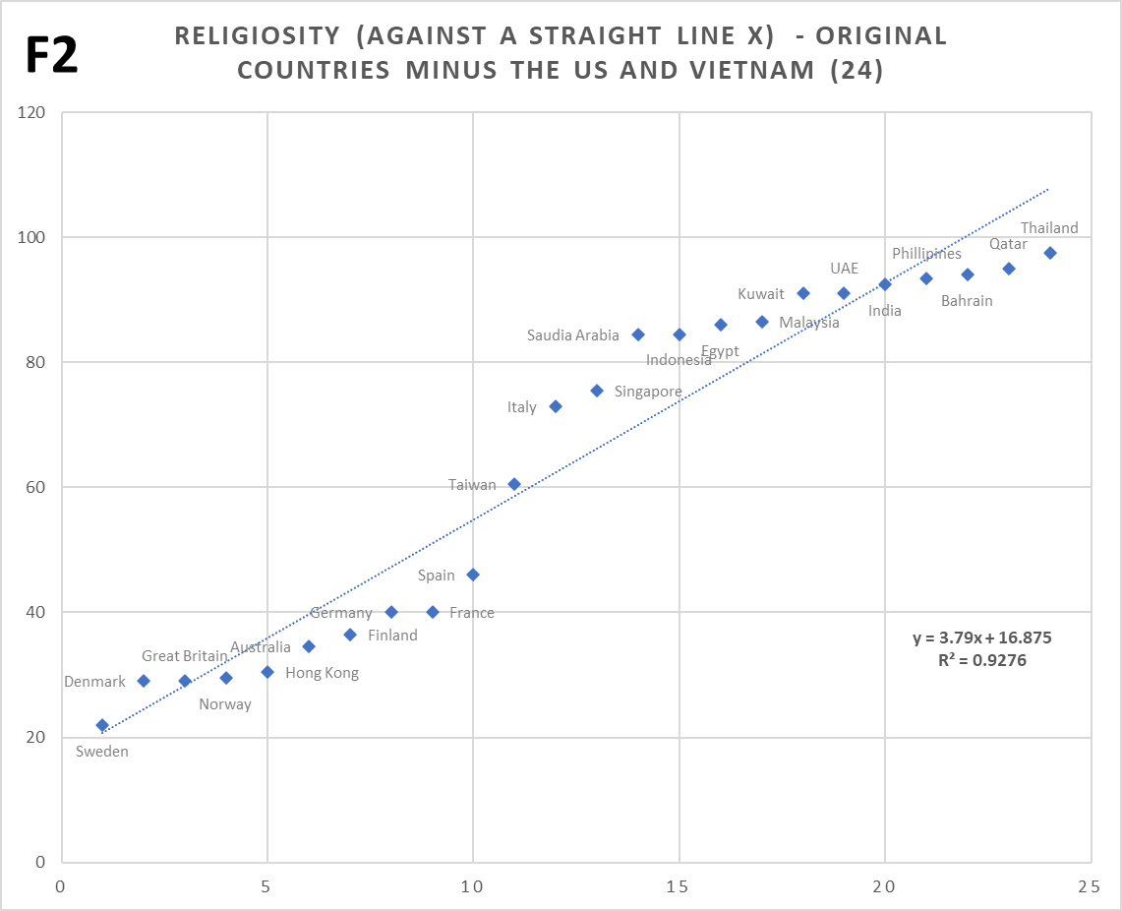
1. The ‘S’ shaped straddle of religiosity about its own linear trend, strongly suggests that this shape has nothing to do with climate concerns. See Post 1 and related footnotes for expanded detail; a compressed version follows: I figured that this straddle is very likely an inherent feature of my religiosity scale, in isolation. Note, the same shape appears on all the Charts 1 to 4 of Post 1. And indeed, when religiosity values are simply arranged in strict order (Chart F2, repeated below) i.e. with no reference at all to any other variables, the same ‘S’ shape appears.
Not only that, but an entirely different set of nations covered by the two main religiosity sources, shows a virtually identical shape too (Chart F3, repeated above). Thus, this ‘S’ shape isn’t just a random feature of the original set of nations, and must emerge generically from the combined religiosity scale.
The main candidate for this shape is self-assessment bias. i.e. not just bias caused by the formal pressure from authority in some nations (against faith, or against a lack of faith). Though the latter occurs, a more widespread effect would likely be biased assessment by individuals themselves, due to the social need to conform to perceived norms and peers (a subconscious effect). [See the first post, Footnote 7a, for why self-assessment bias is much more likely than the skewed values reflecting reality].
So, in highly religious nations, individuals would likely over-assess themselves compared to the reality of their actual behavior and beliefs, while oppositely where low religiosity is the accepted norm, they would likely under-assess relative to their actual behavior and beliefs. Such bias would likely be worse nearer the switch point between high / low religiosity, because cultural defensiveness / aggression is likely greatest when a majority is threatened or (going the other way) in reach. I’ve no idea why this isn’t symmetrical about the 50% mark though; the balance-point seems to be about 60% religiosity. In the very highly religious nations, the level of bias must tail off as ‘actual’ religiosity approaches 100%, because obviously no individuals or nations can exceed this level. In practice, even the most highly religious nations will have 2 or 3% of disbelievers, unless this is indeed forbidden by law or highly discouraged.
De-biasing is simply achieved by finding the residuals of the plot of religiosity against a straight line, and subtracting these from the religiosity scale for the main charts. [Chart F2 provides the residuals to debias Charts 1, F1, 2, 3 and F6, Chart F3/3+ provides the residuals to debias Charts F4 and F5, and Chart F7 debiases for Charts 4 and 5]. Note: Because the ‘S’ shape straddled the trend fairly evenly, this exercise has little impact upon r in each case.
2. Consistency check that there isn’t a separate effect in Chart 2 regarding the apparent horizontal grouping of nations between ~18 and 23%. To get an alternate view, I charted the same UN poll figures against religiosity for a raft of 24 new nations (not covered by the original YouGov climate survey). The nations I (re)used are mainly those for Chart F3 (above), which came from looking at the ‘S’ shaped straddle on the religiosity scale. However, Macedonia isn’t in the UN poll, so I switched this to Bulgaria, which is geographically close. South Korea also isn’t in the UN poll and there’s no geographically close nation that isn’t already used, so I simply used another nation starting with S, Slovenia. As can be seen (Chart F5 is repeated below), the anti-correlation is looser still here (although maintaining significance), yet is evenly spread even at the high religiosity end. Well, apart from Pakistan, but the point is that there is no odd horizontal grouping, so I proceeded here on the assumption that all was well. However, I later moved onto a much deeper exploration of the high variability about trend for both Chart F5 and the orange series in Chart 2; this variability seemed too much for just noise and had the look of something systemic. From this exploration came Charts 4 and 5. All original charts / data are in the Excel datafile.
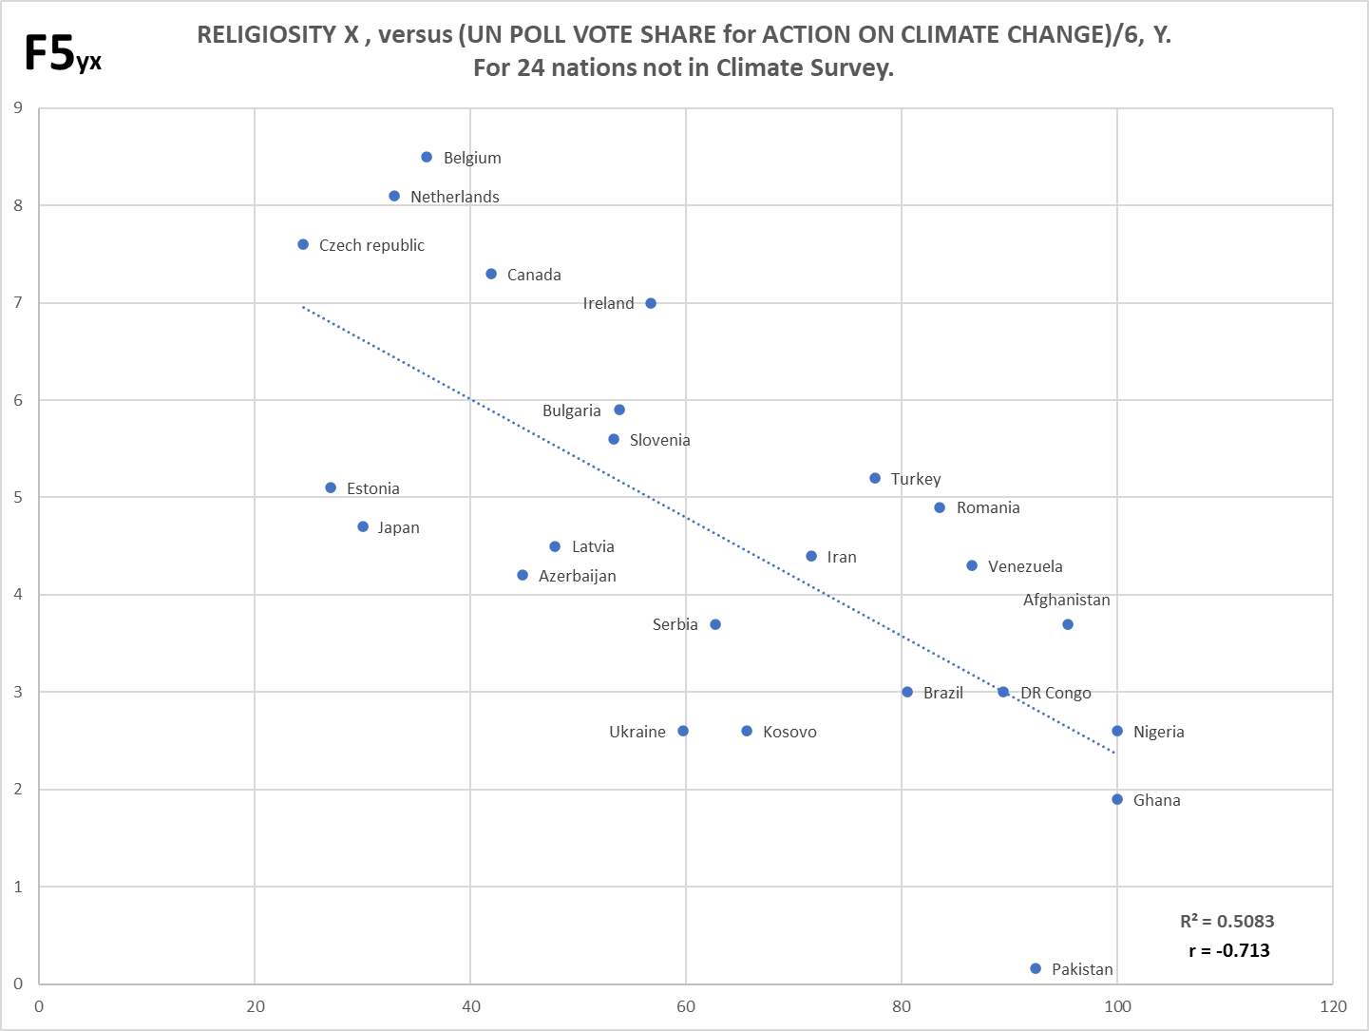
3. Persons for whom religion is more important typically have stronger and much more focused cultural values to defend. This doesn’t mean irreligious folks can’t be committed to strong culture too, but the mainstream faiths are much older / more established and quite encompassing of whole life roles. Newer secular cultures are not typically so encompassing (although can be, for instance in extreme regimes as seen on both left and right), and several at once in a society can create a more balanced cultural diet, so to speak – they can’t afford to be so exclusive if they want adherents (neither always can religions now I guess, but they tend still to operate in modes of times past). So, when a religious adherent is questioned in such a manner that their value-set as created by or at least influenced by their faith, is also challenged, they can respond with strong resistance (ISk) to the challenge; they have more at stake so to speak.

4. There’s much variety in how reality-constrained surveys actually impose their constraints, which results in a range of constraint strengths and corresponding responses. The more the strength rises, the more people have to really believe in a particular issue if they’re still to grant it maximal support against the real-world constraint(s). The most common format asks respondents to pick their most important X issues out of Y other (hopefully) important choices. The strength of the constraint rises as X becomes a smaller subset of Y, but also depending upon what the whole Y set actually is compared to what issues actually matter to respondents (there can be good or poor alignment regarding these). So, a choice of 3 issues out of 10 (where the 3 chosen includes the one we’re interested in, say climate change) survives a weaker constraint than 1 out of 10; in the latter case responders have to believe still more that CC truly supersedes all other issues. 1 out of say 20 is much stronger still, because there are yet more (hopefully relevant and important) issues to compete for the top slot. Indeed, climate change support not infrequently comes last in some nations for lists around 17 or so, suggesting that maybe at least 20 may be needed to find this issue’s natural depth in such nations. Padding lists with relatively unimportant issues is a way to promote the apparent public support for an issue, when in truth it may not survive a real test against the issues which citizens truly regard as important. Even when being scrupulously fair, some lists are weaker than others. For instance, most people rank local issues (which is to say within a global context, national) above global ones. Questioning the personal financial commitment respondents would make to an issue, is an alternate way of introducing reality constraint. No doubt there are more.
5. The faint red trend-line on Chart 3 is Strongly-Constrained Belief, but not ‘fully’ constrained. The trend comes from a two-survey composite, see Footnote 5a below for details on the component series. As noted in Footnote 4 above, global issues within a reality-constrained list (in this case ‘world threats’) are typically perceived as less ‘real’, less of a constraint, than local (i.e. national) issues that have more of a direct impact on individuals, particularly if the global issues are also on a further time horizon, which at any moment in time is usually the case for most global threats (current Covid-19 notwithstanding!) Hence, despite being a single choice which makes for strength, the above plus a list of only 9 issues in total to choose from, means this (composite) series is still far from an ultimate strength constraint. Issues primarily about climate change not infrequently touch bottom out of 17 or 18 total, so in principle a list-length of maybe 20 is needed for full strength, although 17 is probably near enough in practice. Footnote 5b below, gives details on the ultimate strength constraint data shown as red crosses on Chart 3.
5a. The faint red trend-line in Chart 3 is from a two-survey composite covering 16 nations. The first is a YouGov 2016 survey on world threats. The figure from the ‘single’ column represents the single choice of the most serious threat as perceived by each nation. The choice is made out of 9 threats in total. The second survey is Eurobarometer 2017, which has an almost identical wording and for an almost identical list of threats. This means I can legitimately combine these two surveys to get more robust results for some nations and also increase slightly the number of covered nations (by 2, but for significance reasons these are important to capture!) The only difference is that YouGov has ‘limited energy resources’ as one of the threats, whereas the Eurobarometer has a freestyle ‘other’ instead, also having ‘none’ and ‘don’t know’. However, in the nations matching Chart 3 the % choices for all 4 of these options are very low, especially ‘none’, and the latter 3 added up aren’t a lot different to the former YouGov option in all cases. Hence, I ignored this trivial difference, maybe between about 1 and 3% depending on nation.
Some aspects of these surveys lead me to believe that attitudes to this kind of distant world threat format are rather casual, and the ‘bogey-man-of-the-day’ can win big, which may be climate change only when there isn’t another passing scare (real or imagined) on TV / media or UN / NGO campaigns. The default scare in recent years in Europe when something else is not passing, seems to be climate change. No doubt the same survey done now (April 2020) will pick up a huge increase of the option ‘spread in infectious diseases’. There’s some large shifts in the choice of terrorism in N European nations between the surveys, despite they are only a year apart. No doubt terrorist incidents drove a spike in one year but not the other, and rather bizarrely, France records an increase in the choice of ‘poverty hunger and lack of drinking water’, from 16% in YouGov to 37% in Eurobarometer. Anyhow, combining series should also provide more temporal stability for the nations that are doubled up (albeit this is only 6 out of the 16), yet also for the series as a whole where some of these variations are regional (i.e. affect several nations at once, like the terrorism thing). This still means some anomalies for individual nations; e.g. Norway is lower than I’d expect for climate change, very likely because it does not have a paired data-point in the Eurobarometer and is most definitely a northern nation with very high worry about terrorism in 2016 (35%).
Chart F6 in the accompanying Excel file shows the full data and trend for the composite series. Data sources are linked in the Excel file too.
5b. The red crosses on Chart 3 represent a handful of actual fully-constrained top priority choices. The data for these is shown just to the left of the original Chart 3 in the Excel datafile, in columns G to K. France, GB, Germany and Norway are covered by a European Perceptions of Climate Change (EPCC) survey supported by various partners, and a second GB measurement is from the Department of Energy and Climate Change, see ‘challenges’ tab, wave 13 / March 2015 figure. The latter is rather a short list for ‘ultimate strength’, but covering local (which is to say national, not global) issues, which make a big difference. The former largely covers local issues too, out of an excellently large list of 24. Data sources are linked in the Excel file too.
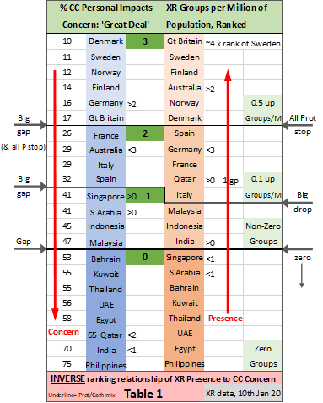
6. Table 1 details (table repeated below). In creating tiers within this table of XR presence (Groups per million of population – right), versus climate concern (Personal Impacts: Great Deal – left), I looked for natural breakpoints in the data that might also match left to right. On the LHS this is large gaps, the first two of which exceed the whole spread of the preceding sections (the third, equals that spread). The first such gap also aligns on the RHS with where there are no more ‘all Protestant’ European nations. This may be a useful marker because, long before CCCC arose (and so before any religious reaction to this strong culture, as revealed here, can have occurred) such nations have had a reputation as being more supportive of environmental causes. Protestant nations are also somewhat more flexible on secular-sponsored social changes, e.g. due to birth control, which may spill over into say modern practices for sustainability (these also present social challenges). All this may, or may not, correspond to a secondary qualitative difference that is not just about religiosity on its own. [Note: Australia sits within this top XR presence tier though, and has similar figures for Protestants and Catholics, of which the former is made up of various sub-groups.] The other two breakpoints on the RHS correspond to large drops in XR presence. The ‘<’ and ‘>’ symbols denote nations that don’t match within corresponding tiers, and where they come from / go to within the opposite column. All nations within the bottom tier on the RHS have zero XR presence. Qatar essentially makes it by chance into Tier 2 for XR presence; it has a single XR group and a very small population.
In mapping the RH column to the main post’s Chart 3, i.e. Tier 3 at leftmost and Tier 2 next leftmost after this, there happens to be an exact match (except for lucky Qatar) even though Germany and Australia are in swapped tiers regarding Climate Concern. However, this is because Australia is much higher than the (blue) Climate Concern trend, and Germany much lower; had they both been on trend, XR and Concern tiers would have matched, as well as the Chart. But I can’t know whether the XR ranking or the Concern figures are more ‘right’.
As noted within the main post, this is rough data on which only loose assessments can be made, but at minimum these are consistent with the proposition about where activism should occur most and least. Data on XR groups was sampled from their website on 10th January 2020.
7. Figures for ‘Children’s Strike Weekly’ (CSW) events per nation, are captured for all the nations in Chart 3, at column Q just to the right of Table 1 in the Excel datafile. These are divided by the national populations (column E) to give a ratio (column R) which is ranked (column S). The CSW event figures were sampled on 10th Jan 2020. Note in some countries (from recall this happens not to be the ones in Chart 3) there are certain other types of events, i.e. not the ‘weekly’ events.
8. Regarding the religiosity gap between children and adults for Spain and Italy, there are few surveys that involve children, so I looked at the (crude average) religiosity gap between younger and older adults, as compared to three other nations in the CSW top ten. The figures are in Table 2. While Italy and Finland have a slightly larger ‘youth’ religiosity gap than the UK and France, Spain has a much larger gap than all the other nations. This likely explains Spain’s high CSW ranking, but the explanation doesn’t hold for Italy unless a similar strength effect for children hasn’t yet surfaced as they mature to adults. The data comes from World Value Survey (WVS), Wave 5, 2005 to 2009. Not all countries have figures available. See the ‘Importance in Life: Religion’ category and cross with ‘Age’. Original captured data and links are in the Excel datafile.
9. The high variability about trend for both Chart F5 and the orange series in Chart 2, as noted in Footnote 4 above, seemed too much for just noise and also had the look of something systemic. An exploration of this resulted in Charts 4 and 5 (these are the same chart just color-coded differently, and with more added detail on Chart 5). Chart 4/5 is a combination of the 22 nations of the orange series from Chart 2, plus the consistency check of 24 nations from Chart F5, plus 2 more nations I used to beef up Chart F4 (Iraq and Morocco, the other F4 extra, Iran, was already in Chart F5). This produced a very respectable total of 48 nations, comprising a good mix of religions and development state and geographic regions. I did a new ‘all nations’ religiosity debias (see Footnote 1 above) for Chart 4/5 usage, in columns Y to AC just to the right of the original Chart 4 in the Excel datafile.
10. Main variability about the trend in Chart 5 is due to GDP per Capita ranking (GDPpCR). 9 of 13 (not greyed-out) nations forming the south-west band of the trend are below low (high number) GDPpCR thresholds per group [and for a) and b), per block too]. The threshold dividers are the dashed lines / values each in the color(s) of the religio-regional group(s) they divide. As the moniker implies, the value is a rank, set about halfway between the two nations nearest to the dividing line within each group. The GDPpCR thresholds mostly descend per block a) to d) as well, although they aren’t strictly constrained to given the blocks / groups have a certain amount of independence. [Regarding the exception, the GDPpCR for Egypt is 92, so the divider for the corresponding group / color could be set at say 90, meaning there would happen to be a descent of the thresholds in sequence. But I kept the same ‘halfway’ rule per above, for all of the groups]. Ireland, Italy and Qatar have the highest rank GDPpCR in their respective (colored) groups (and in fact Qatar has the highest for all of the nations charted); these nations all form part of the north-east edge.
The GDP per Capita values came from the IMF (2017) as reported by Wiki, last accessed 2nd April 2020. The values are recorded by religio-regional group (with threshold values) in columns B to E of the Excel datafile, to the left of the original for Chart 5. [The greyed-out nations are too unique or not near to any others charted, to belong to any religio-regional group. Thus they have no peers to compare GDP against].
11. Chart F4 shows the correlation between IHDI (Y) and the UN Poll Vote Share for Action on Climate Change (X). Most of the 22 nations from Chart 3 are covered, but there’s no IHDI value available for several of the Middle Eastern / Islamic nations (Qatar, UAE, Kuwait, Saudi Arabia, Bahrain), and also Malaysia. To make up for this loss I added Iran, Iraq and Morocco, of which the former two at least are roughly regional to the Middle East grouping. I later realized that Morocco doesn’t actually have an IHDI either (I’d misread the column and used an ordinary HDI), so I neutered this back out. However, I carried forward all of Iran, Iraq and Morocco to other charts as well (that don’t need IHDI). The IHDI figures are from the UNITED NATIONS DEVELOPMENT PROGRAMME Human Development Reports.
12. Cultures often compete and cooperate with each other simultaneously, though if the net result is very much shifted to one end or the other of the spectrum, the dual nature can likely be ignored for most purposes. In the case of CCCC and religion, there seems to be more of a balance. The high correlation represented by ABel shows a surface alliance, but if that alliance went a lot deeper, then CBel, while probably being much smaller than ABel, would slope in the same direction as ABel / religiosity, rather than anti-correlating. It is this anti-correlation which shows that religious nations are not taking onboard the deep values of CCCC, hence reacting as though CCCC is, or at least could be, a competitor. [Note: cultures are neither sentient or even agential, all their ‘choices’ are made purely upon the selection of (emotive) narratives, despite available descriptors in our language tend to lend an (unintended) air of sentience]. There is also circumstantial evidence that religions are not furthering the surface relationship with CCCC. If this were the case, we ought to see a significant exchanging of core cultural narratives that operationally are transmitted across the networks of both cultures, i.e. within communities and field leaders, regularly, not just posturing statements by the top brass. Such an arrangement is the case for the New Green Deal that both the CCCC and Lib/Dem networks promote as shared / exchanged narrative, despite a very serious commitment cost to both cultures. Precious little of this truly shared commitment / narrative appears to happen operationally between CCCC and the major faiths.

