Apparent Paradoxes in the relationship of Climate ‘Concerns, Skepticism, Activism, and Priority’, explained by Religiosity
Explores the contrast between Allied and Core belief in the culture of climate catastrophe, and the relationships of these plus religiosity to Climate Change Activism (XR and Children’s Strikes for Climate). Post 2 of 3.
1. Introduction
The opening post of this series demonstrated a strong correlation between religiosity per nation, and the responses per nation aligned to Catastrophic Climate Change Culture (CCCC), in a 2019 YouGov survey on attitudes to climate-change. [US readers especially please note: due to unusual cultural features per the prior post, the US (and Vietnam too) are exceptions to this correlation]. Examples of cultural responses to the survey include the answer ‘A great deal’ to the questions: ‘How much of an impact, if any, do you believe climate change will have on your life?’ and, ‘how much power, if any, do you think international bodies (e.g. the United Nations) have to combat climate change?’ In contrast, affirmatives to statements such as ‘The climate is changing and human activity is mainly responsible’, aren’t primarily motivated by (emotive) CCCC alignment. Likewise for responses to: ‘do you think that you personally could be doing more to tackle climate change?’ for which a lack of correlation was indeed shown for the ‘could be doing more’ answers. See the prior post for why responses do / don’t provoke a dominantly cultural response.
So, Chart 1 below was shown at the end of the prior post, though is depicted here with the X and Y axes reversed as further results will be overlaid later using a secondary Y axis. Y values show the percentage of ‘A great deal’ responses to the first of the climate survey questions quoted in the above paragraph.
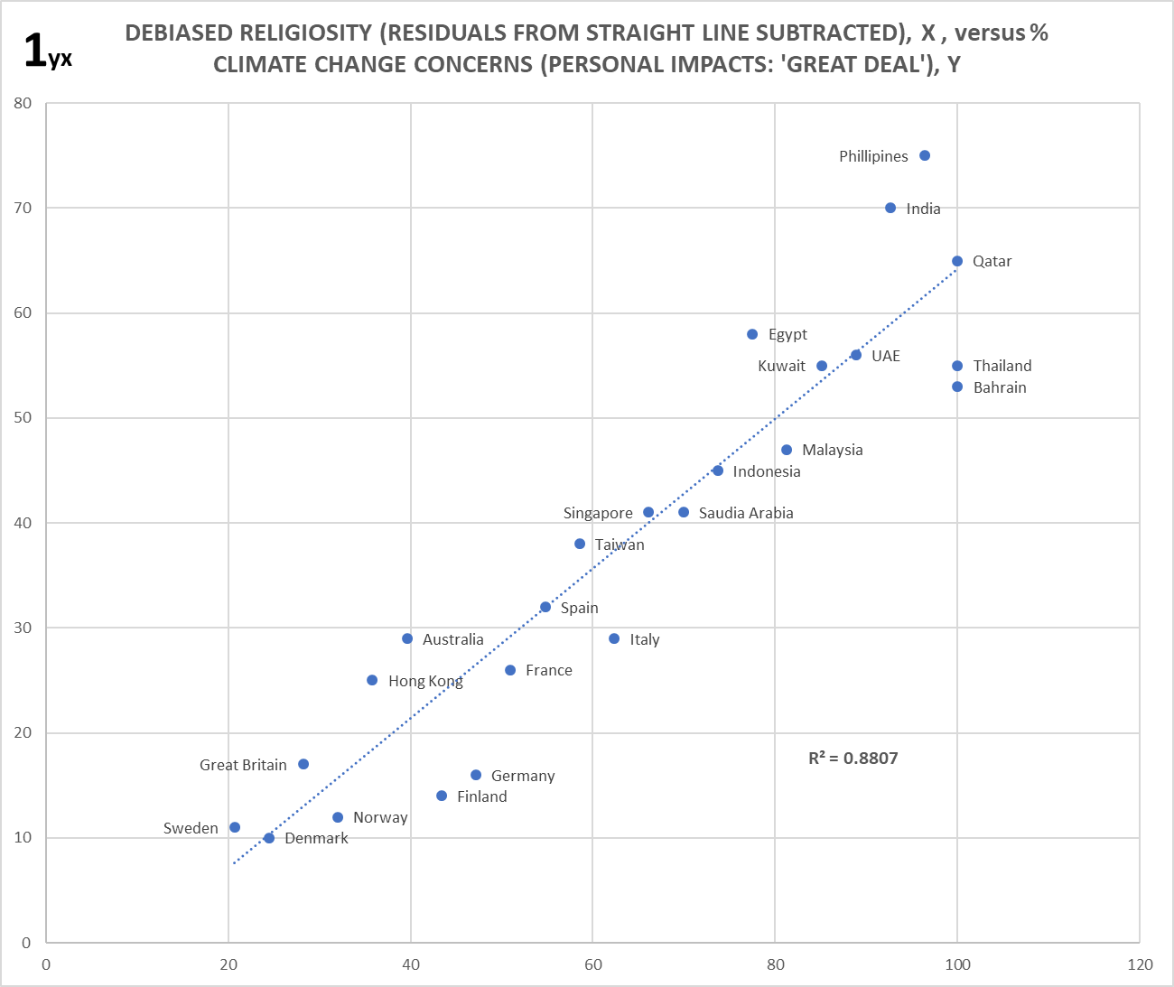
Note: See Footnote 1 with regard to ironing out the (prior) minor ‘S’ shaped skew that occurred on the religiosity scale in isolation; likely due to self-reporting bias. Note: The US can be figured out via the same cultural principles, but it’s more complex; the simpler rules here don’t hold. See the prior post.
As previously set out, my proposition says the demonstrated correlation is due to the (weak) relationship between CCCC and religious faiths globally, which is sufficient to disable Innate Skepticism (ISk) about CCCC in most religious adherents. Thus, as religiosity rises within nations (going left to right), ISk about CCCC narratives falls, and so belief in said narratives rises. Note: ISk is an instinctive mechanism that is very different to rational skepticism.
2. Allied Belief, Constrained Belief, and Core Belief
Because ISk is disabled by a weak alliance with religious faiths, Chart 1 represents what I have termed ‘Allied Belief’ (ABel). In line with the above proposition, survey questions less engaging of CCCC, i.e. less existential / emotive, produce shallower gradients than this blue series. So for instance Chart 2 shows the same blue series, while also the pink series represents the percentage of ‘A great deal’ responses to the second of the climate survey questions quoted within Section 1. [This pink series corresponds to the prior post’s Chart F8, and is kept faint to reduce clutter; only the reduced gradient is relevant]. As theoretical series similar to the pink achieve less and less gradient, they’d likely soon dissolve altogether as cultural significance is lost in the noise.
ABel trends as represented by both the pink and blue series, are an expectation regarding survey questions that don’t impose a constraint on cultural responses via the introduction of other real-world issues (hence: unconstrained surveys, UC-surveys). If such constraints are imposed, either in a reality scenario or indeed via a reality constrained survey (hence: RC-survey), very different reactions (and so trends) result. The orange series in Chart 2 plots results from an RC-survey, in fact the enormous 2015 UN ‘My World’ poll having ~10 million participants from many nations. In this case, constraint arises from having to rank any desire for action on climate change against other global threats, albeit the constraint here is weak; there’s scope to choose as many as 6 priority issues out of 17. Note: the orange scale, the percentage vote-share for action on climate change from this poll, is smaller than the blue. Nations correspond vertically; there’s now only 22 as the UN poll doesn’t cover Taiwan and Hong-Kong.

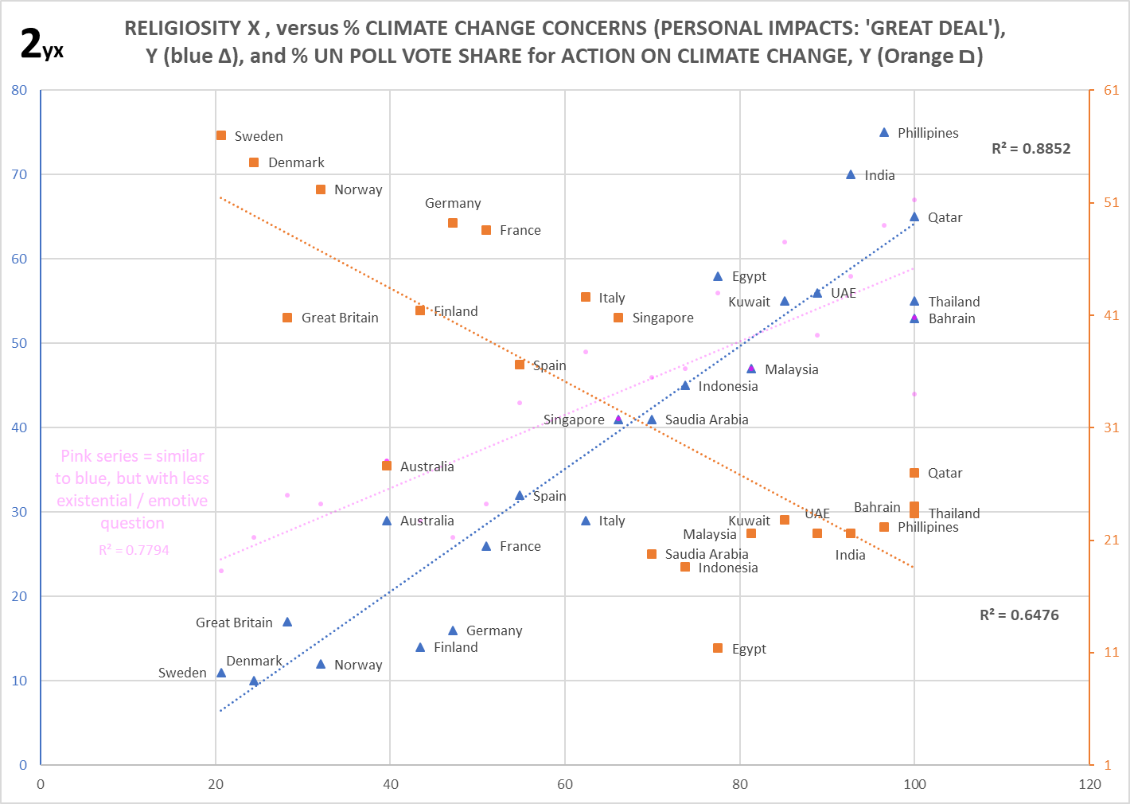

So, there’s apparent paradoxes here! Those nations expressing the highest concerns about climate-change (and inclusive of more faith in the UN to fix it), also express the lowest desire for climate-change action. And oppositely at the LHS. However, this fits fine with what’s likely to be going on regarding the underlying cultural mechanics. But before delving into that, a brief detour regarding a possible oddity…

The orange series anti-correlation with religiosity is rather looser than the blue series correlation. Enough latitude therefore that the apparent horizontal grouping of higher religiosity nations between ~18 and 23% within the former, is likely due just to noise. But this might instead be due to some unknown non-linear effect, maybe with a threshold level. For a basic consistency check, I charted the same UN poll figures against religiosity for an alternate raft of 24 nations (not covered by the original YouGov climate survey). The anti-correlation is looser still here (although maintaining significance), yet is evenly spread even at the high religiosity end. So, I proceeded here on the assumption there is not a separate effect regarding the orange series nations between ~18 and 23%. [See Footnote 2, Chart F5 in the Excel file, and 7 below].
So, back to that apparent paradox. The ‘constraint’ in RC-surveys occurs by forcing real-world context, e.g. via a list of issues that have to be ranked in some manner, or querying personal $ commitment to a particular issue. Regarding climate-change, this creates two effects. Firstly, the issue is forced down to Earth so to speak, robbing a great deal of the emotive power of the climate catastrophe narrative. Yet at the same time, cost and consequence is introduced wrt all the other important issues that are needful in our societies, in turn challenging existing value sets within those societies. [Even moderate consequence and cost via such a question type, is a big difference to ~nothing for unconstrained questions]. For a weak constraint, which is the case for the climate question in the UN poll, the first of these effects wins out for the mainly irreligious people. While ISk has far from disappeared (about half the population of nations towards LH end of the orange series, still place action on climate-change lower than their top 6 issues), skepticism appears much reduced compared to the LH ends of the blue and pink series. There is less emotive power to invoke it. However, the constraint weakness / low minimum cost-commitment, even allows the climate catastrophe narrative to be defied by many of those who did set the issue within their top 6. Given this narrative claims an absolutely screaming urgency above everything else, and from an ultimate authority too (‘the science’), ranking it below e.g. education and freedom from persecution and healthcare, does constitute such defiance. Albeit national publics have essentially no climate literacy from which to make an informed decision, one might say this is at least an attempt at rationality. But the really interesting reaction comes from the mainly religious people.
Although the UN poll constrains pretty weakly, the loss of emotive power / alignment to CCCC narrative is apparently enough to dissolve the subconscious reassurance in religious folks that this topic is allied to their values, to their faith. I presume they don’t subconsciously feel the proclaimed alliance any longer. Hence their ISk, which had been disabled by this reassurance, springs into action. And given also they have stronger and much more focused cultural values to defend³, which additionally are now challenged by societal consequences / costs, that ISk comes in big. So, going left to right, the total ISk of nations now rises with religiosity until at the RH end of the orange series, the vote share for climate action is only at about 20% of their populations, despite this being in direct contradiction to their ABel expressed via the blue (and weaker, pink) series. I term this reaction, ‘constrained belief’ (ConBel).
There’s much variety in how surveys constrain. For instance, even for commonly used issue lists: How many issues? How many to select out of them? Are they all genuinely felt concerns? How closely felt (e.g. national versus international, for the former, country relevant?). And so on; Footnote 4 provides more detail. This will produce a range of constraint strengths. And as this strength rises, less and less people (religious and irreligious) will still commit to the support of CCCC narratives above the other concerns.
Visually, the orange line in Chart 2 would fall with more constraint strength, yet still slope proportionally down to the right. Ultimately, with a long list of very relevant issues from which just one must be picked, most of those still supporting CCCC narratives above all else are doing so out of emotive commitment to CCCC itself, in the same manner as with devout religious belief. The irreligious skeptical folks we know exist from the blue ABel series, will all have bailed-out, as will religious folks whose ISk is now enabled too. Thus, while none of these belief types are fixed quantities, this should leave a firmish ‘core’ level of belief per nation in CCCC. I termed this belief revealed via the ultimate strength constraint, Core Belief (CBel). It’s rather easier to grasp these things visually, so Chart 3 portrays the big picture.
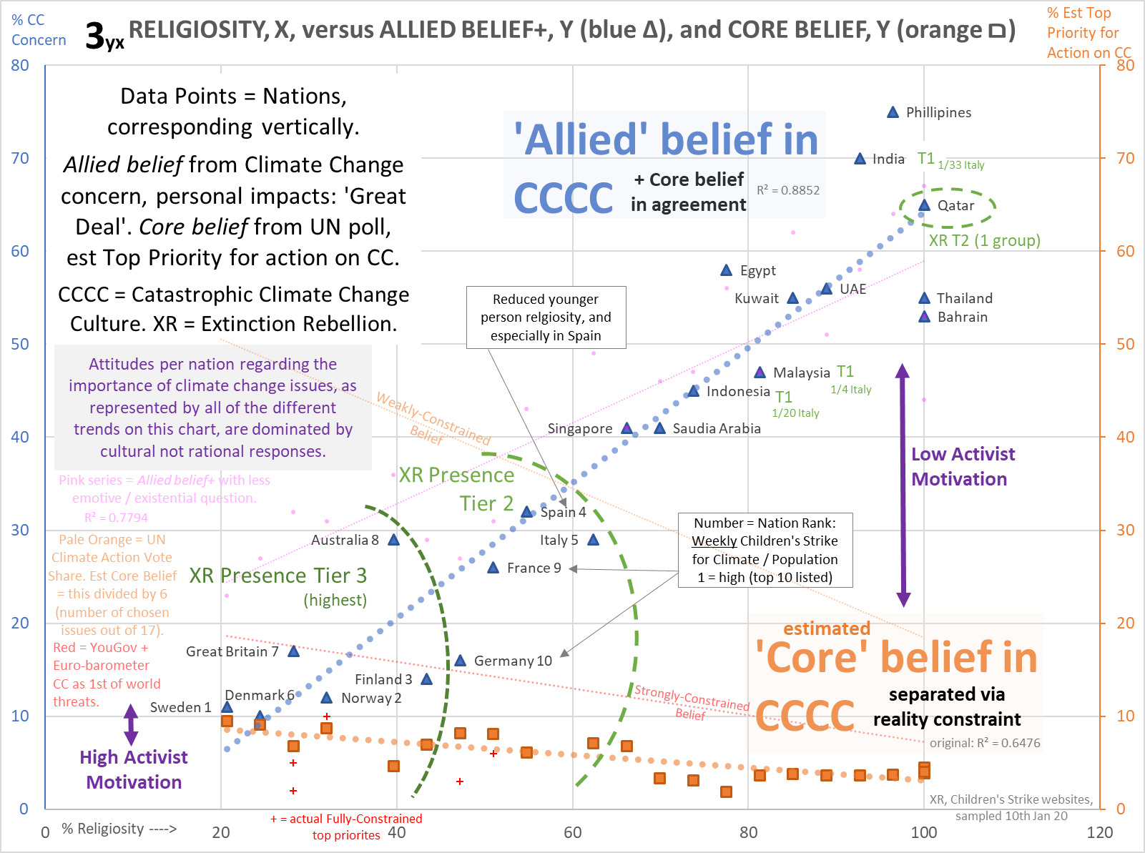
There’s a lot of other info on the chart, which we’ll come to later. It’s probably too small here to easily see detail; look at the original in the Excel datafile. The thick blue series is the same as in Chart 2, and represents ABel. The faint pink series is shallower ABel, also the same as in Chart 2. From the orange series in Chart 2, only the (now faint) trend-line is shown here, representing Weakly-Constrained Belief.
3. CBel estimation / measurement
The problem with attempting to measure CBel, is that there’s few ‘fully constrained’ surveys around, and afaik none that cover a wide range of nations with similar method. But CBel can be estimated. A simple way is to just divide the UN Poll vote-share for action on climate-change, by 6; the reasonable assumption of evenly distributed votes on the selected issues means this is how many would have chosen that option as their top priority. The thick orange line represents this estimated CBel. While being asked to make that top single-choice directly is a different context, which might skew the estimate somewhat, we can also box CBel in via measurement.
The faint red trend-line is from a two-survey composite covering 16 of the nations in Chart 3, which are much more strongly-constraining than the UN poll, albeit not fully (see Footnote 5 for why, and Chart F6 in the Excel file for full data). While achieving significance and approximately the expected trend this composite is not without issues^{5a}, yet it’s a great indicator. The red crosses^{5b} represent a handful of actual fully-constrained top priority choices, of which 2 for GB. With such low percentages, any signal might well be lost in the noise. But if nothing else they tell us that estimated Cbel is within the right ball-park at the LH side, possibly hinting it’s a little high. Pending better evidence, I use the thick orange line as my CBel going forward.
4. CBel / Abel amounts, and resulting expectations for Climate Activism
Having isolated CBel the first thing to note is that, because core believers will respond positively to both constrained or unconstrained questions testing for support of climate-change issues, the blue (and pink) ABel responses will contain some CBel too (as noted in the chart legend). However, CBel is far smaller than ABel across most of Chart 3. Where this is not so at the LHS, moving from pink to blue, i.e. to a more emotive and personal sub-narrative, simultaneously provokes more ISk and more response from core belief, though the former dominates. Cultures are polarizing engines; as in-group loyalty is invoked, out-group resistance likewise increases.
Subconsciously biased communicators for or against climate-change issues / support, can find comfort and claims at various places upon these trendlines. This increases confusion about what publics actually think, and cultures can take advantage of confusion. I’d be surprised though if communicators have any inkling about the global role of religiosity; no doubt they’ll see what they want to regarding motivations both ‘good’ and ‘bad’. However, a huge problem for CCCC adherents within irreligious nations, is that innate skepticism of any narratives that veer too much towards the existential / emotive, is huge. Yet cultures don’t work rationally and propagate / amplify such narratives at every opportunity, turning off a big majority of people even as they gain adherents. Similarly, any real-world strong constraint such as the sacrifice of petrol cars or gas heating, is likely only to achieve CBel levels of support at best. Though all lines change with time too (CCCC is growing) even lesser sacrifices won’t likely get support beyond the strongly constrained (red) line in Chart 3 – if the real-world clashes are properly communicated / realized, which may not necessarily be the case. [Note: the huge new reality-constraint of COVID-19 will highly likely squeeze the thick orange line down still further wrt priorities; minimal fervent believers only, albeit this effect could evaporate after a year or two. Cultures are typically very robust to such damage, and may even find ways to turn to advantage in the longer term].
This leads to enormous frustration for core believers within irreligious countries, but far less for those in religious countries where support will often seem very high (albeit being from ABel, it is ephemeral). So, regarding Climate Activism, we expect this to occur most in nations at the LHS of Chart 3, where core believers are defending their existential culture from the great majority of non-believers; and for cultures as for armies sometimes, attack (aggressive proselytization, civil disobedience) is a good form of defense. In very religious countries, there’s far less apparent need to rail against society, and less core believers to start with in order to maintain activism. So, we expect proportionally high activism at left, to low at right.
There are issues with attempting to demonstrate that climate activism conforms to this pattern. Orgs like Greenpeace and the WWF existed before climate-change was a big thing and support many environmental causes, hence dilute specifically CCCC support within wider concerns. And long-lived international orgs may also develop strategic or financial reasons for offices or other presence that isn’t simply a reflection of the local attitudes to their core mission. Brand new orgs spawned only to support CCCC, do not suffer from these issues. But OTOH they aren’t in relative equilibrium and are probably still expanding rapidly. So, it could be that a map of their presence reflects more a snapshot of expansion rather than the net status of national attitudes. Hence for either option the data was going to be rough; I went for the latter…
5. Extinction Rebellion conformance to expectation
Table 1 below shows the nations from Chart 3 above, ranked per the blue series in climate concern order (blue vertical stripe, lowest at top) against XR group presence for the same nations (beige vertical stripe, highest at top, presence is groups per million of population). That I’ve had to break the table into tiers to make clearer that there’s some correspondent structure between the two stripes, itself indicates alignment isn’t fantastic, and all hope of statistical confirmation is abandoned here! But also, the tiers aren’t wholly arbitrary and there’s approximate conformity tier to tier; and better still for XR tier placings upon Chart 3.
Footnote 6 explains in more detail (and the data is in the Xcel file). In short, the tiers mapped onto Chart 3, in green, do show the highest XR presence tier (3, dark-green) at the leftmost side, and the second-most XR presence tier (2, mid-green) covering the next few nations to the left. Excepting Qatar, which happens to have 1 XR group and a very low population, a lucky high-score. XR group presence within tier 1 is far lower, figures in green show fractions of the presence in Italy, which is the lowest nation in tier 2. There is zero XR presence for tier 0 nations. Hence, while the order of nations within tiers varies, there is some structural correspondence and this is anchored to more presence on the LHS. (As it happens, Great Britain at the top XR presence is massively higher; this is where the org was founded). Given the rough data, this is at least consistent with motivational expectations from ABel and CBel trends.
6. Implications for youth, and Children’s Strike conformance to expectation
The top ten ranking of ‘Children’s Strike Weekly’ (CSW) events per nation is mapped onto Chart 3, again as a ratio of national population; see the numbers trailing the nation name labels (1=highest). Footnote 7 and the Excel datafile provide details. Matching the section 4 expectation, this ranking once again picks out the leftmost nations, albeit ordered differently to the XR ranking. The data is likely too rough anyhow to expect the same ordering (of activism measures to each other, or to the exact trend prediction). In an example of noise / chance, single CSW events put Qatar (once again) and Bahrain just outside the top ten; both nations have very low populations. Plus, the founding nation of CSW (Sweden) gets a hugely higher absolute score, similarly to the XR case in the UK. However, despite all of this it’s noticeable that Spain and Italy seem rather far rightwards to achieve CSW scores of 4 and 5 respectively, which brings us to an issue specific to youth.
In Western nations where religion is receding (all of the top 10 CSW rankers match this), young adults are considerably less religious than older adults. While there are very few surveys involving children, this rule presumably extends downwards in age, given this is where young adults recently came from. So at the national level, children should behave as though they come from a nation rather to the left (on Chart 3) of their actual home nation. Which is to say, as a group having in theory less ABel so more skepticism, yet simultaneously more CBel so more climate activism (if allowed to pursue it, which may not always be the case). However, an issue with the ABel side of this is that, as noted within this previous post, children are primed to pick up cultural templates (as provided by CCCC), yet may not have developed a balancing ISk yet. So, children’s CBel could be even more amplified. While CSW presence does indeed seem much higher than XR presence for most nations, this is hardly robust, and I can’t think of any straightforward means to verify the expectation.
The religiosity gap separating children and adults can also be different per nation, which will explain at least some CSW ranking changes relative to XR, also to any data reflecting mainly adult attitudes. For the 2 nations of most interest, Spain and Italy, plus 3 others out of the CSW top 10 for comparison, I looked at the religiosity gap between younger and older adults. Spain does indeed have an unusually big gap. On the assumption of a similar effect between children and the average for all adults, this explains Spain’s high CSW ranking. However, the explanation doesn’t hold for Italy, unless a similar strength effect for children hasn’t yet surfaced as they mature to adults. See Footnote 8 for details.
As with section 5, the (CSW) data here is far from ideal and likely reflects several effects at once. While both are more consistent than I expected, confirmation work is needed to fully demonstrate that activism levels are predictable from the relationship of religiosity with CCCC (and an ancillary factor – see section 7). Note: ‘Child prophets and proselytizers of climate catastrophe’ focuses upon the interaction of CCCC with children, including a compare and contrast of other child pitches to authority and historic children’s movements, plus the widespread pushing upon susceptible children of a strong cultural template (CCCC, whose main narrative mainstream science agrees is false). And some fall-out wrt children’s anxieties.
7. The variability within ConBel / estimated CBel
Variability about the UN poll weak ConBel (or estimated CBel) trend, is significantly larger than for the (opposite direction) ABel trend. To investigate this further (noise? something systemic? something to do with individual faiths?), i.e. beyond the quick consistency check of F5, I created Chart 4 below. This is a combination of the orange series from Chart 2, plus the consistency check of Chart F5, plus two more nations I used for F4⁹. All nations have been color-coded to reflect their main faith(s). [Note: The Y scale happens to match estimated CBel, i.e. the original UN poll vote-share for climate action, divided by 6].
Considering the social profiles of these countries, there certainly seems to be structure within this plot over and above the downward trend with religiosity. And yet individual faiths don’t look like the main determinant for this. Given the influence of religion in society for say, Ghana, is much more similar to neighboring nations than to NW European Protestant nations, regionality is a big clue. The journey away from religiosity is as much if not more about the regions where this has advanced most, rather than faiths, although the particular faith(s) of some regions may still form a useful definitional factor. So, I re-colored to dilute the particular faiths and add a strong regional dimension, producing Chart 5.
There are 4 main religio-regional blocks, a) to d), within which further subdivisions (groups) are color-coded. The distribution of several different regions unfortunately overlaps inside c), so I’ve assisted the eye with line connections for a couple of groups. Note: greyed-out nations are too unique or too far from any others to associate, they remain only for reference. This representation reveals far more clearly the regional rather than faith-related nature of the trend in religiosity, albeit some regions / faiths essentially correspond. As some faiths span blocks, this helps to show that faiths behave the same everywhere. Yet some only occur in a subset, maybe just 1 block or subdivision thereof. And variability about the main trend is so large, it can’t be contained, so to speak, by some less sizeable faiths or regions. Meaning that looking exclusively inside either, the main trend may not just appear weak, but non-existent or reversed. However, clearly this variability isn’t to do with the faiths either. So, where does it from?
The above insight means the issue is addressable per religio-region; they’re likely pseudo-independent. And it turns out that a lot of the variability is coming from GDP per Capita ranking (GDPpCR). 9 of 13 (not greyed out) nations forming the bottom-most band of the trend are below low (high number) GDPpCR thresholds per group [and for a) and b), per block too]. There’s also some highest (low number) GDPpCR nations per group on the uppermost edge, plus an upper threshold in block a). Footnote 10 has detail. Likely, the remaining variability is noise.
So, for a given religiosity, the publics of less-wealthy nations (lower GDPpCR), are even less disposed to transfer any serious cultural allegiance from their religious faith to CCCC. This is opposite to what one would expect if these publics were clamoring for more climate-change $ from richer nations, albeit some governments may be. The more pressured financial circumstances will sharpen reality constraints still further, leading to still more ISk and less conversions into core belief. Such cultural mechanisms easily outbid a dream of filtered down $.
The number trailing the name-label of nations towards the top-left in Charts 4 & 5, is the national Electric Vehicle sales ranking. See the next post for expectations regarding these figures.
Note: In Footnote 13 on the first post of the series, I considered possible dependency of the ABel trend on IHDI, the Inequality adjusted Human Development Index (which anti-correlates well with religiosity). As noted there this possibility raises at least one major issue, however religiosity as the common factor that drives both, fits the data fine. Given the ConBel / CBel trend is opposite to ABel and hence correlates well with IHDI (see Footnote 11, and Chart F4 in the Excel datafile), I have to again consider possible dependency in this case. As Chart 4 shows, both religiosity and GDP-per-capita are factors in the ConBel / CBel trend plus variability. Yet a big factor of IHDI is about wealth, so there’s already a relationship between religiosity and GDP that in theory is independent of any climate domain issues. Completely untangling these factors may not be possible, but identifying which factors are main cause should be. I think the critical test here is the highest religiosity nations. For a constant factor such as national wealth, there’s no reason to suspect that attitudes to climate-change driven directly by the same, could radically shift from the highest national support to the lowest, depending only upon how the survey questions are framed. But there’s every reason to believe this would be the case for responses that are mostly cultural in nature; in this case the resultant cultural position of two interacting cultures. Hence the bottom of the pile, so to speak, is the older culture of religion, which long-term has caused conditions that lead to IHDI, and shorter term is interacting with the newcomer of CCCC. Once again, religiosity is the root cause.
8. Public attitudes on Climate Change are due almost entirely to cultural factors
The positions of nations on the various trendlines shown here represent the most affirmative responses to climate-change issues, and are due to cultural not rational responses. Even the secondary GDPpCR angle that causes variation about the ConBel / CBel trend, is only the exacerbation of a cultural factor. Not only are these positions unrelated to climate science or policies or the potential exposure of particular nations to any actual climate impacts, rationality appears to have almost no role at all (this aspect is explored in the third post of the series). ‘CCCC aligned’, means of course that for the UC-survey questions we filtered for culture; but as explained in the first post this also selects for the most fundamental and most cohesive views. And RC-surveys sharpen importance relative to other issues as their constraint increases. The final post also shows that even weakly-framed questions (low cultural alignment, or weak constraint) largely produce responses in ranges predicted by religiosity.
In the public domain, a culture based upon climate apocalypse and salvation defines what’s important, completely independently of whatever more bounded program mainstream science may still erroneously believe holds the reins. For the religious (so mainly as revealed in religious nations), this culture appears to be perceived as potentially competitive¹²; their deep values aren’t shifting to it despite a cozier surface alliance clearly strong enough to disable their Innate Skepticism. Within irreligious nations, CCCC appears to be partially filling the recent cultural vacuum. All this leads to apparent paradoxes. In highly religious nations, the most climate concern lives simultaneously with the least priority, each dependent only upon the survey question types; maximum activism occurs within those nations having the most skepticism and so the least concern about climate-change in UC-surveys. Yet as explained above, these paradoxical attitudes do follow the logic of cultural mechanisms.
The concluding post looks at elite attitudes and consequent policy penetration, the responses generated from Weakly-Framed survey questions (which turn out to also have significant dependency on religiosity, albeit not in a simple linear fashion), plus more regarding the influence of youth, before summarizing the provisional findings across the whole series.

