Who is Who
Detecting a cultural position in debates, with focus on creationism and climate change.
1. Classes of debate
There are different classes of debate. Some debates occur between two or more culturally defined (CD) positions, of which none are ‘correct’; all positions are simply a matter of cultural support and beliefs. An example of this class is the clash between two sides of a religious schism.
Some debates occur between evidentially defined (ED) positions where, nevertheless, the current state of knowledge is such that no resolution can yet be attained. In such a debate there is theoretically a ‘correct’ answer, despite it is not yet uncovered. An example of this class is the dark matter debate, on which the scientific method could take decades or longer to eliminate challenging uncertainties. In scenarios like this all competing positions claim evidential support, but the uncertainties are wide enough such that the total evidence cannot yet resolve candidate theories, and indeed may even include what seem to be (from a state of limited knowledge / data) complete contradictions.
Other debates are hybrids of the above cases, wherein one side is largely characterized by (an) evidential position(s) while the other side is largely characterized by a cultural position. In this ED versus CD class the ‘correct’ answer may, like the ED versus ED case above, simply be unobtainable yet. Or the correct answer may actually be available, but it is largely obscured by the cultural inertia working in opposition (and so also keeping a debate alive). Or the very process of obtaining an answer is likewise resisted and undermined by the opposing culture. An example of this class is the evolution versus creationism debate.
It should be borne in mind that for any debate that actually matters to society at large, there is never a complete absence of cultural bias. And oppositely, even strong cultural arguments may co-opt real-world evidence (albeit selectively). However, debates may be largely CD versus CD, or ED versus ED, or ED versus CD. In the first case there is no ‘correct’ answer. In the second case, no answer is yet obtainable (otherwise there would be no debate). In the third case, whether the answer is obscured or genuinely not yet available, and without any detailed knowledge on the actual subject of the debate, social analysis can nevertheless tell us who is who. That is to say it can confirm an ED versus CD scenario, and tell us which side is arguing (largely) from the cultural perspective, and which (largely) from an evidential perspective.
Note: in this context ‘evidentially defined’ by no means indicates correctness. A range of evidential positions may even include at the fringe, wacky theories. It indicates a position or range of positions that whatever their merits, are not based mainly on a cultural argument or culturally enforced consensus, but on (potentially subsets of) evidence, no matter how well or how badly that evidence has been interpreted, or indeed how complete or incomplete the total evidence available currently is. Rather than stretch ED bounds still further, i.e. to arguments from complete ignorance or arising from misinformation or emotive memes that nevertheless have not been culturally co-opted, it seems more appropriate to tag these as non-evidentially-defined (NED), the main point still being that they are not CD.
2. The Robot from Mars
A cultural entity can be detected by its artifacts and alliances and by direct bias effects upon society, the latter of which typically form a positive feedback reinforcing the culture. Critically, culture contributes to identity, so a strong CD position will be tangled with identity; this is not the case for ED/NED positions.
A principal artifact of mature culture is a narrative text, and often physical objects too that serve the principles of this text (for instance the bible and churches). Yet when seeking to identify the presence of a culture, how would we know that it is not our own influences from culture which lead us to assume for example that the IPPC AR5 is more akin to the cultural narrative we know as the bible, or indeed more akin to, say, the evidential collection of works defining General Relativity?
A good way to address this issue when executing social analysis, is to attempt maximum objectivity by taking the view of a robot from Mars. This robot initially knows nothing about the Earth’s religions or what evolution is, nor indeed anything regarding climate change and associated science. It picks up only the most basic public expressions of these (from all sides) as it goes along. Of course we do have to grant it knowledge of social analysis, and it also knows what the general endeavor of science is about, along with other basics like what education is for. And if our robot focuses mainly upon societal effects and alliances, these can be observed more or less independently of domain knowledge (e.g. about religion or climate change), hence avoiding the need for value judgments made on specific texts or other artifacts or enterprises that may or may not be largely the product of arbitrary cultural emergence.
3. A classic ED versus CD debate
The creationism versus evolution debate is a classic ED versus CD model that we can use to walk through our robot’s analysis method, to see whether it correctly identifies the scenario and also who is who.
The first big clue as to the nature of this debate comes from Figure 1, which shows that views on evolution in the US polarize with increasing science knowledge. I.e. going right on the X-axis, those leaning more to religion believe (slightly) more emphatically in creationism, and those leaning less towards religion believe (much) more emphatically in evolution. This is a sign of strong cultural influence; polarization of this kind arises because initial bias sets people upon educational paths to different knowledge, and also for the culturally influenced, the use of more knowledge to better support their cultural position. The different gradients for the two lines provides further clues (see footnote 1), but these may be too subtle for our detached robot. At this point it simply assumes strong culture is involved, but is this a CD versus CD scenario, or CD versus ED? And if the latter, which side is which?
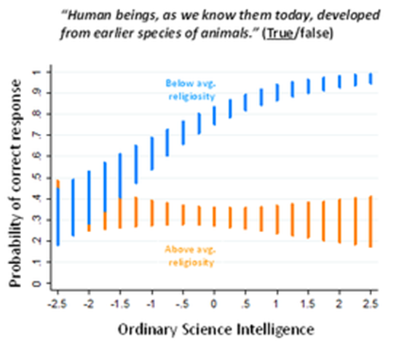
Figure 1: polarized views on evolution with increasing science knowledge. From a post at Dan Kahan’s Cultural Cognition blog.
To answer these questions our robot moves on to Figure 2, which can be visualized from any of many recent surveys regarding US public views on human origins. From Gallup 2012, this shows the proportion of people believing humans were created by God, or believing in ‘God guided’ evolution, or believing in a purely natural evolutionary process in which God plays no part, mapped against political allegiance.
The interesting feature in this chart is the stripe in the centre. Ask any respondents in this stripe if they believe in God, they’ll say ‘yes’. And yet they disbelieve a fundamental tenet of the cultural text from which the concept of their God springs. Their God is not some other God, it is (overwhelmingly²) the Christian God, for which the only root validation that counts is the bible. A text with which they are fundamentally at odds. There is no latitude in this text for evolution (over thousands of millions of years), only complete contradiction well outside the scope of merely human fallibility in representing the divine word.
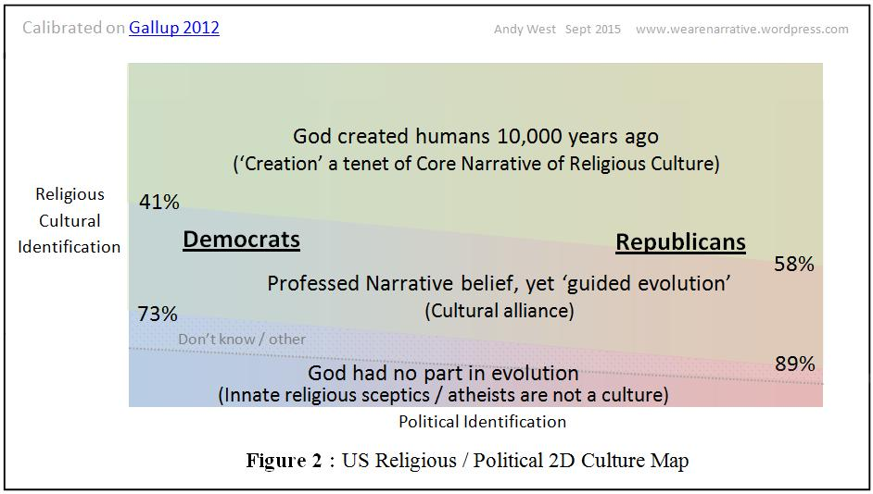
This is a classic identity issue. Despite an awareness of major narrative inconsistencies, the identity and social embedding of these respondents is too tangled with their belief in God for them to deny Him. Yet allowed to respond in a manner that doesn’t so directly challenge their identity, they reveal that they don’t really believe in the core narrative of the religious culture that created the concept of their God in the first place. This kind of ‘convenient alliance with belief’ occurs at the edge of a culture, outside but linked to the domain of full belief, a fact our robot knows. Given that folks in both the top and bottom stripes say evolution is incompatible with creation, yet the ‘convenient belief’ links upwards to religious narrative, the robot deduces that the strong culture detected in Figure 1 must be coming from the top of this chart. Or at least mostly; there is still the possibility that the bottom of the chart is also CD, rather than ED.
The robot from Mars is thorough. It also double checks for any ‘convenient belief’ linked downwards to atheism. No such is significant in public surveys currently⁶. This in itself suggests that the bottom stripe may be ED. A way to get confirmation is to look at the spread of host narrative into society. Via emotive memes a strong cultural narrative will spread to influence or even dominate many aspects of society; indeed our robot can observe wide social applicability in the US of Christianity now, and even more so historically. In contrast ED positions tend to have only limited applicability to or influence upon, social behavior. While the notion ‘belief in evolution’ does not really have a well defined host narrative like creationism does with religion, it certainly has solid roots going back to atheism and science. Our robot observes that atheism does not impose strong behavioral controls on many aspects of US society, or early incursion ahead of such. Rather it tempers aspects of existing religions. And knowing what science⁸ is, our robot also links this to the support of an ED position. The bottom stripe must be ED.
Along the way the robot notes that there is another domain with wide applicability that regulates the behavior of folks in society, which therefore it suspects is cultural, and in which ‘Republicans’ oppose ‘Democrats’. Cultures typically form cross-coalitions with other cultures, and religious belief certainly seems to be a major component of both political parties. Maybe explicit atheism is still too challenging for either party, which would help to explain the width of the ‘alliance’ stripe. Yet there is significant asymmetry; the Republican party has a stronger link to religion.
Back here on Earth, we can try to confirm the robot’s conclusion by looking at our society’s attempts to objectively measure itself across influence categories. In this case measure US society, as undertaken by Pew in Figure 3. This chart shows what factors influence US public views on the question of whether humans evolved due to natural processes. Footnote 4 provides guidance on what we should generically expect in the various categories.
In particular, Figure 3 shows that the strongest influencing factors in the evolution versus creationism debate are Religion and Age. We humans would thus conclude that Religion constitutes the CD position, defended by older persons and also with extension into Education and Ideology, the latter through the asymmetrical relationship of US political parties with religion, per Figure 2. The ED position fights back in Education, and via youth plus in part the Democrat party. Race seems unimportant for this topic, and I have no clue why Gender is involved. While the robot from Mars has not our intimate knowledge of Earth civilization, Figure 3 is at least consistent with its findings thus far. It also knows age is a battleground for newer ideas (ED or CD) that challenge existing culture. It can see that ‘Religion’ is the very same domain that hosts the narrative of creationism, which it already fingered from Figure 2. And it knows that where a CD position is in play, polarization per Figure1 may prevent Education overall being a top influencer¹. Plus from Figure 2, it expects Party weighting wrt support of religious narrative. All consistent. So, it would then attempt to validate this candidate confirmation, by looking at the same Pew system for a different controversial topic that pervades US society; for instance GM foods per Figure 4.
Here the robot sees a completely different picture from Figure 3. Those topics it suspects are main cultures (far left and far right) do not feature. And ‘Education’ is the main driver of attitudes for this topic. Whatever turf wars and psychology are going on, these are not currently driven by a mainline culture. While not knowing what the issue of GM foods is all about, it can conclude that this Pew self measurement system is capable of picking up debates where only ED/NED positions compete, i.e. mostly non-cultural, which it knows would likely feature ‘Education’ as the largest influence⁴. This adds to its confidence in the system, and supports the likelihood that those influences reported in Figure 3 are real, reflecting the battle of religious culture against an ED position.
4. Conclusion for the Creationism Debate
So with knowledge of social analysis supported by only modest perceptions of current Earth civilization, and acquiring only the most simplistic domain detail regarding the creationism debate, our robot rightly attributes a CD position to the creationists, and an ED position to those promoting evolution⁵.
5. The Climate Debate
Now we are armed to follow our robot from Mars as it performs exactly the same walk through the clues from the climate debate. From Figure 5, the first stage unfolds in the same way as with the creationism case. Views on climate change in the US polarize with increasing science knowledge. I.e. going right on the X-axis, those leaning more to anthropogenic dominance believe this still more emphatically, and those leaning more towards natural dominance believe more emphatically in natural causes. The extra ‘climate science literacy’ (prototype) test, filters for an even higher domain knowledge. Just like before, our robot knows this indicates strong cultural influence; initial bias sets people upon educational paths to different knowledge. (Regarding more matched gradients for the two lines than in Figure 1, see footnote 1).
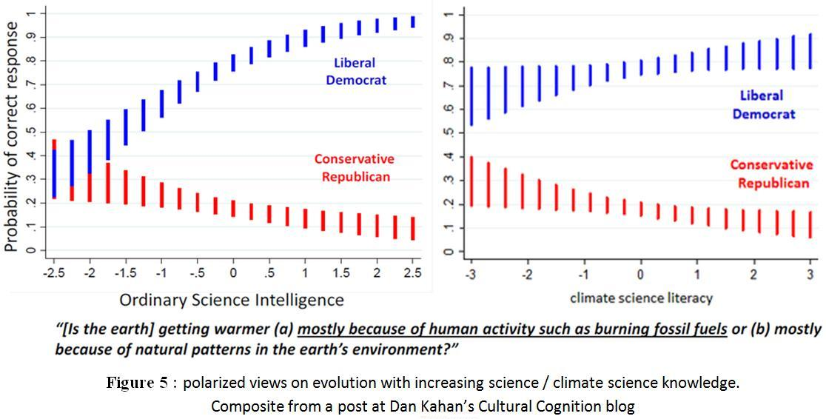
A key difference here though is that the initial bias and subsequent polarization on the issue is determined w.r.t. political party / ideology, and not w.r.t. an explicitly climate related framework (be it CD or ED) in the same way that creationism sits in a religious framework. Suspecting already from the creationism case that ‘party’ implies culture, which can have cross-coalitions, our robot doesn’t yet know whether Figure 5 depicts direct cultural impact (so, political), or is a result of close association.
Dan Kahan, from whose excellent blog the Figure 5 data is sourced, claims that political ideology is the main source of the cultural bias and assigns it all to the Rep/Cons, by virtue of pinning the Lib/Dems to correctness via the underlined answer. Down here on the Earth this detailed Climate Etc post shows us how that assumption does not fit the data. More simplistically our robot, just like before and cautious of the biases of Earthlings, knows only that these charts reveal strong cultural influence, and proceeds in the same manner as before to identify its source.
Hence it moves on to Figure 6, which can be visualized from any of many recent surveys regarding US public views on climate change. The chart shows the proportion of people professing to believe in CAGW and placing it as a top priority, the proportion of people professing to believe in CAGW yet not giving it top priority, and the proportion of people skeptical of CAGW, mapped against political allegiance.
Once again, the most interesting feature in this chart is the stripe in the centre. Ask any respondents in this stripe if they believe in dangerous man-made global warming, and they’ll say ‘yes’. And yet they disbelieve a fundamental tenet of the narrative of climate change as it is propagated by world leaders and scientists and policy makers and NGOs around the world; namely that this is a critical and urgent issue. Even for the Democrats (or Dem/Libs) alone, survey after survey establishing a list of priorities for the President or government to execute on, show climate change low or very low. For this result, many of those in the centre stripe must be expressing virtually no concern at all about climate change, hence they essentially sabotage the top priority choosers. (See footnote 7 for detail regarding the variable percentage range for these charts / surveys). As polled across both parties, climate change generally comes last.
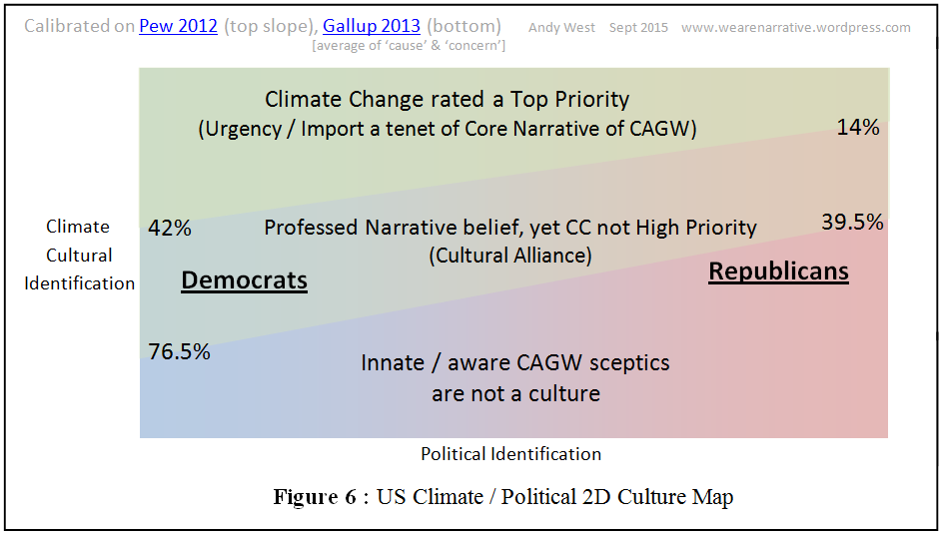
This is an identity issue, just as with the creationism case. Despite an awareness of major narrative inconsistencies, the identity and social embedding of these centre respondents is too tangled with their belief in CAGW for them to deny it. Yet allowed to respond in a manner that doesn’t so directly challenge their identity, they reveal that they don’t really believe in the core narrative that dangerous man-made climate change is the issue that trumps all others. Just like before, the ‘convenient belief’ links upwards, this is where the cultural influence must be coming from. Our robot concludes the green stripe is CD.
The robot double checks for any systemic ‘convenient belief’ linked downwards. This is not visible in public surveys. (But see footnote 9 for what this might look like, and Kahan’s claim to have found some e.g. in farmers). So it provisionally assumes that the bottom stripe, CAGW skepticism, is ED. It then checks the host narratives for both the bottom and top stripes to see what these yield. The top stripe is hosted by a strong emotive narrative about imminent calamity (the very reason for a ‘top priority’), which as expected for a culture stretches well outside the narrow domain of climate into various areas of society. Useful confirmation. (Bear in mind that although adherents say this scope is necessary to save the planet, all major cultures declare that their wide application is a highly important necessity, and bias mechanisms powerfully reinforce this for adherents – the robot sees no difference to other cases). It does perceive that the culture may still be young and facing innate resistance; while spilling into many social areas, climate change has not gained the social control of, say, historic Christianity. It also notes that climate skepticism has limited scope; rather like atheism it is really only defined in opposition to that which expresses itself as a main culture, and has no framework as a standalone issue. This marks it as ED.
The robot then notices that both the host narrative for man-made climate change and the roots of climate skepticism, claim validation by science. This is not so for creationism in the case above. However, it’s knowledge of social analysis tells it that science is fragile; over a course of years the scientific endeavor itself can easily be assimilated by the co-evolving framework of emotive memes in a mainline culture. There is no reason to change its analysis thus far. This fact does lead to a further assumption though: the ‘correct answer’ is less likely to exist and be obscured by culture. More likely, the scientific uncertainties are such that there cannot yet be an answer, and this lack of knowledge is the window through which the climate culture originally gained its emotive leverage, which leverage now works (net) against further efforts towards an answer (cultures evolve to maximize their environment).
This time around, the humans’ own Pew system of evaluating all influences appears to have an omission, yet despite this once again provides further validation. The omission is that there is no separate category for a climate culture in its own right, which once again suggests that this culture is new, humans have not yet realized that it does have an influence in its own right. So another clue to verify the ultimate cultural source would thus be useful, but for now the robot can fortunately continue unhindered, because it knows from Figure 6 that there is major asymmetry on climate belief between US political parties, so the ‘party’ category is a useful reflection of the candidate climate culture. (From Figure 5 and 6, Democrats are about as religious as they are climate calamitous, yet Republicans are significantly higher for the former and dramatically lower for the latter). So armed with a good proxy, the robot moves to Figure 7.
This looks very much like Figure 3 for the creationism case, except that the strong cultural influence has switched from the far RHS, i.e. religion, to the far LHS, i.e. ideology / party, which is the proxy for climate culture. Otherwise all the same factors apply: the battleground of age resisting new culture and youth promoting it, the polarization in higher education preventing it being a highest strength influence¹, etc. All this is once again a great fit to the robot’s prior findings. Race may creep in because it also has a political dimension (and political asymmetry is higher than for creationism), yet once again I have no clue why gender is involved. The religious-political and climate-political slopes are in opposite directions, so presumably will cancel in part to produce the observed weak influence of religion. (The Pope’s attempt to form a cross-coalition with climate culture is too recent to impact; it could further polarize the Catholic-racial divide on climate change³, or alternatively pull more white Catholics into concern).
As noted this Pew system does not distinguish a separate climate culture, and hence is unable to verify earlier findings that there is such. Reading Figure 7 in isolation gives the impression that differences in belief regarding climate change in the US are mainly a matter of political allegiance. Hence this time the robot seeks a different confirmation: outside the US there is not strong political polarization on climate change in many countries, yet there is still cultural behavior regarding climate change issues. It knows from social analysis that fundamental emotive bias and social consensus mechanisms are common to all humans, or at least all those in similar developmental stages (e.g. all modern societies, as opposed to say an isolated and primitive New Guinea tribe). Hence the ultimate behavioral drive in the US should be the same as elsewhere, i.e. a drive from climate culture, albeit with which there is more asymmetry regarding cross-coalitions with (US) political parties.
6. Conclusion for the Climate Change debate
So using identical methods as employed for its analysis of the creationism debate, regarding the climate change debate our robot has attributed a CD position to the mainstream climate change Consensus, which promotes a narrative of imminent (decades) calamity, and an ED position to the climate skeptics.
However, it also knows that climate change culture was spawned by science and in terms of generational penetration, is likely still new. Hence the core climate change narrative and wind turbines may not be wholly equivalent to the bible and churches. Yet our robot would certainly assume that the former have more in common with the latter than with, say, the evidence for General Relativity and power stations.
Andy West www.wearenarrative.wordpress.com
References
Dan Kahan post at Cultural Cognition blog including Figure 1 & 5 charts.
Gallup 2012 poll calibrating Figure 2.
Pew 2015 poll including Figures 3,4 and 7.
Pew 2012 and Gallup 2013 polls calibrating Figure 6.

Footnotes
1. In Figure 1, while the polarization is marked, the lower slope (of the more religious who believe more emphatically in creationism when science educated), is shallow compared to the diverging slope for the less religious participants. It’s likely that this is because religion is largely ‘received’ knowledge rather than formally learned knowledge; it has been around so long and is so entrenched that people are raised with its main principles. Hence there is less to discover regarding those principles when higher education (in science or generally) begins. In contrast the principles of evolution still have to be formally learned from scratch by most folks, who thus experience a bigger leap in new knowledge (and resulting attitudes) during higher education.
Climate change culture is very new (in generational terms) and is not a ‘received’ culture. Thus the slopes of both lines in the equivalent chart for climate change (Figure 5), are similarly steep. Both the paths to orthodox and skeptic knowledge are real journeys of education performed by adults or older youths; only a small % of people would currently be raised on the principles of calamitous climate culture, though this will grow if the culture continues to penetrate society, and for instance be taught during early schooling. Similar slopes but less emphatic are observed for higher education generally, rather than just in science.
Polarization will typically mean that more education will not overall come out as the most critical factor in determining support for or against a CD position. But it depends on the net movement when the two opposing slopes are combined, which will also depend on the number of people in each camp. In the US creationism debate, the net movement with higher education favors support for evolution (steeper slope and more younger people have initial leanings that way). Thus simple polls reflect this, but they miss the underlying subtlety of polarization. The situation for climate change is more balanced, yet polls report a slight net movement towards skepticism with increasing education, which is also reflected in the higher educated Independents (the least partisan of all US voters, so subject to the least party political influence; their net skepticism cannot be due to entrenched Rep/Con identity).
2. Religious Americans are overwhelmingly Christian. But as the detailed political-religious coalition map below (from Brookings / PRRI 2012) also shows, the simple overall picture in Figure 2 of the main post hides many complexities beneath. These don’t affect the first level analysis of the robot from Mars, but they certainly demonstrate that cultural coalitions are not black and white and rarely stop at an alliance of two. Cultural coalitions are generally strings linking many shades of grey through different domains, which also dynamically shift when strengthening relationships in one domain weaken bonds in another; the whole effect a kind of wriggling dance of competition and co-operation with other such strings. Religion is very old and entrenched, indeed pre-dating the political parties by a very long time, and contains various branches some of which buck the main trend in Figure 2 by having majority Democrat support. These include Hispanic Catholics for instance, and Jews in the ‘non-Christian religious’, which however are both minorities in the US population so get subsumed in the overall religious majority of the Republicans. The strings connecting (multiple) race and (multiple) religious groups and politics, and indeed the culture of climate change, are revealed in maps like this (also see 3 below).

3. Read 2 above. And from PRRI 2014, 43% of Hispanic Catholics are very concerned about climate change, but only 17% of White Catholics.
4. There are some generic expectations regarding the Pew 2015 blue squares charts featured in the main post. One would not expect the categories at the centre, gender and education, to have the strongest influence regarding support or resistance for a core cultural narrative that has penetrated much of society. Gender can be a strong influence in particular narrow topic domains, but theoretically not wider (although having said that, it crops up in both creationism and climate change, I don’t know why). The polarizing effects of a major culture on the higher educated, per footnote 1 above, may prevent this being a top influencer too. Race is typically tied to culture and hence may score higher, either via direct influence or cultural coalition, and age is a powerful influencer because on average older folks tend to defend existing culture against newer ideas (whether those are also CD, or ED), which the young on average promote. And the outer categories essentially are mainline cultures; so where religion or politics is the heart of the issue, they will dominate, plus they may also score high via a strong cultural coalition. The robot from Mars ought to suspect the cultural nature of the outer categories straight away in fact, because they are apparently unrelated to physical characteristics like age, race or gender, and the formal education system.
For an issue that is (largely) not driven by culture, one would expect education to be the strongest influencer, because this is what, theoretically at least, sorts ED from NED positions. In practice it may not achieve this in the shorter term; the knowledge system behind education is fallible and it can also be diverted by emotive memes which, nevertheless, may not be ones that are integrated into a major culture.
5. The sheer age of Christianity is a huge and obvious extra clue confirming the section 4 conclusion regarding creationism, a clue which the robot from Mars could easily have acquired. Christianity was birthed many generations ago when much less sophisticated societies were typically dominated by entrenched cultures, and critically, at a time before the scientific method was properly established and before society systemically supported science. Christianity is thus far more likely to be CD. But this easy means of identification is not available for young cultures whether secular or religious, and so cannot be used in generic probing for such (potential) cultures. Hence I had our robot avoid this clue.
6. While the basic search of the robot from Mars would not find evidence of a culture of atheism in the US, we can see sparks of potential atheist culture that may or may not blossom one day. The provocative stance of Dawkins and others against religion is emotive rather than reasoned, and those who presume the religious to be deluded, with the implication of mental illness, are wrong by definition considering that the vast majority of humans are religious. Not so long ago, essentially all humans were religious. It’s also the case that globally, some atheist regimes (e.g. the Soviet regime) have sought to eliminate religion by aggressive means that essentially encompass cultural behavior.
7. I introduced 2D cultural maps (climate change culture / political culture) first in this Climate Etc post, please reference for further details. The percentages marked vary considerably depending on the survey organization and precise phrasing of questions and the context with other questions and year taken, etc. However for surveys within 2 or 3 years of each other, the basic shapes and slopes are always similar (for any single survey, the figures tend to move together[ish]). The top left percentage can go down close to 20% and the bottom left can be above 80%. Even picking those surveys / survey pairs that don’t seem to be outliers, the Democrats merely in alliance with climate culture can sometimes considerably outnumber the true adherents. The Republican figures also vary. For each survey set I’ve bothered to map though, the slopes are always in the same direction and the middle stripe is always wider at the Democrat end.
8. At this stage, our robot has assumed that science is a pure endeavor (largely) without its own cultural dimension. Yet although it isn’t enough to upset the first analysis, science has most certainly picked up a significant social baggage in recent times. The kudos of scientists and the authority attached to their pronouncements has led to various emotive reactions both inside science and in wider society, reactions that are morphing to entrenched behaviors, i.e. tangled into culture. This hinders the mission of science. On the second analysis and specifically for the climate change domain, the robot does perceive a cultural diverting of science.
9. ‘Convenient belief’ linked downwards in a chart like Figure 6 would be picked up as respondents who profess skepticism regarding CAGW, but when questioned in a way that does not invoke identity, do not hold true to this skepticism and reveal that they’re not really skeptical at all. Kahan claims to have found people who behave in this manner, with some US farmers put forward as a model case. See his Kentucky Farmer post at Cultural Cognition. However, as several commenters (including myself) have pointed out, the main paper cited in the post does not appear to support his conclusion. See my objections at the top of the second comments page, February 6, 2015.
There’s some further exchange on the Kentucky Farmer here, where Kahan says: ‘But I would not expect anyone to treat the evidence I have adverted to as reason to adjust their priors if they have different ones from mine. If I have am able to attain evidence of that sort, I will make it known (and make known in *what direction* I think priors should be adjusted…’. Well that’s fair enough.

